AUTISM INSURANCE COVERAGE IUC SCHOOLS PROVIDING COVERAGE FOLLOW HOUSE BILL 463

HOUESE BILL 463-AUTISM INSURANCE COVERAGE

Self-insured state employee health plans may provide autism services coverage, but are not required to.

**Coverage required by House Bill 463.**

For children under the age of fourteen (14), the following services must be covered at a minimum:

* Speech and language therapy or occupational therapy performed by a licensed therapist, twenty (20) visits per year for each service;
* Clinical therapeutic intervention provided by or under the supervision of a professional who is licensed, certified, or registered by an appropriate agency of this state to perform such services in accordance with a health treatment plan, twenty (20) hours per week;
* Mental or behavioral health outpatient services performed by a licensed psychologist, psychiatrist, or physician providing consultation, assessment, development, or oversight of treatment plans, thirty (30) visits per year.

The services in question must be prescribed or ordered by either a developmental pediatrician or a psychologist trained in autism and must have been approved by prior authorization.

Coverage also includes evidence-based care and related equipment prescribed or ordered by a licensed physician who is a developmental pediatrician or a licensed psychologist trained in autism who determines the care to be medically necessary, including any of the following:

* Clinical therapeutic intervention- therapies supported by empirical evidence, including, but not limited to, applied behavioral analysis, that are necessary to develop, maintain, or restore, to the maximum extent practicable, the function of an individual and are provided by a certified Ohio behavior analyst, psychologist, professional counselor, social worker, or marriage and family therapist;
* Pharmacy care - medications prescribed by a licensed physician and any health-related services considered medically necessary to determine the need or effectiveness of the medications.
* Psychiatric care- direct or consultative services provided by a licensed psychiatrist.
* Psychological care - direct or consultative services provided by a licensed psychologist.
* Therapeutic care - services provided by a licensed speech therapist, occupational therapist, or physical therapist.

**Limits on what is covered.**

* Services are required only for children under the age of 14.  Minimum amount of coverage is as listed under #4.  More coverage may be provided but is not required.
* The insurer may review an individual’s treatment plan annually, unless the insurer and the enrollee's treating physician or psychologist agree that a more frequent review is necessary.

CSU

|  |  |  |  |
| --- | --- | --- | --- |
| Autism Spectrum Disorders (other than ABA) | Only the following services are covered per benefit period (up to age 14); OP Therapies - Occupational & Speech (20 visits each); OP Mental Health and Physical Therapy Unlimited | |  | | --- | | Benefits paid based on services rendered | |

|  |  |  |  |
| --- | --- | --- | --- |
| Applied Behavior Analysis (ABA) | (up to age 14; limited to 20 hours per week) | |  | | --- | | Benefits paid based on services rendered | |

osu

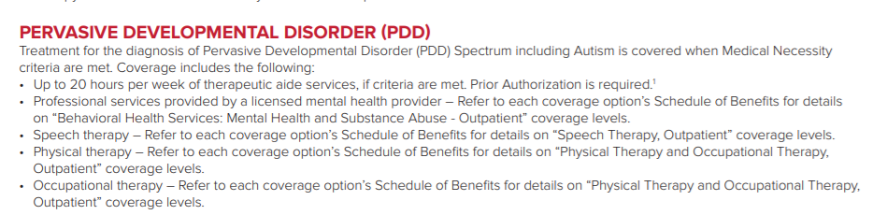

UC

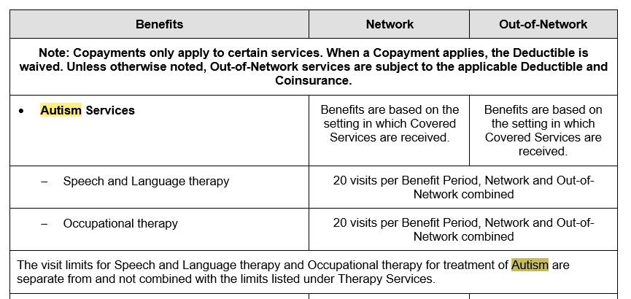

WRIGHT STATE -Similar Coverage per House Bill 463

HOUESE BILL 463-AUTISM INSURANCE COVERAGE

Self-insured state employee health plans may provide autism services coverage, but are not required to.

**Coverage required by House Bill 463.**

For children under the age of fourteen (14), the following services must be covered at a minimum:

* Speech and language therapy or occupational therapy performed by a licensed therapist, twenty (20) visits per year for each service;
* Clinical therapeutic intervention provided by or under the supervision of a professional who is licensed, certified, or registered by an appropriate agency of this state to perform such services in accordance with a health treatment plan, twenty (20) hours per week;
* Mental or behavioral health outpatient services performed by a licensed psychologist, psychiatrist, or physician providing consultation, assessment, development, or oversight of treatment plans, thirty (30) visits per year.

The services in question must be prescribed or ordered by either a developmental pediatrician or a psychologist trained in autism and must have been approved by prior authorization.

Coverage also includes evidence-based care and related equipment prescribed or ordered by a licensed physician who is a developmental pediatrician or a licensed psychologist trained in autism who determines the care to be medically necessary, including any of the following:

* Clinical therapeutic intervention- therapies supported by empirical evidence, including, but not limited to, applied behavioral analysis, that are necessary to develop, maintain, or restore, to the maximum extent practicable, the function of an individual and are provided by a certified Ohio behavior analyst, psychologist, professional counselor, social worker, or marriage and family therapist;
* Pharmacy care - medications prescribed by a licensed physician and any health-related services considered medically necessary to determine the need or effectiveness of the medications.
* Psychiatric care- direct or consultative services provided by a licensed psychiatrist.
* Psychological care - direct or consultative services provided by a licensed psychologist.
* Therapeutic care - services provided by a licensed speech therapist, occupational therapist, or physical therapist.

**Limits on what is covered.**

* Services are required only for children under the age of 14.  Minimum amount of coverage is as listed under #4.  More coverage may be provided but is not required.
* The insurer may review an individual’s treatment plan annually, unless the insurer and the enrollee's treating physician or psychologist agree that a more frequent review is necessary.