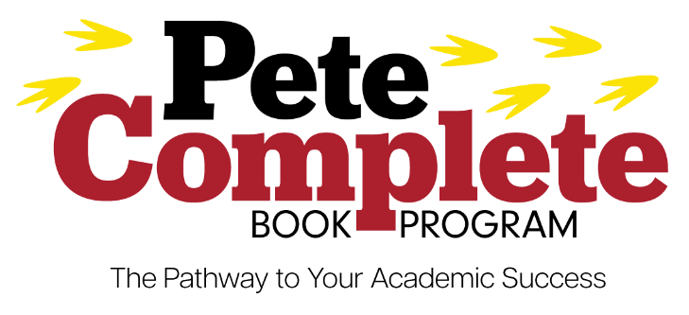
The Pete Complete Book Program is an innovative course material model supporting student outcomes through equitable access, convenience, and affordability. In these forums, students, faculty and staff will learn about the program and how it could assist students at YSU.
This initiative is being explored through the Bookstore Advisory Committee and is not finalized. These informative sessions are to share information and gather feedback from stakeholders to finalize the program and address concerns.
For additional information please contact Joy Polkabla Byers at jlbyers@ysu.edu.

September 12, 2023, 4:00pm-5:00pm, Debartolo Hall, Room 548
Beeghly College of Liberal Arts, Social Science & Education
https://ysu.webex.com/ysu/j.php?MTID=m36cf571e47f0e0fc7e2e80b9ac2e5700
Webex:

September 21, 2023, 4:00pm-5:00pm, Cafaro Hall, Room 103
Sokolov Honors College
https://ysu.webex.com/ysu/j.php?MTID=mc06ae4d47431982bab281ca3889abb16
Webex:

September 26, 2023, 4:00pm-5:00pm, Cushwa Hall, Room 1515
Bitonte College of Health & Human Services
https://ysu.webex.com/ysu/j.php?MTID=m631d46a2b0fdd8ceb155a7ac0ca893ee
Webex:

September 28, 2023, 4:00pm-5:00pm, Bliss Hall, Room 2200
Cliffe College of Creative Arts
https://ysu.webex.com/ysu/j.php?MTID=m70563adede0eac5df1efc7eee3e124fe
Webex:

October 5, 2023, 4:00pm-5:00pm, Moser Hall, Room 2335
College of STEM
https://ysu.webex.com/ysu/j.php?MTID=m24fc2da2b4e3af7fc61f929ce850bdf3
Webex:

October 10, 2023, 4:00pm-5:00pm, Rossi Room, Kilcawley Center
Faculty and Staff
https://ysu.webex.com/ysu/j.php?MTID=m443bf4311bc0a7f311fa72141746d212
Webex:

October 12, 2023, 4:00pm-5:00pm, Williamson College, Room 2221
Williamson College of Business
https://ysu.webex.com/ysu/j.php?MTID=mc981efbd8627aa4b0947249b091b8e2d
Webex:

October 17, 2023, 4:00pm-5:00pm, Rossi Room, Kilcawley Center
Faculty and Staff
https://ysu.webex.com/ysu/j.php?MTID=m75fb2be8c8d860f388a716a40f516c98
Webex:

First Day Complete Timeline
April | Share presentation and gather feedback from stakeholders | X
May | Share presentation and gather feedback from stakeholders | X
June | Share at Dean’s Council again | X
July
August | Present at Chairs Meeting | X
September | Present at SGA, open forums scheduled for each college and 2 sessions for faculty, Introduce to BOT
October | Present Academic Senate 10/4
November | Present and vote at Academic Senate 10/4
December | Present at BOT
January
February
March | Implementation completed – March 22 – Honors Orientation
April
May
June
July
August | Student will have option to opt out, 30 days prior to school starting

For additional information and FAQ, please refer to
https://ysu.edu/office-student-experience/pete-complete-book-program-information

