Initiate a Supervisor Change Request
- Login to NEOED. Click Forms in the menu list on the left side.
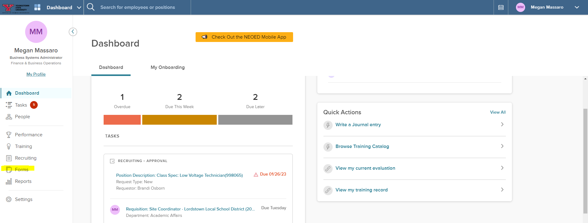
- Click the Supervisor Request Change Process link in the Quick Links tile on the right side.
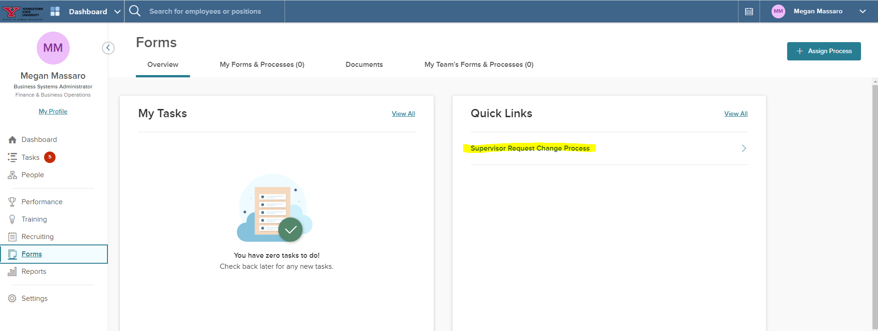
- Click Start Process.
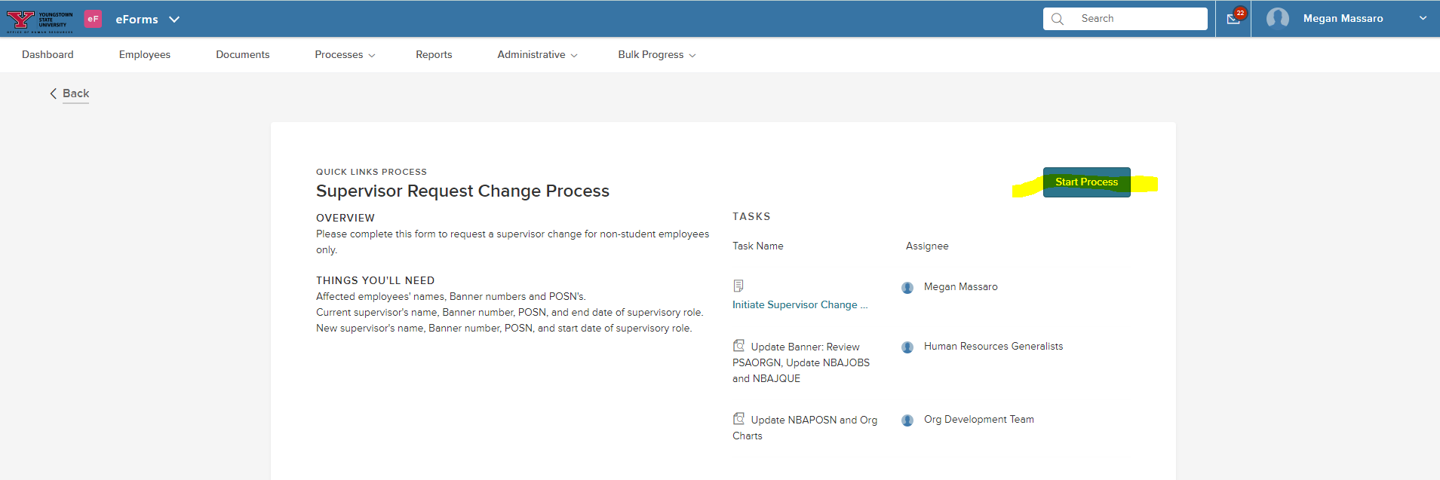

- Click Start Process.
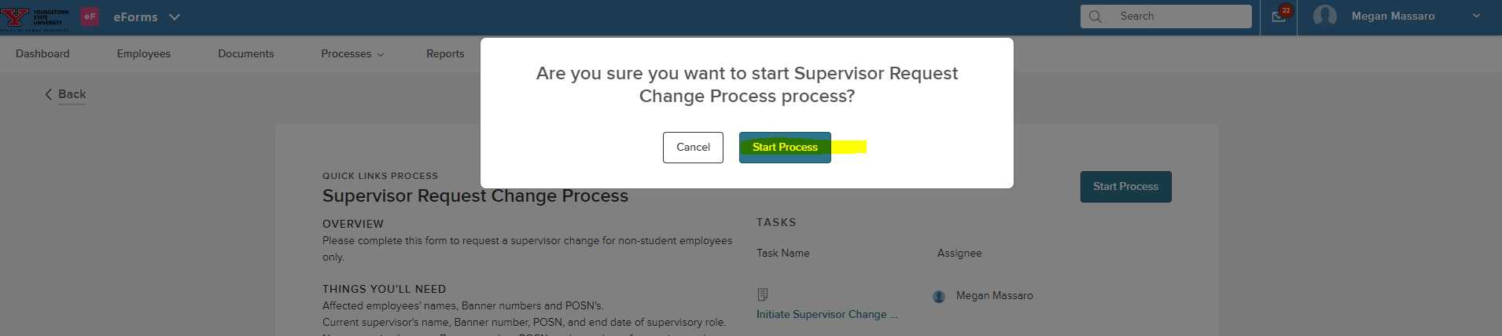
- Review success message and click Complete Form.
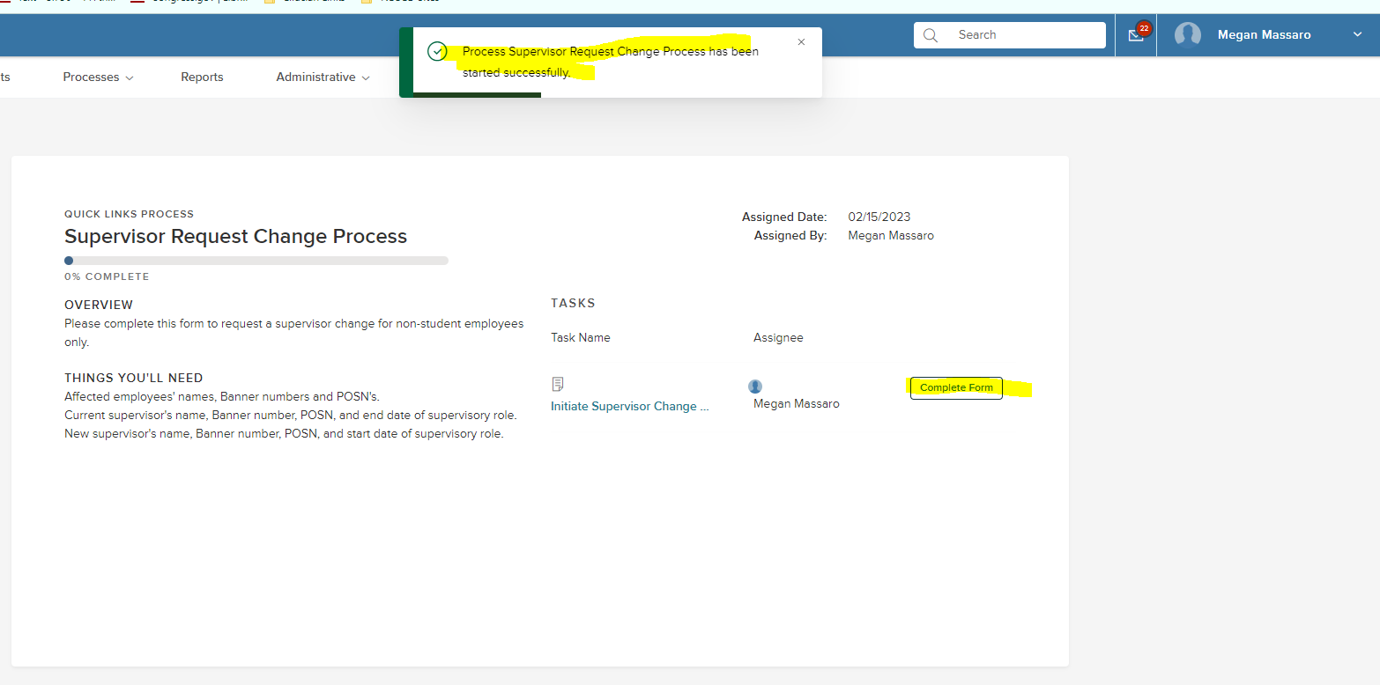
- Fill in the requested fields/information and click Submit.
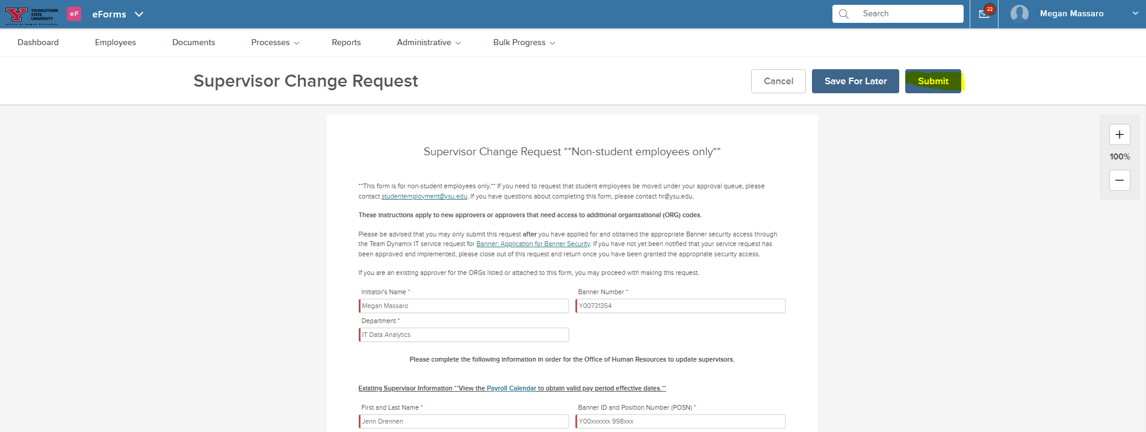

- Review success message. You will receive a notification via email when the process is complete.
