Create & Route a Faculty Posting in PeopleAdmin
This process will take place when a hiring manager has a position that needs to be filled; it takes the place of the paper formerly known as the Requisition.
- Log into the PeopleAdmin system using your YSU portal credentials.
- Change your Current User Group in the upper right hand corner of the page to Hiring Manager.
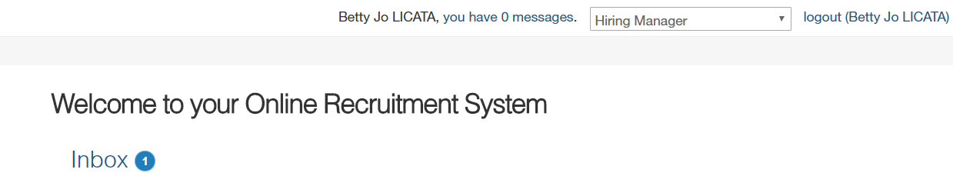

- Ensure you are viewing the “Home” Screen in the Applicant Tracking Module.

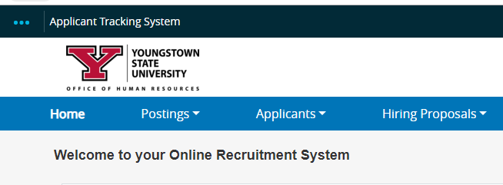

- On the bottom right hand side of the Home Screen, in the “My Links” menu, select “Create New Faculty Posting”.
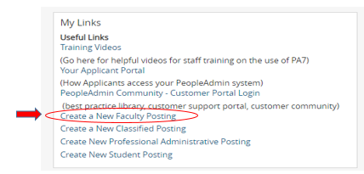

- Select Create New Posting.

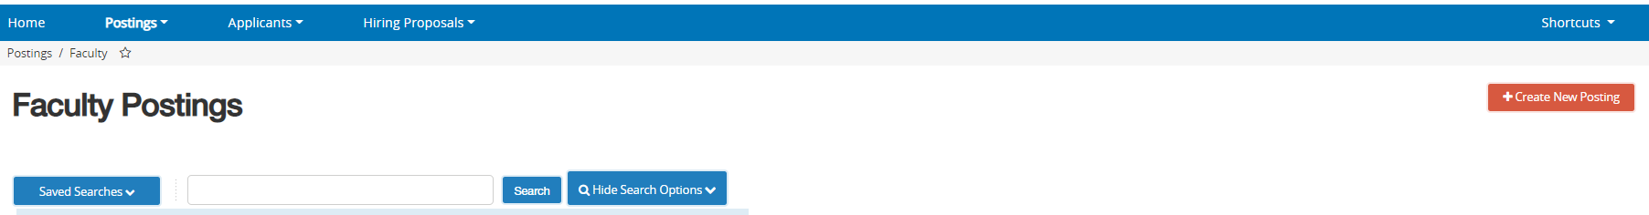

- Select Create from Posting Template.
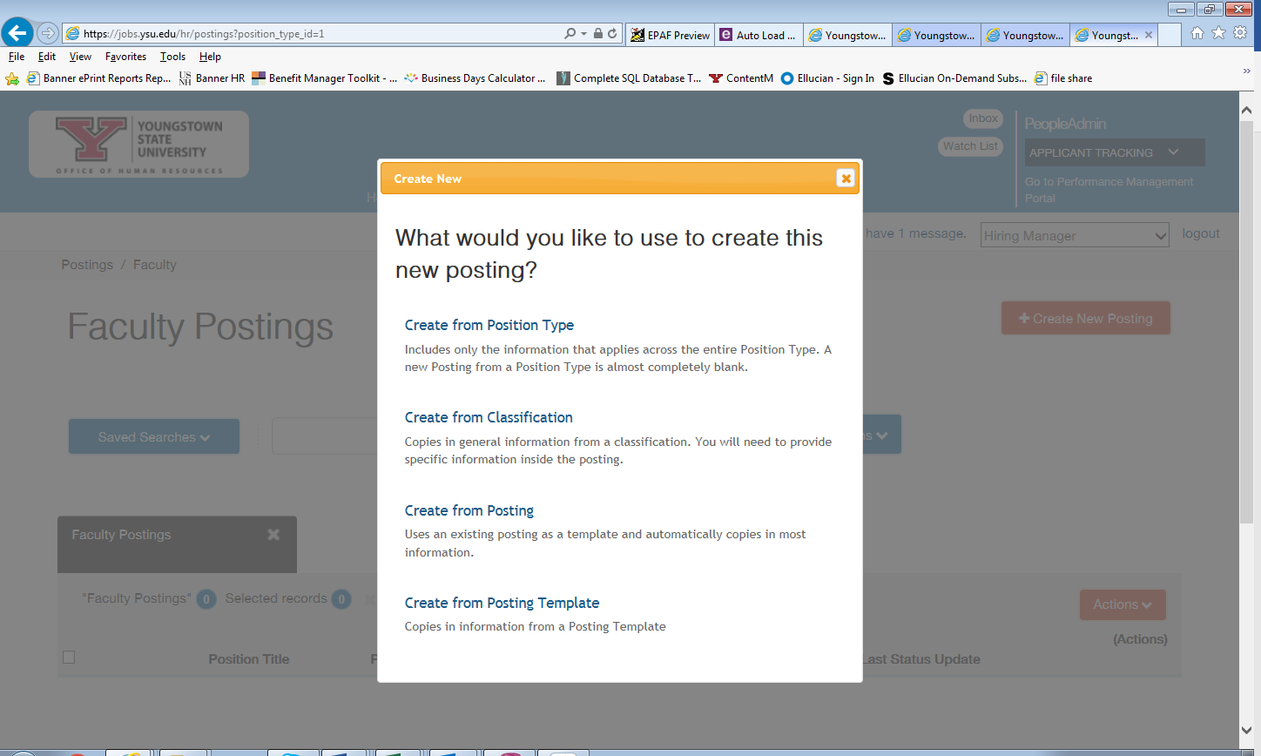

- Select the the type of posting to create ( College Credit Plus, Part-time Faculty or Full Time Faculty).
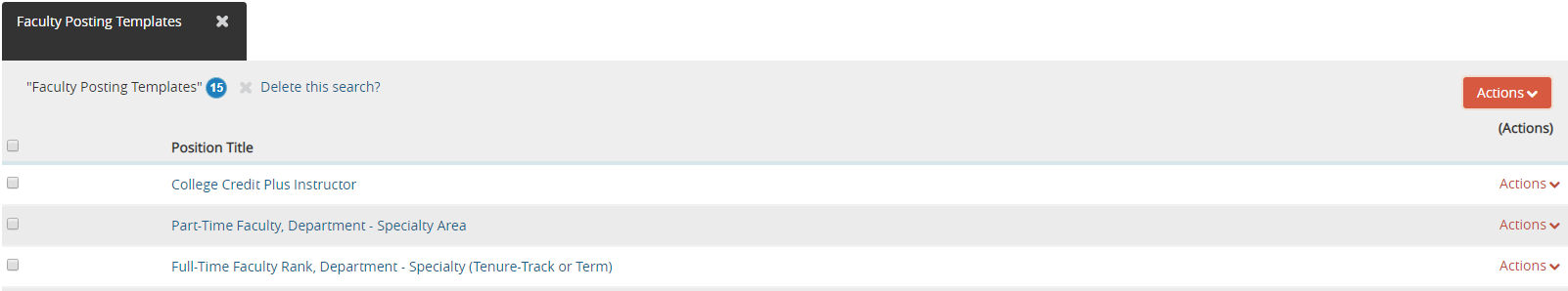

- Choose Create Posting from this Posting Template.

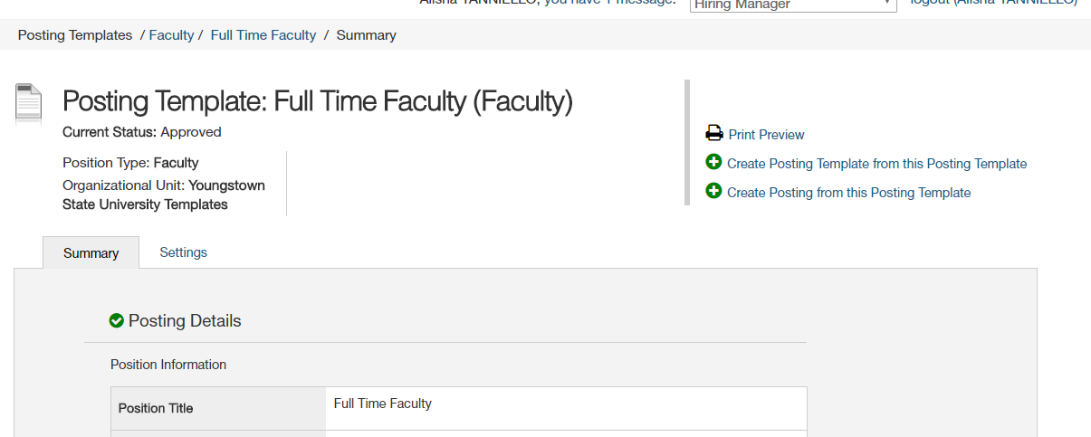

- Enter the Position Title (include the rank & corresponding department), select your Department from the drop down menu:
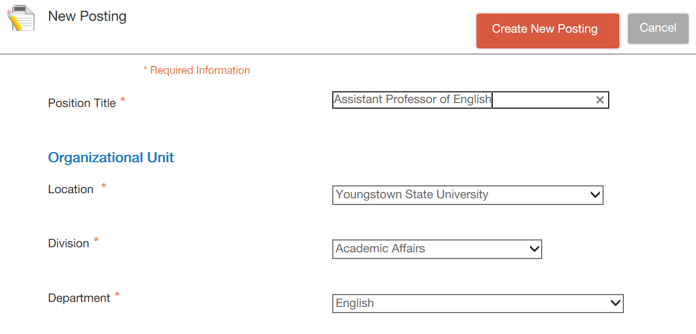
Insert Position Title
Select Department

- The Applicant Workflow and References settings shold not be changed. Ensure the Accept online applications box is checked and under the heading Accepted Application forms, the type of faculty application should be checked:
NOTE: Include any special instructions for the applicant, but always include the Transcript instruction below.
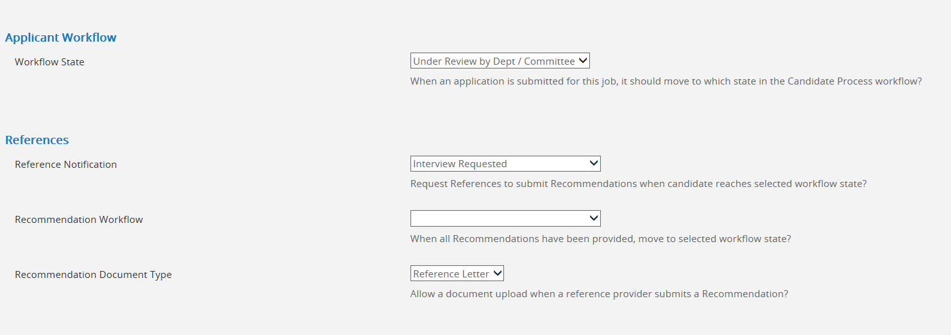
Please do not change these settings. If you would like to change how or when reference requests are sent please contact HR for assistance.
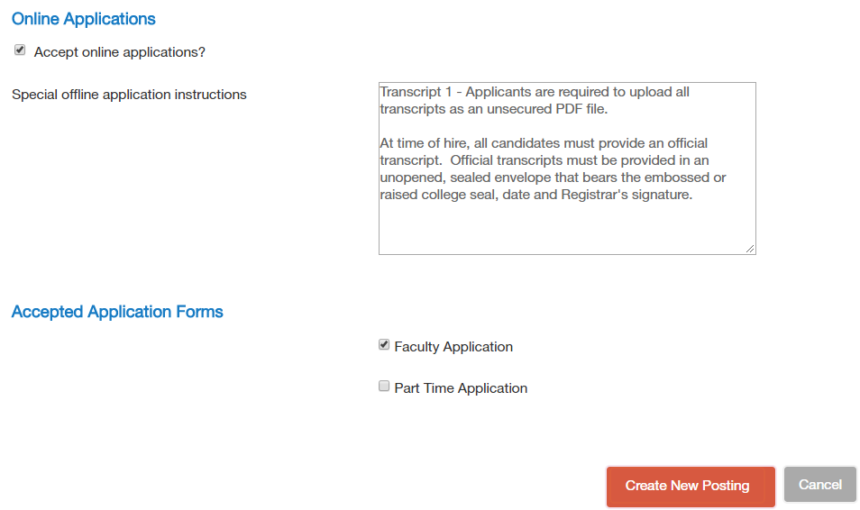
Choose Part-time Application for CCP and Part-time Faculty postings. Then uncheck the Faculty Application box.

- Only the above listed information should be entered. Once the information above is entered, click the orange “Create New Posting” button.

- Enter the Position Information. The position number, length of the appointment, full-time appointment length. The work schedule fields will be left blank. Please indicated in the position title (rank), department and Tenure – track or Term. For Part time Faculty include Part-time Faculty – and department.
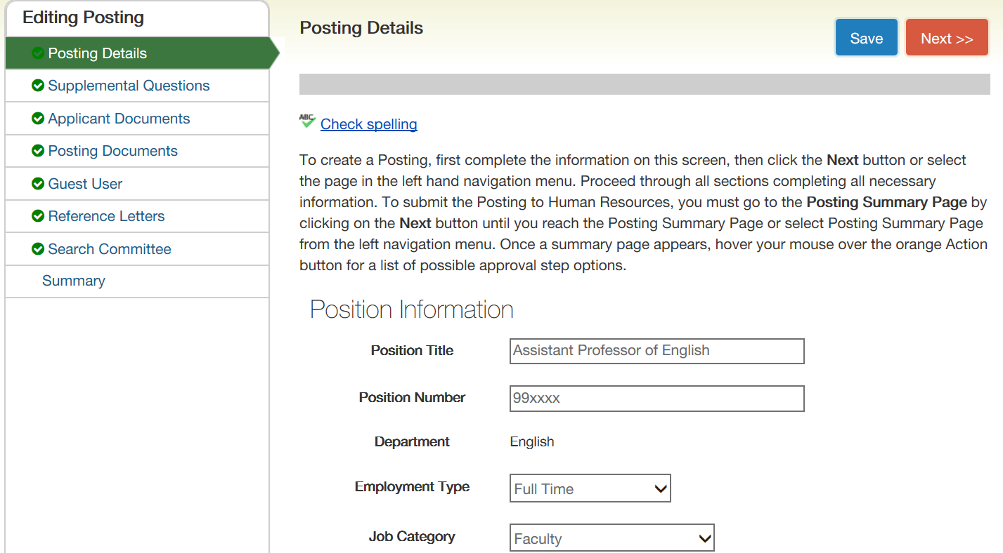

- Utilizing the information provided, you may add information to the Major Work Characteristics and the Minimum Qualifications section. You may add additional Desired Qualifications if needed.

Please note: When deterimining whether to list Desired Qualifications, keep in mind that International candidates for employment may be required to meet both the Minimum and Desired Qualifications.

The Equipment Operated field and Job Duties Section will be left blank.

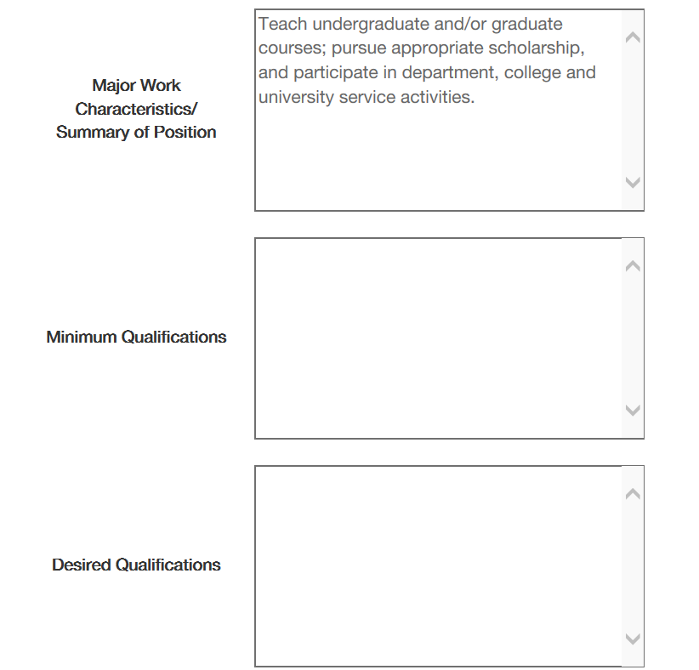
Include minimum education requirements and any other additional requirements such as certifications, licenses, years of experience etc.
Qualifications that are not required, but are important enough that you will choose a candidate who meets these over a candidate who does not.

- Enter the Posting Detail Information. Select Hiring Manager and Search Chair from the drop down menu. As Department Chair, you will be the Hiring Manager. If the name is not available in the drop down menu, please contact Brandi Osborn x7133, Cindy Blevins x2106, or Jennifer Lewis-Aey at x3759. The following fields will not be utilized: Number of Vacancies, Position End Date (if temporary), and Close Date.

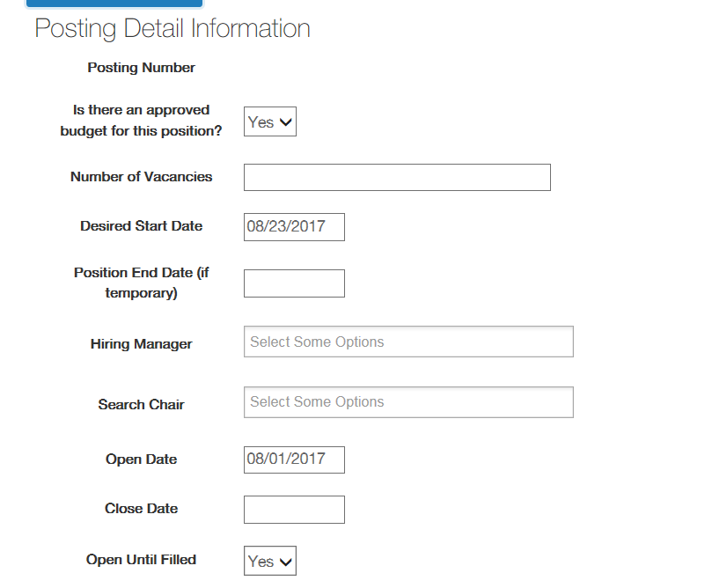

- In the Special Instructions Summary and Requested Advertising Sources, enter any additional infomration that is needed but not provided by the template. The YSU Career website is the only advertising used for Part-time Faculty or College Credit Plus postings.

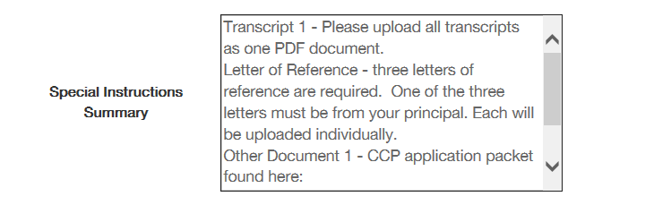

For Full-time Faculty, please indicate if you prefer additional advertising sources. The Office of Human Resources and the Provost Office advertise on the University’s website, HigherEdJobs.com and on the Higher Education Recuritment Consortium (HERC) website. Please note: Requests for additional advertisement will be charged back to your department budget.
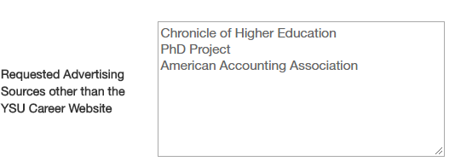

- Once all of the information has been entered, scroll back to the top of the page and Check Spelling. Make any necessary changes and then click “Save” to move to the next step.

- You should see at the top of the page that the Posting was successfully updated. Once this message appears, you will click the “Next” button.

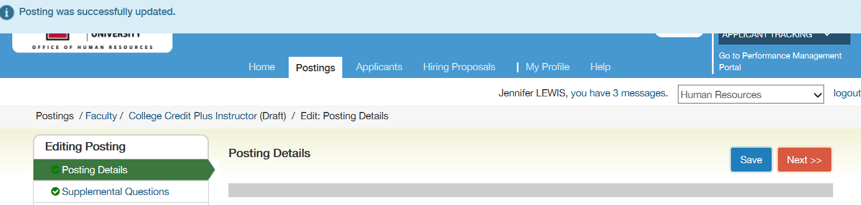

- Supplemental Questions may be added based on the minimum qualifications. Click on the “Add a question” button to add a supplemental question.

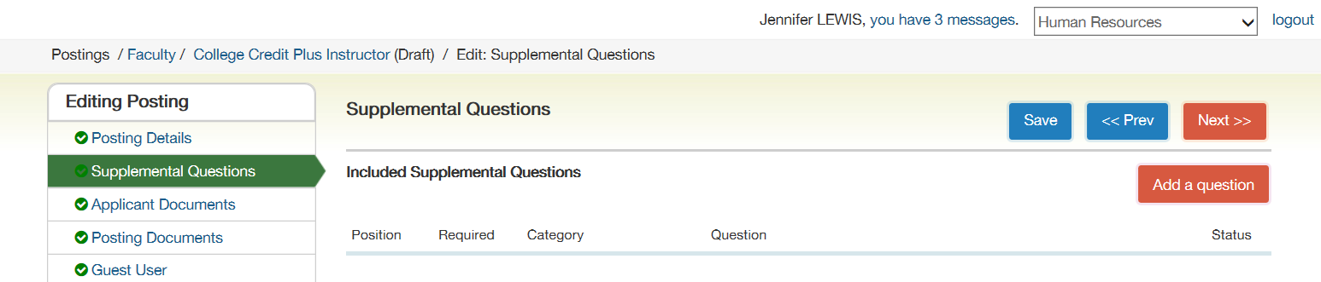

- In the keyword field, type “highest level”. Check the add box and click the “Submit” button. You may also choose to add a new question if you do not find one which is already prepared. Click “Add a new one” above the Submit button

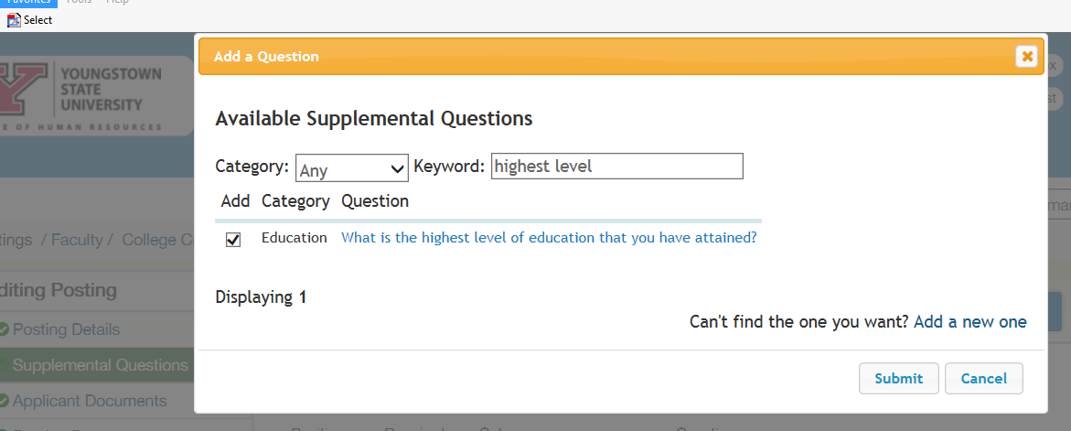

- The question will then appear under Included Supplemental Questions. Check the Required box.

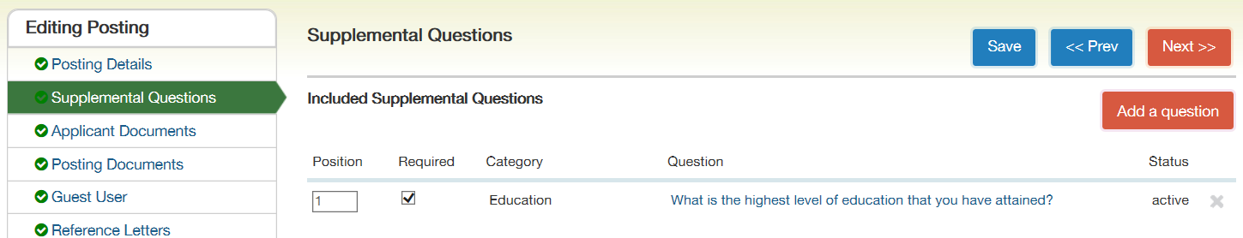

- Then click on the question, place a checkmark in the appropriate Disqualifying boxes. Click the “Save” button.

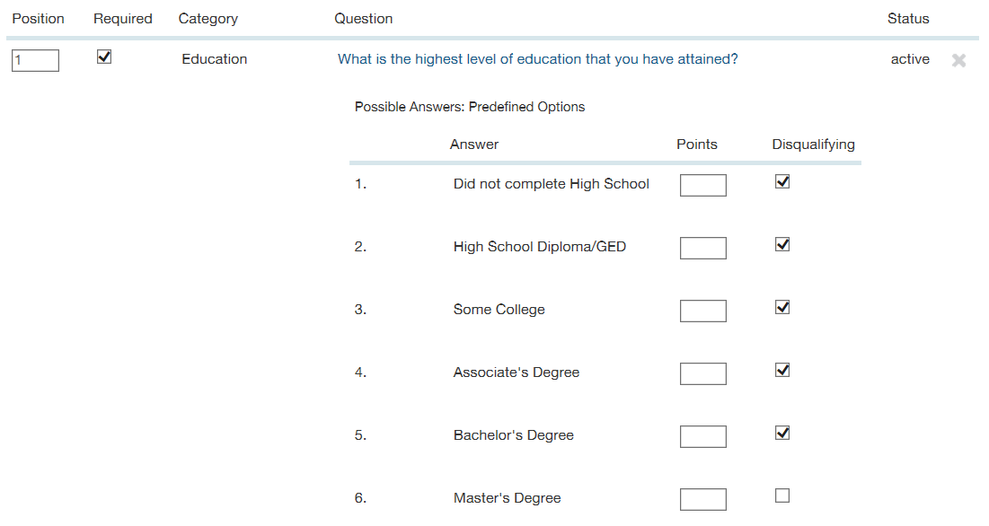

- Once the message displays that the Posting was successfully updated, click the “Next” button. 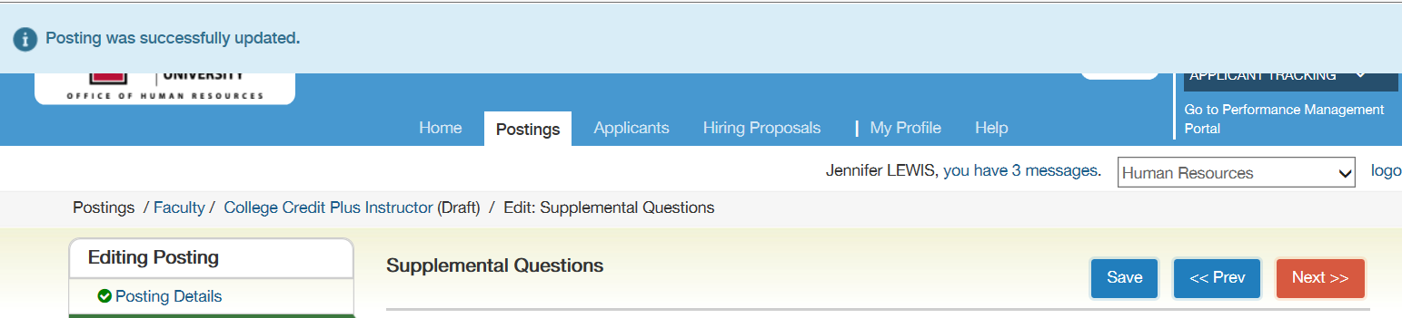

- Select the applicant documents listed below by clicking the radio button and then click the “Save” button. Once saved, all required documents will move to the top of the list. Then click the “Next” button.

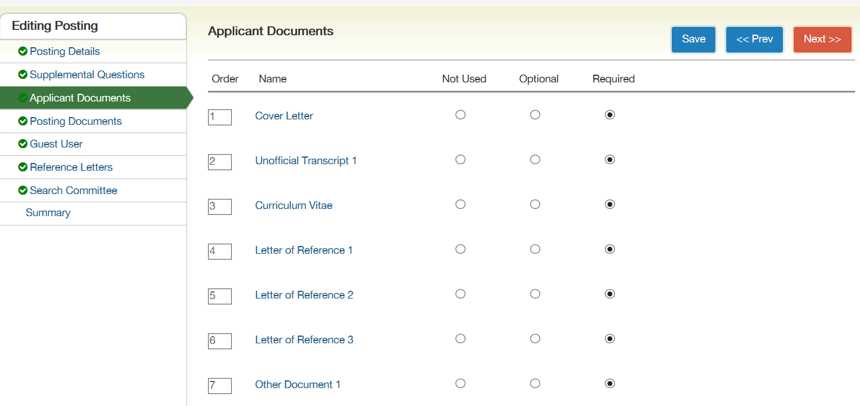
For Part-time Faculty postings, only the Vitae or Resume and Transcript are required. Additional documents may be added.
- No action is required on the Posting documents tab, the Guest User tab or the Reference Letters tab. Click the “Next” button to move to the next tab.

- To add members to the search committee tab, click the “Add Existing User” button.

Please do not click the “Create New User Account.” If a new user account is required, please contact Brandi Osborn at x7133, Cindy Blevins at x2106, or Jennifer Lewis-Aey at x3759.

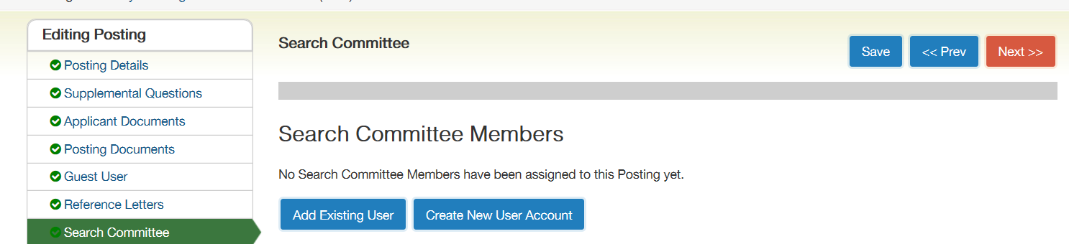

- Type the “name of the search committee member” to be added in the search box. When the names appear, click the “Add Member” button to add an employee to the search committee.

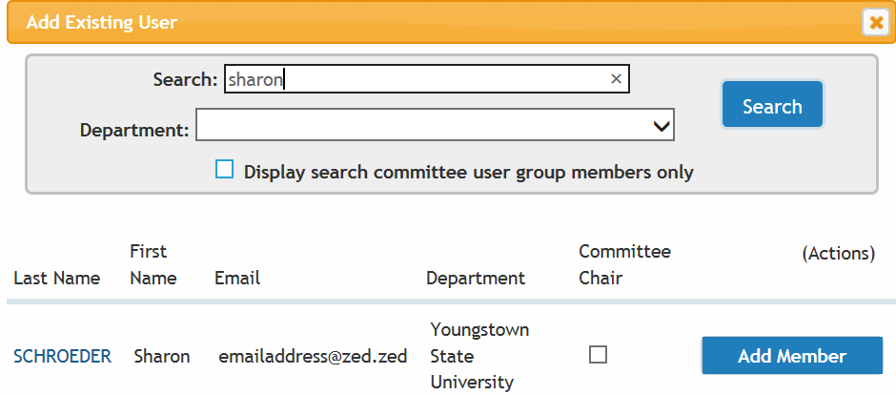

- After all employees that require access to the posting are added, click the “Save” button. Check the box labeled “Search Committee Chair” for the appropriate person. Click the “Save” and “Next” button.
NOTE: If the employees are not found, please contact Brandi Osborn at x7133, Cindy Blevins at x2106,
or Jennifer Lewis-Aey at x3759.
- The summary of the Posting Document will display. Review the Posting. Click “Edit” if changes are necessary. Be sure to save any changes made.

- Once the posting is complete, select the Take Action on Posting button. In the drop down menu select the “Approve – Move to Admin Approval Executive Director/Dean/ Associate Provost.”
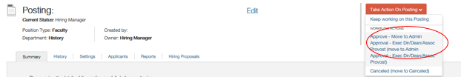

- The Dean will then receive a notice to approve via the PeopleAdmin System. The Dean will then move the posting to
A. FULL TIME FACULTY: “Approve Full Time Faculty – Move to Budget.”
- PART TIME FACULTY: ‘’Approve Part Time Faculty- Move to Compensation.’’
- COLLEGE CREDIT PLUS: “Human Resources: Final Review – HR.”
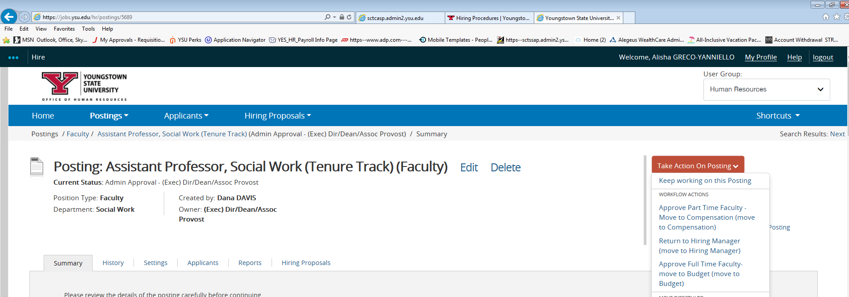
- A: FULL TIME FACULTY: Budget will have the option of returning the posting to the hiring manager or sending forward to Compensation. The final few steps of approval will be Division Signature Authority approval and Presidential approval. Human Resources will have the final approval before the posting is visible to applicants.
B: PART TIME FACULTY: Compensation will have the option of returning the posting to the hiring manager or sending forward to Human Resources – Final Review.
C: COLLEGE CREDIT PLUS: Not applicable for this faculty type.

If you have any questions regarding posting a College Credit Plus or Part time Faculty position, please contact Cindy Blevins at x2106 or Jennifer Lewis-Aey at x3759.

If you have any questions regarding posting a Full time Faculty position, please contact Brandi Osborn at x7133.

