## Enter the Penguin Portal

1. Click the Penguin Portal Link

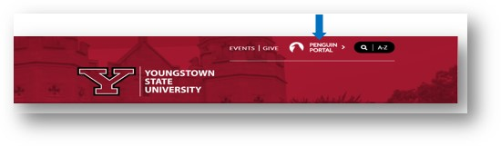

1. Sign into the Penguin Portal using your Username and Password.

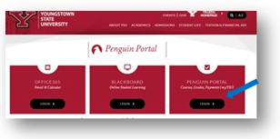

1. Enter your login credentials.

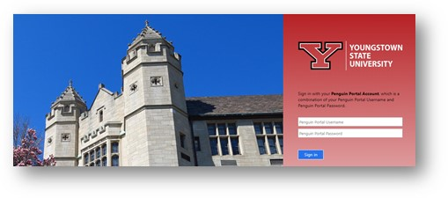

1. Click Banner Self Service under e-Services for Faculty and Staff.

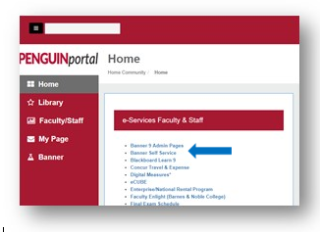

## Access Your Faculty Appointment

1. Click the **Employee Tab.**
2. Click the **Faculty Load and Compensation** menu option.

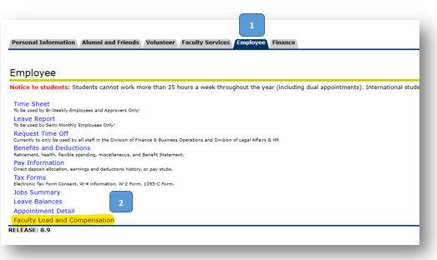

1. To view or acknowledge your appointment click **Compensation and Acknowledgement.**

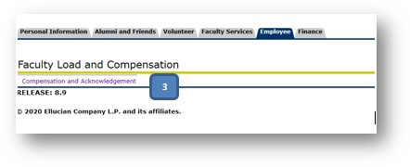

1. Select the term from the dropdown; click **Go**.

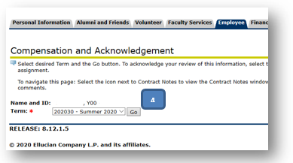

1. Under Subject and Course; click on the highlighted course to view the course calculation and details.
2. After reviewing your appointment(s); click on the **FACULTY ACKNOWLEDGEMENT Box.**
3. Click on the grey box **ACKNOWLEDGE SELECTED POSITIONS**.

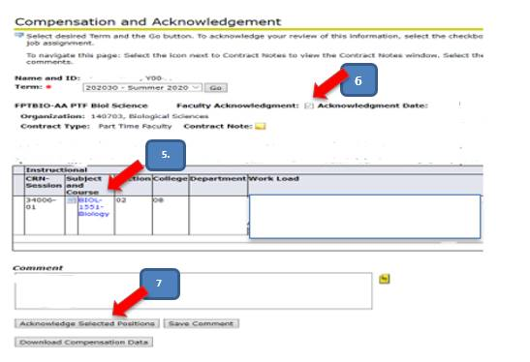

1. **Download Compensation Data** will put your appointment(s) in a spreadsheet.
2. Once acknowledged, faculty can view their appointment detail in the form of an **appointment letter** on the Employee Tab by Selecting Appointment Detail.

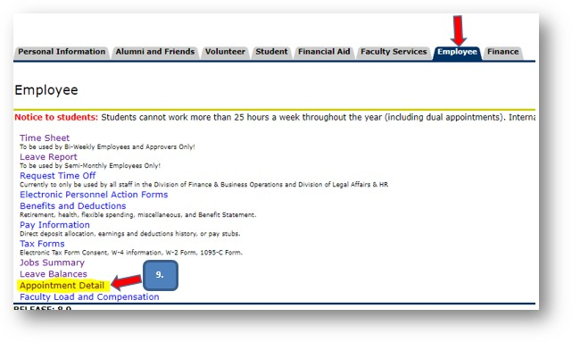

1. Then select the desired appointment from the dropdown list and click display to generate the appointment letter. All faculty summer positions will begin with FS. Each course will generate a separate appointment detail.

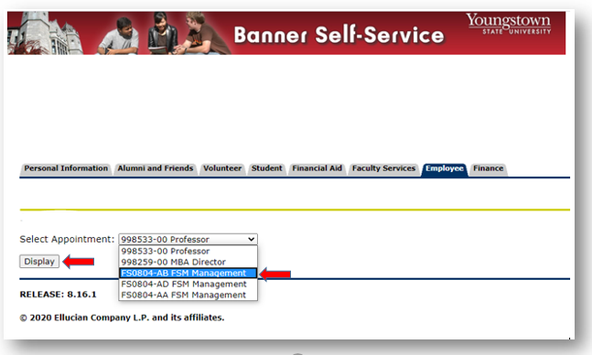

1. The letter will then display and may be printed by right clicking on the mouse and selecting Print.

