A Pranzo In Italy  Thursday, February 22, 2018  Menu  Aperitivo  *Italian Chopped Salad  Entré  *Penne Alla Vodka  Served with or without seasoned meatballs  Accompanied by a slice of buttery garlic bread  Dolce  Cannoli Cone  Bevande  Smooth Iced Tea, Iced Water & Coffee  *Vegetarian alternative entrée available upon request | Easter Lunch  Thursday, March 29, 2018  Appetizer  Hoppy Poppy Strawberry and Mandarin Orange Green Garden Salad  with  Sweet Bunny Buns  Entrée  Herb Spinach and Three- Cheese Stuffed Manicotti  Dessert  “Carrot Patch Dirt” Pudding Cup  Beverages  Unsweetened Iced Tea, Sweet Sunshine Lemonade, Coffee, Water | Thursday, April 19, 2018  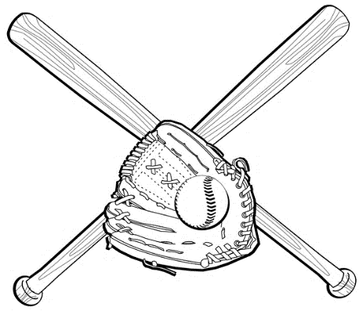  Appetizer  Stadium Soft Pretzels  with Dipping Sauce  Entrée  Grand Slam BBQ Pulled Pork Sandwich or Hall of Fame Black Bean Burger  with Coleslaw and Ballpark Fries  Dessert  Root Beer  Floats  Beverages  Iced Tea, Coffee, and  Water  Ball Game  Out to the  Take Me
FNUT 2612 will be hosting luncheons this year on the following dates with
accompanying menus:
Lunch Cost: $9.50
Seating Times: 11:30 am, 11:45 am, 12:00 pm
Location: 3342 Common Room, Cushwa Hall

If you would like to purchase tickets, please call:
The Box Office: 330-941-1493
Open Tuesdays and Thursdays from 10:30 am to 11:30 am
OR
Human Ecology Office: 330-941-3344
Open Monday – Friday 8:00am to 5:00pm

