Instructions: oral presentations (April 5, 2023)
https://event.fourwaves.com/quest-2023/pages
- Log in
- Use your YSU email address and the password you created
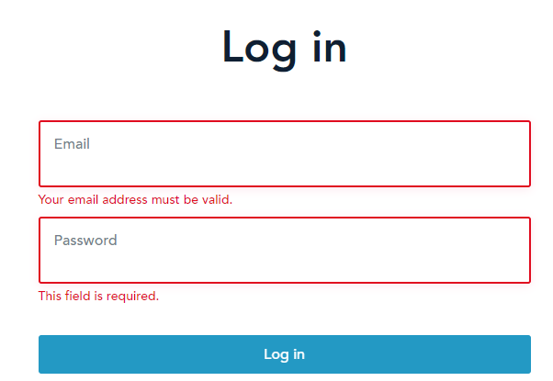

- Select Schedule from the top menu
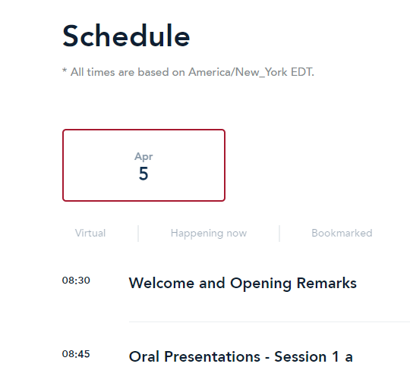

Click the session you would like to attend.

Click join livestream and start meeting

