Create & Route a Faculty Posting in PeopleAdmin
This process will take place when a hiring manager has a position that needs to be filled; it takes the place of the paper formerly known as the Requisition.
- Log into the PeopleAdmin system using your YSU portal credentials.

- Change your Current Group in the upper right hand corner of the page to Hiring Manager.
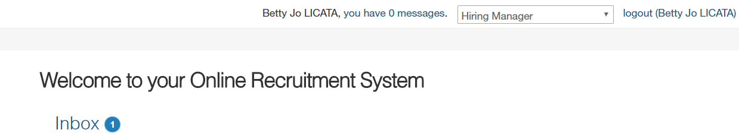

- On the right hand side under the Shortcuts menu, select Create new “Faculty Posting”.
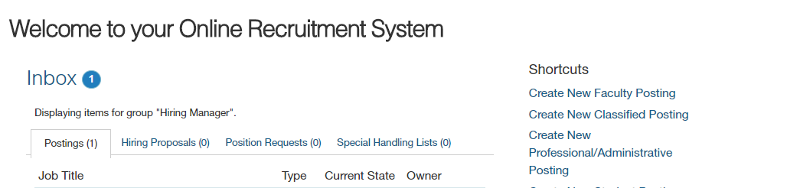

- Select Create from Posting Template.
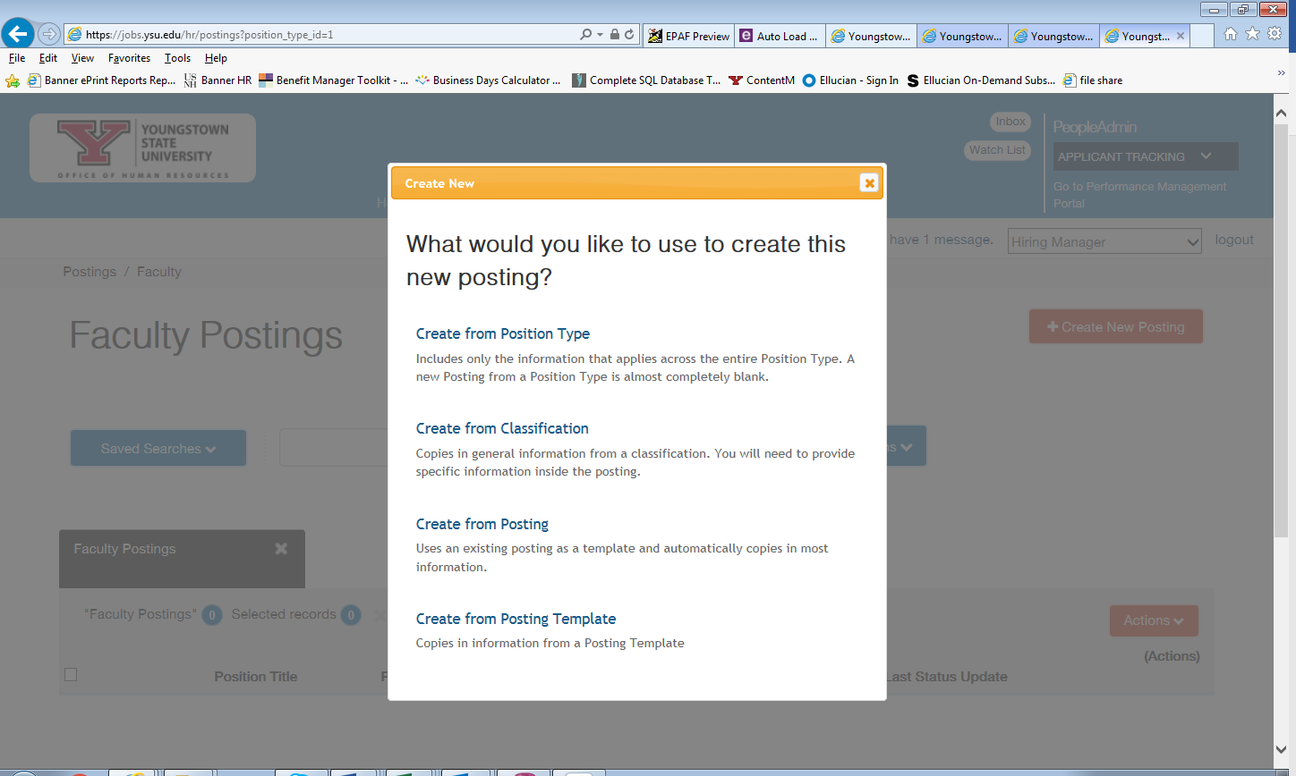

- Select the the type of posting to create ( College Credit Plus, Part-time Faculty or Full Time Faculty).
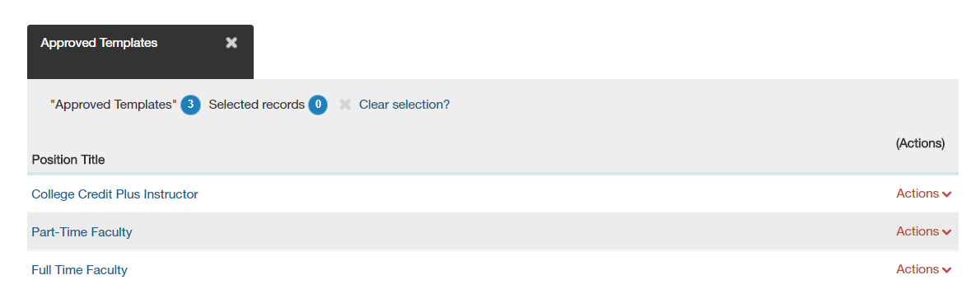
- Choose Create Posting from this Posting Template.

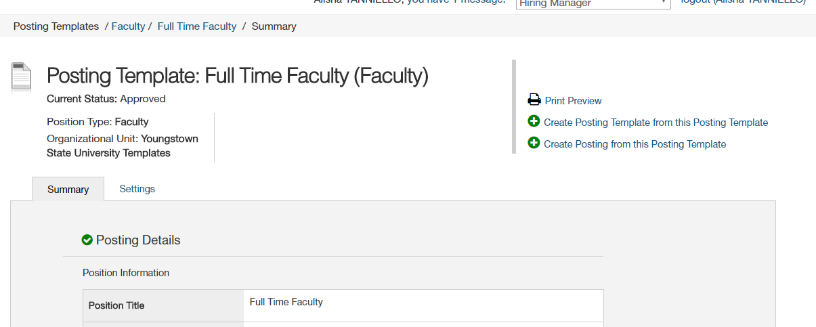

- Enter the Position Title (include the corresponding department), select your Department from the drop down menu:

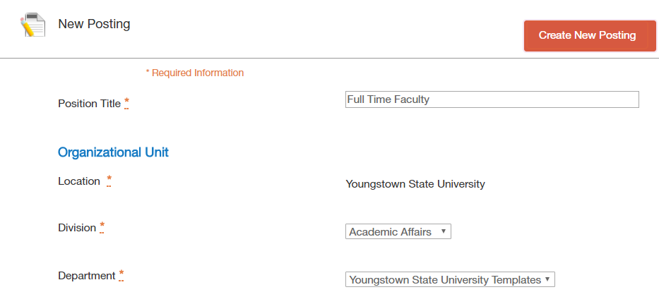

- Ensure the Accept online applications box is checked and under the heading Accepted Application forms, the type of faculty application should be checked:
NOTE: Include any special instructions for the applicant, but always include the Transcript instruction below.
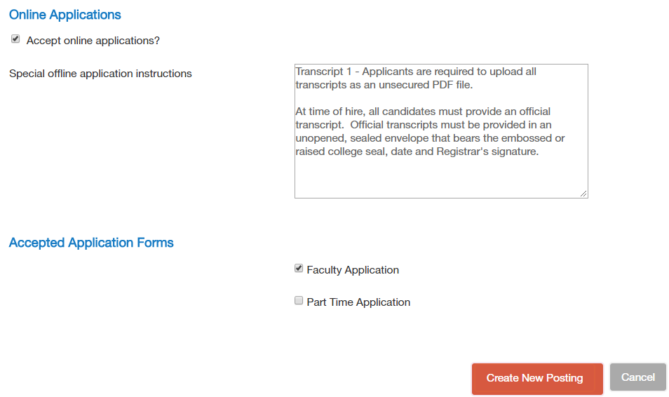
Choose Part-time Application for CCP and PTF postings.

- Only the above listed information should be entered. Once the information above is entered, click the orange “Create New Posting” button.
- Enter the Position Information. The position number, length of the appointment, full-time appointment length. The work schedule fields will be left blank. Please indicated in the position title the rank, department and Tenure – track or Term. For Part time Faculty include Part-time Instructor – and department.
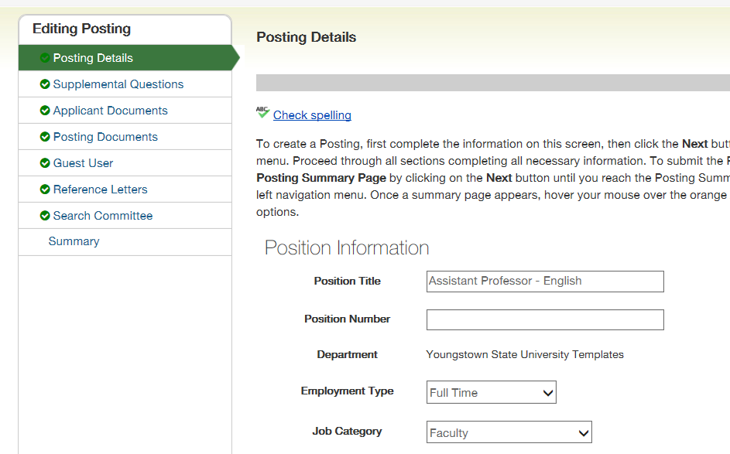

- Utilizing the information provided, add in the Major Work Characteristics and the Minimum Qualifications provided. You may add additional Minimum Qualifications and Desired Qualifications if needed. The Equipment Operated field and Job Duties Section will be left blank.
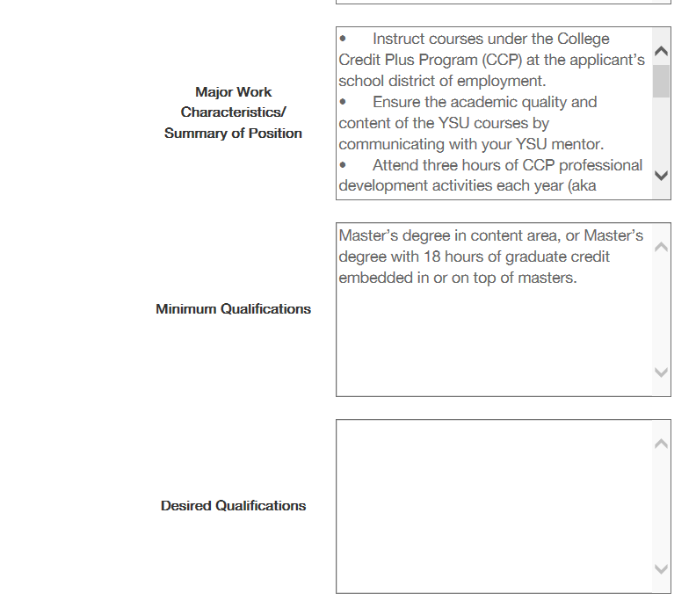
- Enter the Posting Detail Information. Select Hiring Manager and Search Chair from the drop down menu. As Department Chair, you will be the Hiring Manager. If the name is not listed, please contact Fran LeGoullon x2989 or Jennifer Lewis-Aey at x3759. The following fields will not be utilized: Number of Vacancies, Position End Date (if temporary), and Close Date.

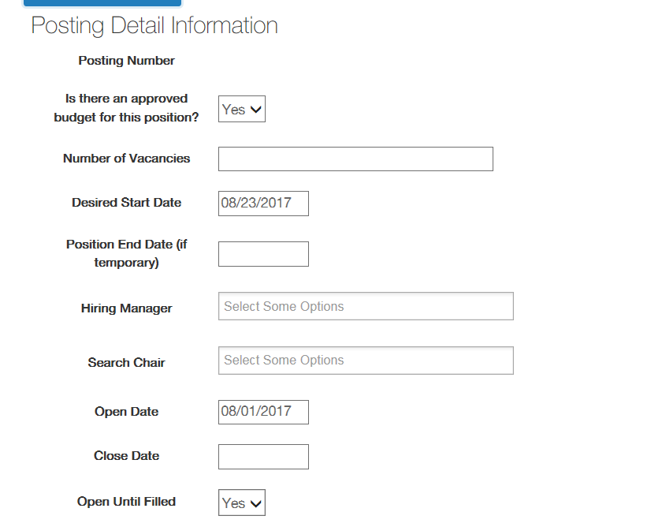

- In the Special Instructions Summary and Requested Advertising Sources, enter the provided information. The YSU Career website is the only advertising which occurs for Part-time Faculty or College Credit Plus postings.

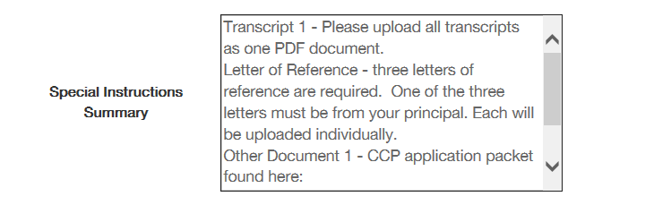
Also indicate your preferred advertising sources.
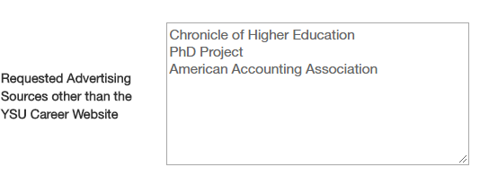

- Once all of the information has been entered, scroll back to the top of the page and Check Spelling. Make any necessary changes and then click “Save” to move to the next step.

- You should see at the top of the page that the Posting was successfully updated. Once this message appears, you will click the “Next” button.

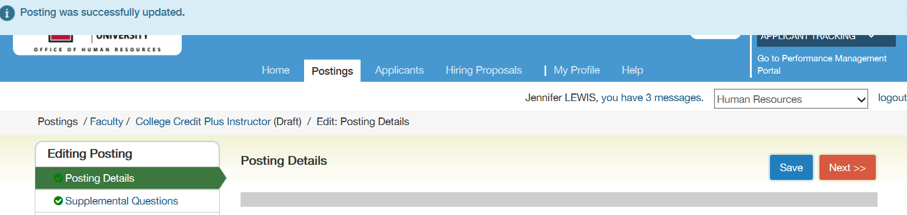

- Supplemental Questions may be added based on the minimum qualifications. Click on the “Add a question” button to add a supplemental question.
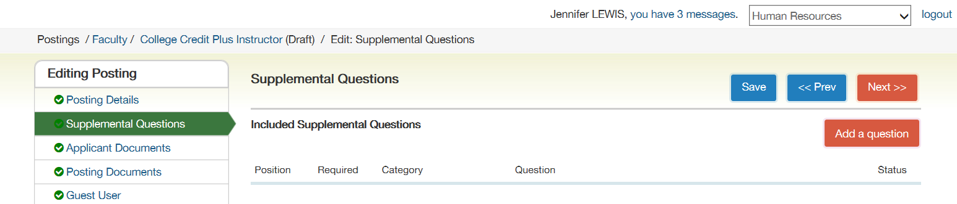

- In the keywork field, type “highest level”. Check the add box and click the “Submit” button.

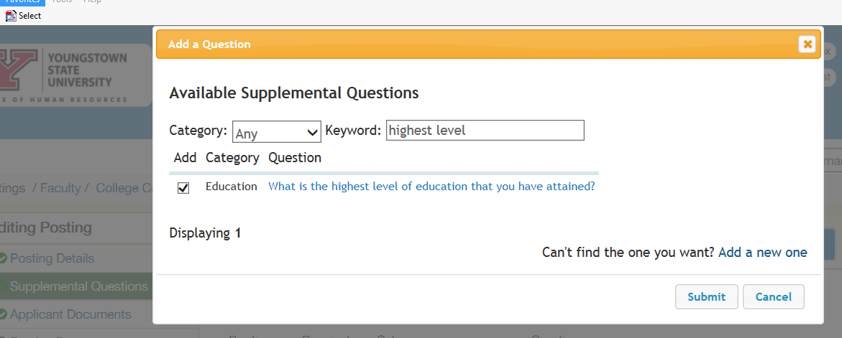

- The question will then appear under Included Supplemental Questions. Check the Required box. 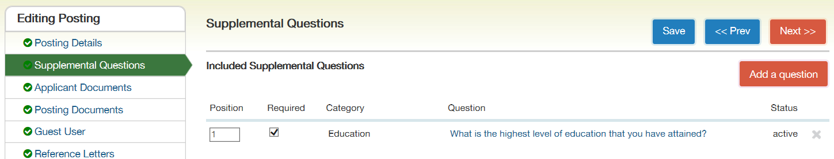

- Then click on the question, place a checkmark in the following Disqualifying boxes. Click the “Save” button.

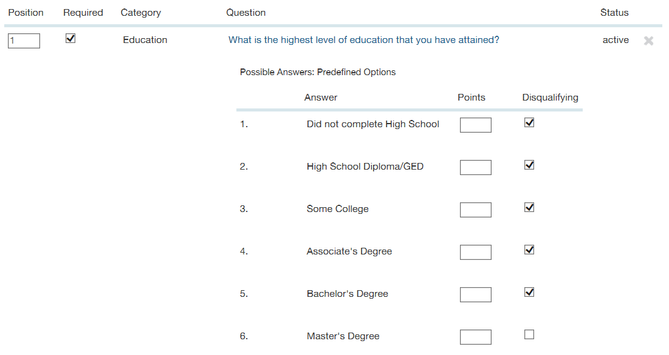
- Once the message displays that the Posting was successfully updated, click the “Next” button. 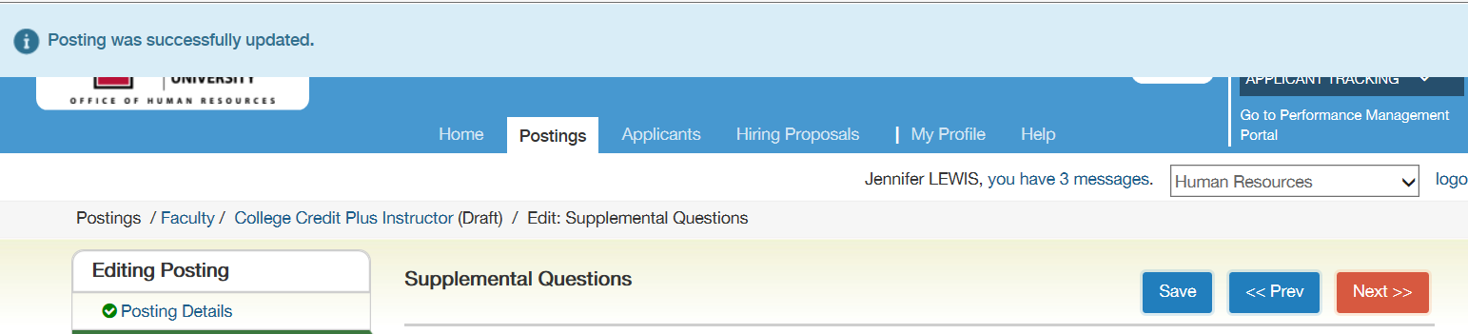

- Select the applicant documents listed below by clicking the radio button and then click the “Save” button. Once saved, all required documents will move to the top of the list. Then click the “Next” button.

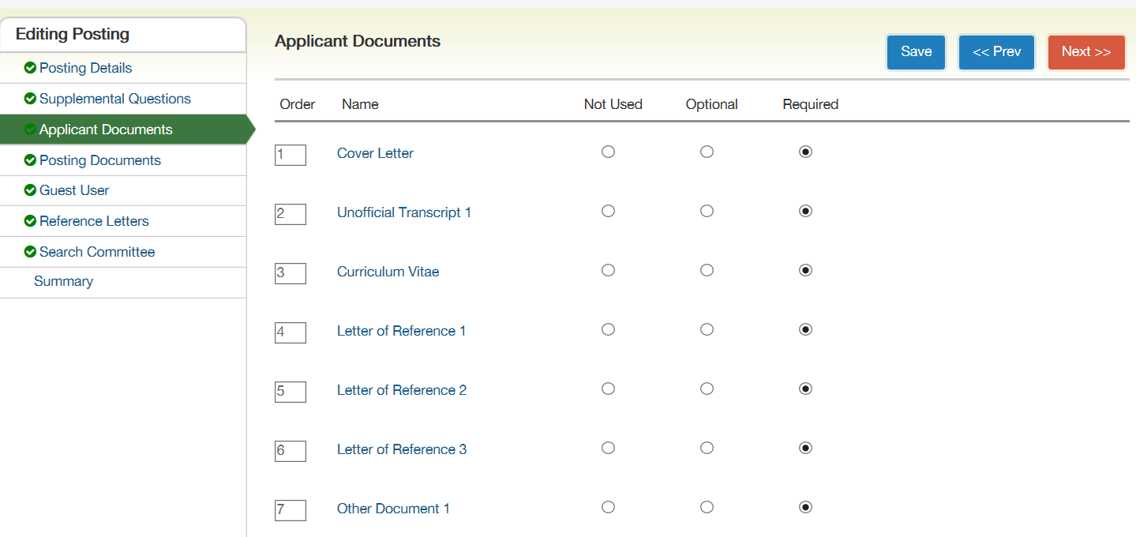

- No action is required on the Posting documents tab, the Guest User tab or the Reference Letters tab. Click the “Next” button to move to the next tab.

- To add members to the search committee tab, click the “Add Existing User” button.

Please do not click the “Create New User Account.” To create new user accounts, please call Fran LeGoullon at x2989 or Jennifer Lewis-Aey at x3759.

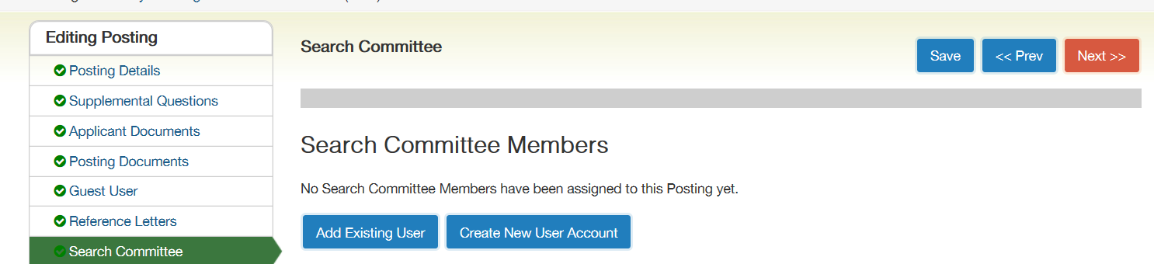

- Type the “name of the search committee member” to be added in the search box. When the names appear, click the “Add Member” button to add an employee to the search committee.
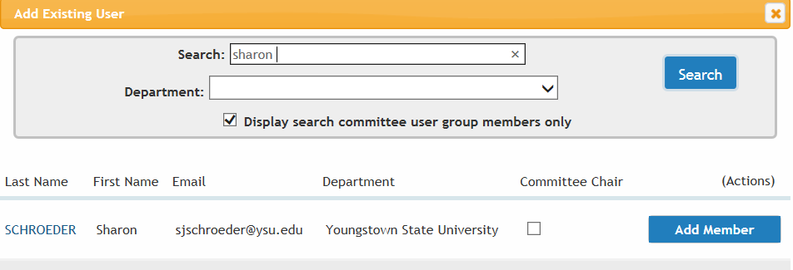
- After all employees that require access to the posting are added, click the “Save” button. Check the box labeled “Search Committee Chair” for the appropriate person. NOTE: If the employees are not found, please call Fran LeGoullon at x2989 or Jennifer Lewis-Aey at x3759.

- The summary of the Posting Document will display. Review the Posting. Click “Edit” if changes are necessary. Be sure to save any changes made.

- Once the posting is complete, select the Take Action on Posting button. In the drop down menu select the “Approve – Move to Admin Approval Executive Director/Dean/ Associate Provost.” 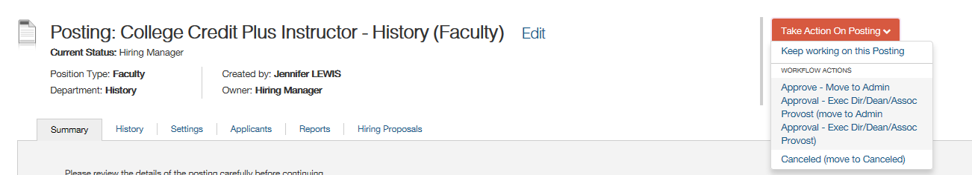

- The Dean will then receive a notice to approve via the PeopleAdmin System. The Dean will then move the posting to A. FULL TIME FACULTY: ‘’Approve FT Faculty- Move to Compensation.’’ or
B. College Credit Plus / Part Time Faculty: “Human Resources: Final Review – HR”.
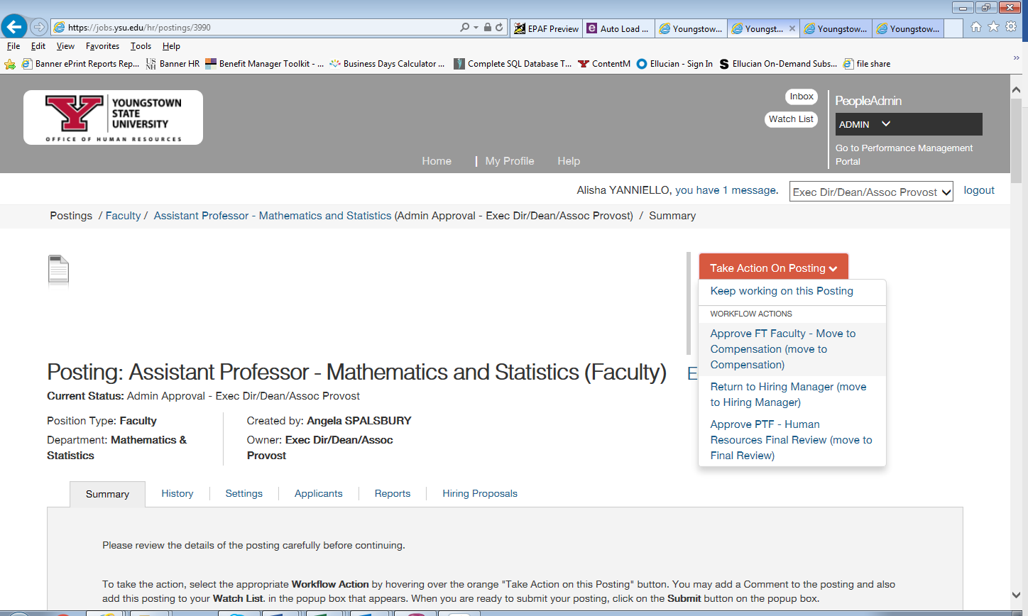

- A: FULL TIME FACULTY: Compensation will have the option of returning the posting to the hiring manager or sending forward to Division Signature Authority (Provost). The final few steps of approval will be Budget approval and presidential approval. Human Resources will have the final approval before the posting is visible to applicants.

If you have any questions regarding posting a College Credit Plus or Part time Faculty position, please contact
Jennifer Lewis-Aey at x3759.

If you have any questions regarding posting a Full time Faculty position, please contact
Fran LeGullon at x2989.

