Create & Route a CCP Posting in PeopleAdmin
This process will take place when a hiring manager has a position that needs to be filled; it takes the place of the paper formerly known as the Requisition.
- Log into the PeopleAdmin system using your YSU portal credentials.
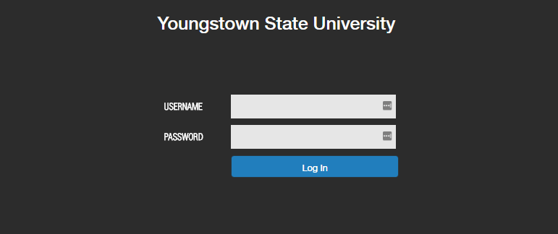

- Change your Current Group in the upper right hand corner of the page to Hiring Manager.
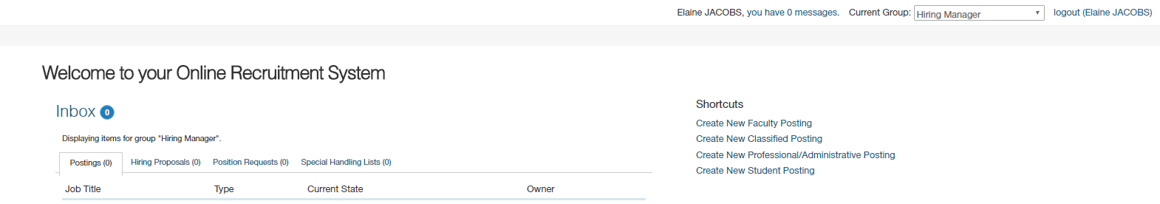

- On the right hand side under the Shortcuts menu, select Create new “Faculty Posting”.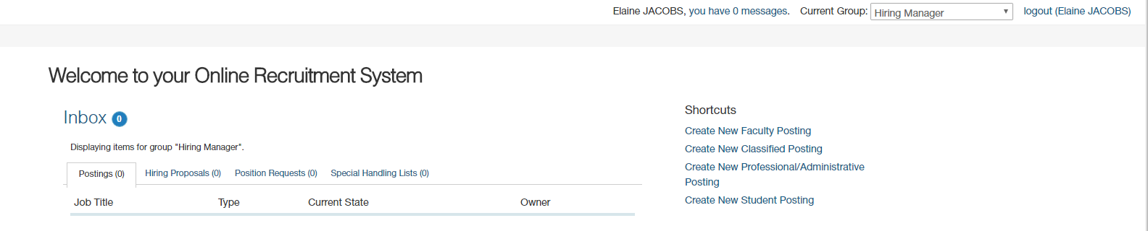

- Select Create from Posting Template. Choose College Credit Plus Position Template.
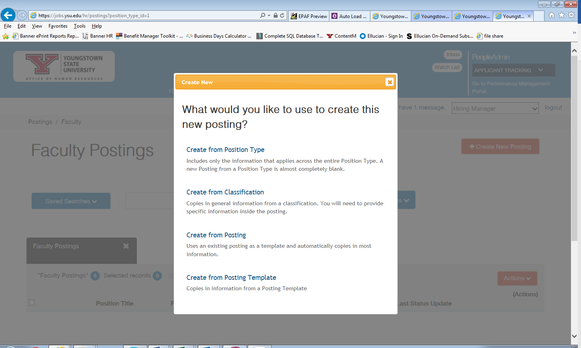

- Enter the Position Title, Location, Division, select your department from the drop down menu and the workflow state “Under Review by Dept./Committee” as described below:
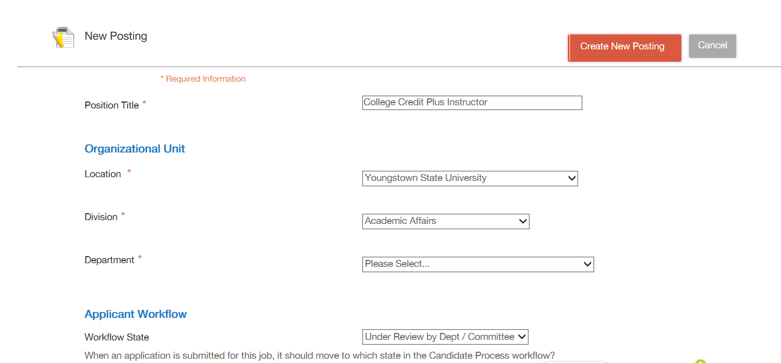

- Ensure the Accept Online applications box is checked and under the heading Accept Application forms, the Part-time Application should be checked:

- Only the above listed informatin should be entered. Once the information above is entered, click the orange box labeled “Create New Posting”

- Next we will enter the Position Informaiton. There is not currently a category for CCP Instructor. So, Part-time Faculty will be used. The position number, length of the appointment, full-time appointment length and work schedule fields will be left blank.
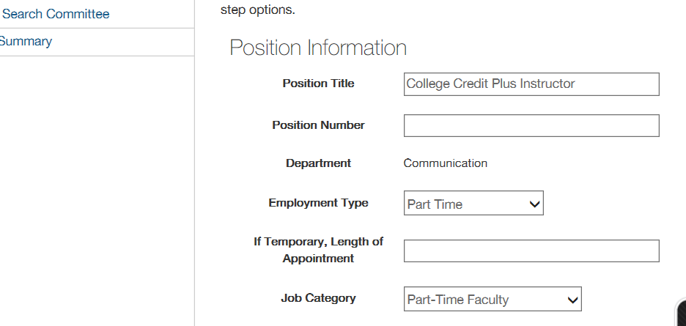

- Utilizing the informaiton provided add in the Major Work Characteristics and the Minimum Qualifications provided. You may add additional Minimum Qualifications and Desired Qualifications if needed. The Equipment Operated field and Job Duties Section will be left blank.
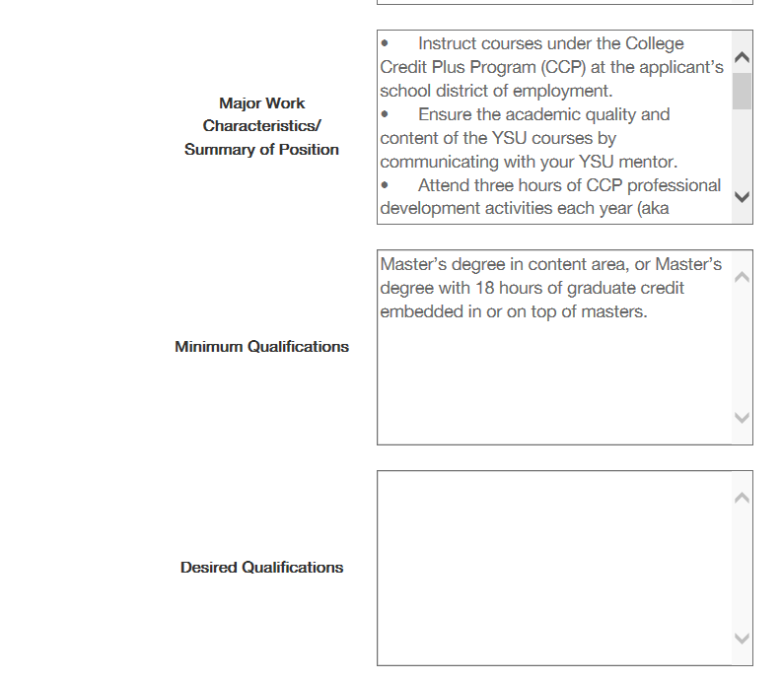

- The next step is to enter the Posting Detail Information. The following fields will not be utilized: Number of Vacancies, Position End Date (if temporary), and Close Date. As Department Chair, you will be the Hiring Manager. Select your name from the drop down menu. If your name is not listed, please contact Jennifer Lewis at Ext. 3759. The Search Committee Chair field should also list your name.

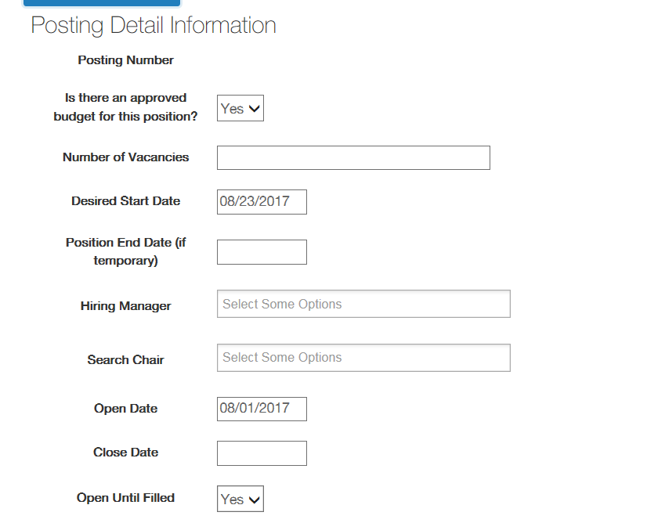

- In the Special Insturctions Summary, enter the provided information.

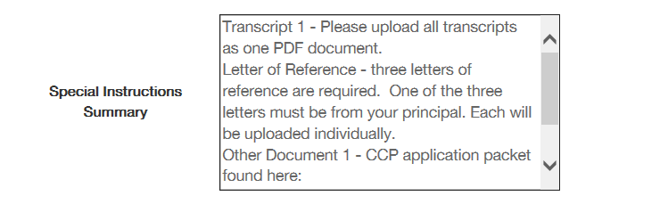

- Once all of the information has been entered, you can scroll back to the top of the page and Check Spelling. Make any necessary changes and then click the blue “Save” block to move to the next step.
- You should see at the top of the page that the posting was successfully updated. Once this message appears, you will click the orange “Next” block.

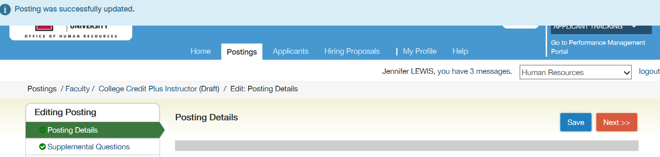

- Supplemental Questions may be added based on the minimum qualificaitons. The minimum qualification for CCP Instructors is a Master’s Degree. Click on the orange “Add a question” block to add a supplemental question.
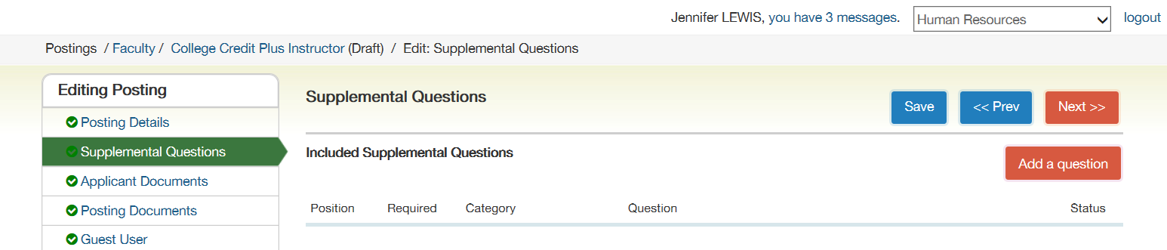

- In the keywork field, type “highest level”. Check the add box and click the “Submit” block.

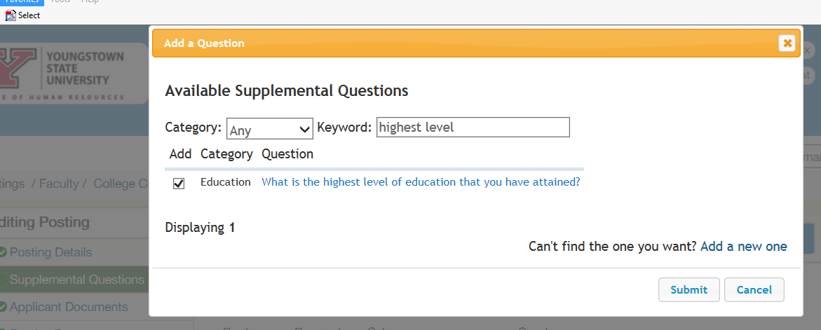

- The question will then appear under Included Supplemental Questions. Next check the required box. 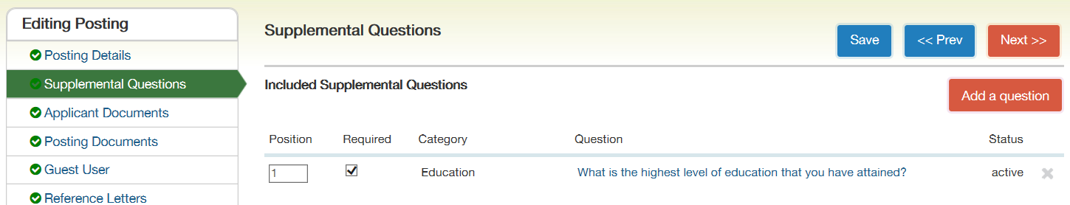

- Then click on the question, place a checkmark in the following Disqualifying boxes and click the “Save” block:

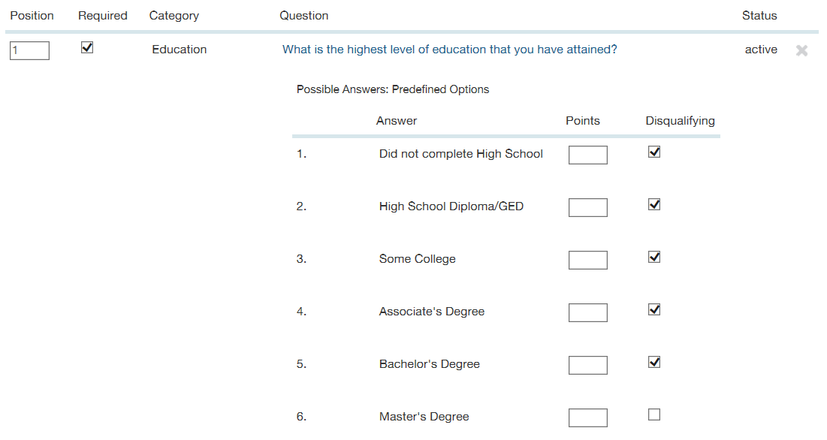
- Once the message displays that the posting was successfully updated, click the orange “Next” block. 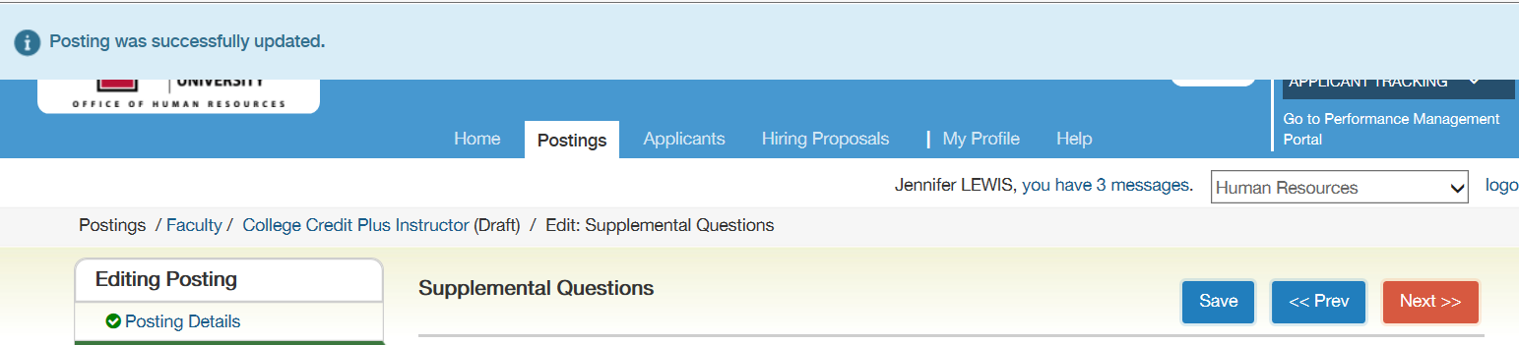

- Select the applicant documents listed below by clicking the radio button and then click the blue “Save” block. Once saved, all required documents will move to the top of the list. Then click the orange “Next” block.

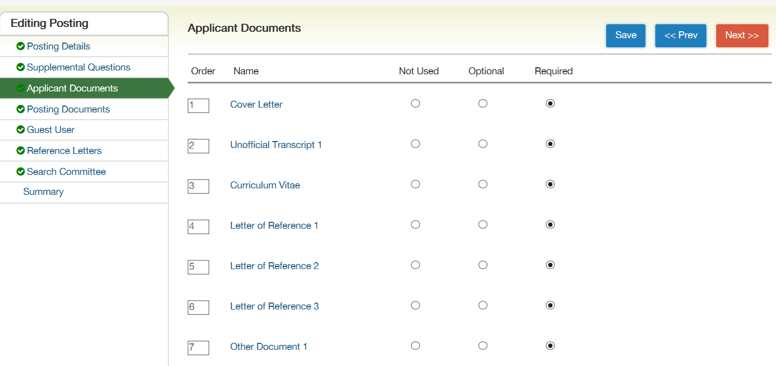

- No action is required on the Posting documents tab, the Guest User tab or the Reference Letters tab. Click the orange “Next” block to move to the next tab.

- To add members to the search committee tab, click the “Add Existing User” block

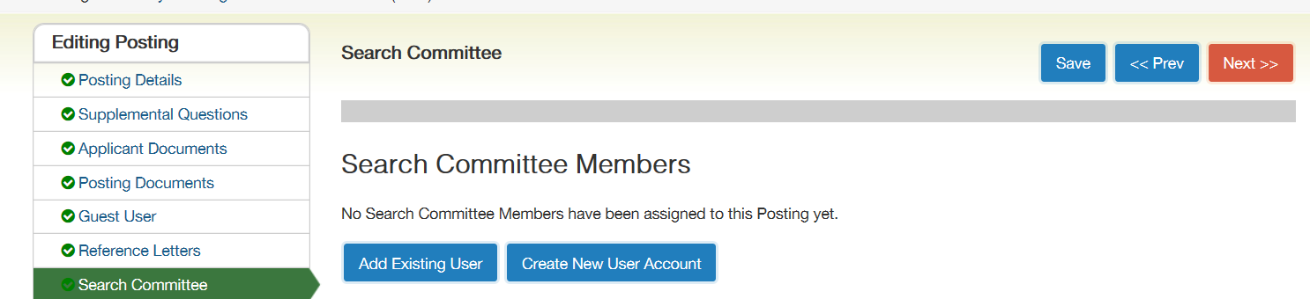

- Type the name of the search committee member to be added in the search box. When the names appear, click the blue “Add Member” block to add an employee to the search committee.
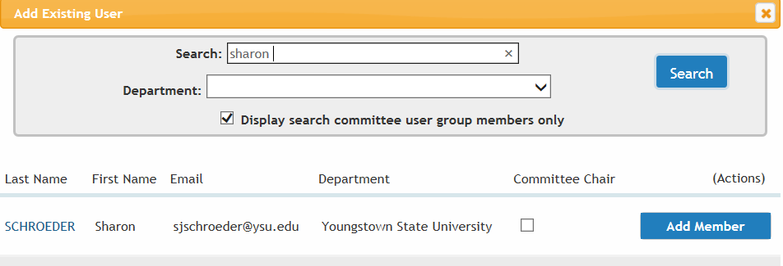
- After all employees that require access to the posting are added, click the blue “Save” block. As Chair of the Department you should be added as Search Committee Chair by clicking the check box labled Committee Chair. Sharon Schroeder and Jennifer Young should always be listed as search committtee member.

- The summary of the Posting Document will display. Review the Posting. Click edit if changes are necessary. Be sure to save any changes made.

- Once the posting is complete, select the Take Action on Posting Block. In the drop down menu select the Approve – Move to Admin Approval Executive Director/Dean/ Associate Provost. 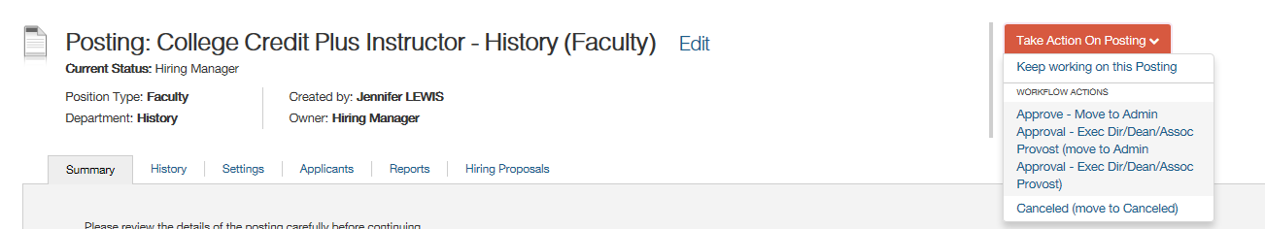

- The Dean will then receive a notice to approve via the PeopleAdmin System. The Dean will then move the posting to Final Review HR. HR will review an transition the posting to the website for candidates to apply.

