Pomodoro Technique:
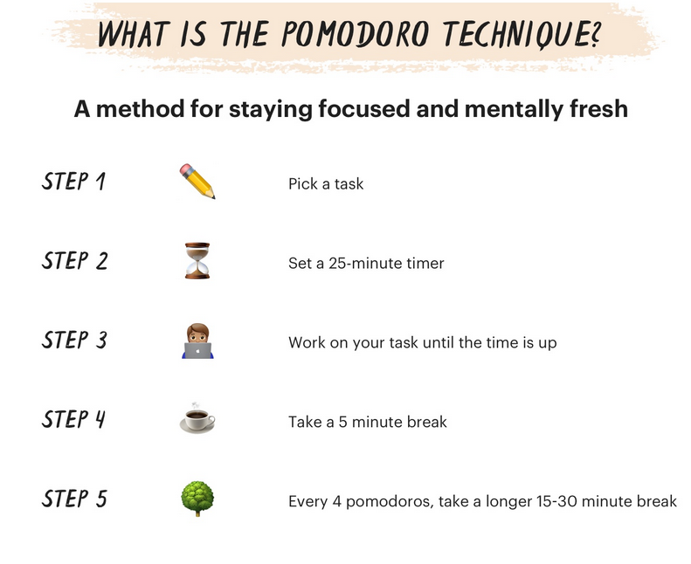
Pomodoro is flexible! If you can work longer than 25 minutes, work as long as you can without feeling unfocused. Be sure to do a mindless task during your 5-minute breaks such as getting a snack, taking a quick walk, or doing dishes. This will help your brain to create stronger links in your long-term memory.
You can even find videos on YouTube to do a guided Pomodoro study session with a virtual buddy!

For your longer breaks, what are some effective ways to take a fulfilling break while still staying motivated to return to work or studying?

Structured vs Unstructured Breaks

Structured Break | Unstructured Break
Have a definitive end point  More likely to return to task  Example:  Tanner decides to play four rounds of Mario Kart during his break – enough to compete in a Cup tournament. | Has no definitive end point  Less likely to return to task  Example:  Suman decides to play Skyrim which has no definitive endpoint in the game.  Note: Often when students choose an unstructured activity, they will set a timer. While this may work for some individuals, many others still struggle to return to task when the timer goes off.

This resource was adapted from the following sources:
https://pomofocus.io/
https://learning.edx.org/course/course-v1:BarbaraOakley_OlavSchewe+LLAP+2T2022/home
The Pomodoro Technique — Why It Works & How To Do It (todoist.com)

