HIGHLIGHTS FROM THE FALL 2019 STEM EXPO . . .

On Thursday, October 3,2019 the College of Science, Technology, Engineering and Mathematics (STEM) hosted the Fall 201 STEM Expo. The event was held at YSU Stambaugh Stadium.

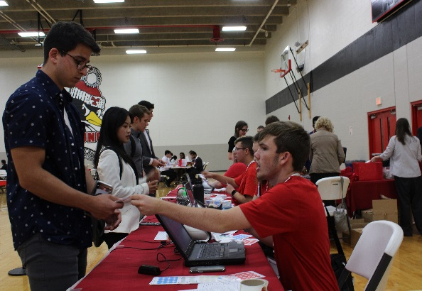
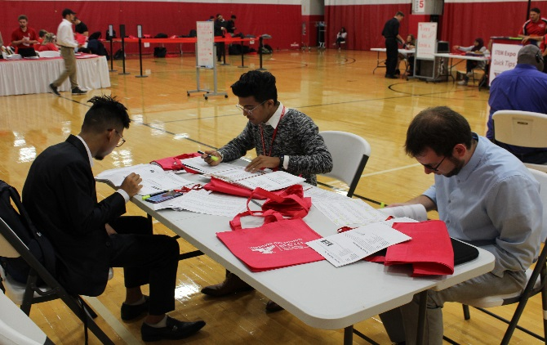

Students Checking-In Area Students Preparing

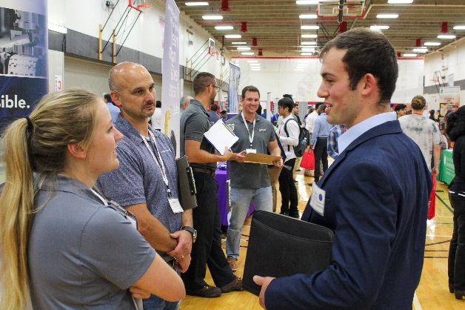

Employers Networking with Students

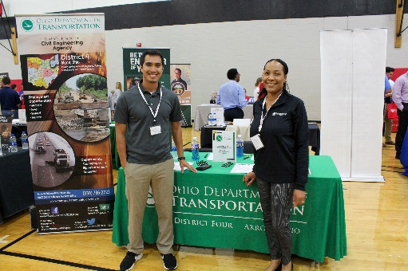
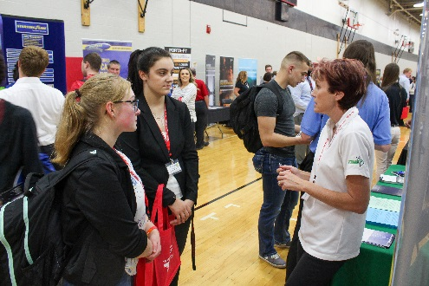

Ohio Department of Transportation Precision Castparts Corp –
(TIMET)
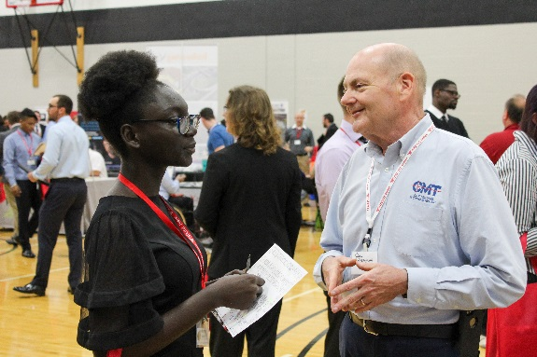

City Machine Technology (CMT)

