**GRADUATE OUTCOME REPORT FOR ACADEMIC YEAR 2023-2024**

**EXECUTIVE SUMMARY**

The Graduate Outcome Report is a summary of employment and continuing education decisions made by Youngstown State University graduates who completed degrees during the 2023-2024 academic year. They are collectively referred to as the Class of 2024.

**Who had the opportunity to take the survey:** The survey was distributed through Handshake (the university’s career management system) to 2,813 individuals who received degrees in August 2023, December 2023, and May 2024.

**How the data was collected:** Students who did not respond to the survey mentioned above, were sent multiple emails over a period of six months after graduation. In addition, staff gathered student knowledge rate data (defined by the national Association of Colleges and Employers) via current social media profiles, information reported by the Alumni Office and faculty, and pre-graduation exit interviews.

**Knowledge Rate:** The YSU total knowledge rate is **54.25%.** Out of 2,813 graduates, there were 1,526 reported student outcomes.

**“Career” Outcomes Definition:** Respondents that are working as an employee, freelancer, or contract worker; accepted into a program of additional education; in the military; started a business; or in a service position (AmeriCorps, Peace Corps, etc.).

**Career Outcomes Rate:** The YSU total career outcome rate is **90.62%.** Out of the 1,526 respondents, 1,383 had outcomes related to a career. (Of those respondents, approximately 72% are working or in the military and 18% are continuing their education.)

**Ohio Retention Rate:** **79.83%** of respondents remained in Ohio.

**Reported Salaries by Degree Type:**

**Associate** **Bachelor** **Master** **Doctorate**

**Responses = 7 Responses =169 Responses = 88 Responses = 4**

Mean: $39,094 Mean: $57,078 Mean: $75,465 Mean: $188,700

Median: $36,400 Median: $60,000 Median: $65,500 Median: $193,900

Prepared January 2025

________________________________________________________ _____________________________ 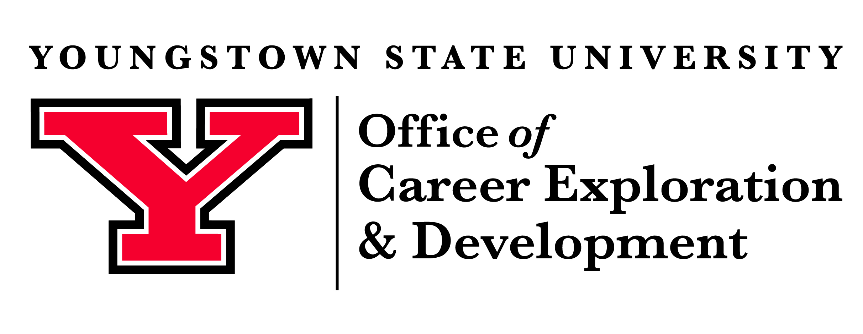

GRADUATE OUTCOMES 2023-2024