Emergency
Operation Plan

Student Housing

WICK HOUSE

Table of Contents
Introduction 4
Emergency Defined 4
Reporting Emergencies 5
Anonymous Reporting 5
Building and Department Contact Information 6
Incident Command System 7
Communications 8
Crime Prevention 9
Security and Tram Escorts 9
Missing Persons 10
Lock-down and Shelter in Place 11
Lock Down 11
Housing Specific Lock Down 12
Shelter in Place 13
Building and Campus Evacuations 14
Building Evacuation 14
Building Evacuation Maps 15
Wick House Basement 15
Wick House 1st Floor 16
Wick House 2nd Floor 17
Wick House 3rd Floor 18
Campus Evacuation 19
Campus Evacuation Map 20
Active Shooter, Assault, and Human Trafficking 21
Active Shooter: 21
Workplace Violence & Unruly Individuals 22
Sexual Assault: 23
Human Trafficking: 23
Terroristic and Civil Related Incidents 25
Terrorism: 25
Hostage Situations: 25
Civil Disturbance: 25
Bomb Threats: 26
Suspicious Package or Mail: 26
Mental Health Related Incidents 27
Suicidal Persons: 27
Mental Health/Counseling Services: 28
Student Outreach and Support: 28
Medical Related Incidents 29
General Medical Emergencies: 29
Blood-Borne Pathogens: 29
Medical Pandemic: 30
Poison Control: 30
Drug Overdose: 30
Unidentified Drugs and Paraphernalia: 31
Fire and Chemical Related Incidents 32
Fire: 32
Explosion: 37
Chemical Release: 37
Nuclear Incident: 38
Weather Related Incidents 39
Tornado: 39
Earthquake: 40
Flood: 40
Disruption of Public Services 41
Power Outages: 41
Water Outage/Restriction: 41
Gas Leak: 41
Campus Map 42

Introduction

Purpose: This plan is an effort to protect employees, students, and visitors. The plan is meant to maximize human safety and survival, minimize danger, preserve and protect property and critical infrastructure, provide for responsible communications with the University community during and after an emergency, and finally to restore normal activities as soon as possible.

The plan outlines the expectations of faculty, staff, and students as well as providing authority for personnel to enact the plan as needed. The plan identifies internal and external communications; authority and references as defined by state mandates and actions the University will use for prevention, protection, mitigation, response, and recovery.

The Departmental Emergency Operation Plans stem from the “Campus Emergency Management Plan” (CEMP). The CEMP reflects the uniqueness of the campus location while conforming to the essential common elements set forth in the Guidebook policy number 3356-4-20 “Emergency Response”.

Emergency Defined

An Emergency is any event or condition that presents an imminent risk of death, serious injury or illness to the University Community, suspension or significant disruption of university operations, significant physical or environmental damage, or significant threat to the University’s financial wellbeing.
Rather than establishing rigid parameters for qualifying an event as an emergency, this definition is intended to emphasize the actual and potential catastrophic effect, the imminent threat, and seriousness inherent to emergencies. Other events may produce crises or harmful effects but an emergency is distinguished by the severity of the threat and its effects as well as the ongoing threat posed to the University Community.

Revision History:

4/18/2019 Emergency Plan Updated

To update or correct this emergency operation plan contact:

William Rogner (330) 941-7496 whrogner@ysu.edu

Reporting Emergencies

Anyone witnessing a safety, security or medical related incident in or near the University should secure their immediate safety, and the safety of those involved and around the incident. Call the YSU Police Department and provide the dispatcher with the following information:
- Incident Location.
- Incident Description.
- Injuries.
- Your Name and Contact Information.
Follow the dispatcher’s instructions and do not hang up until directed to do so.

If you are on campus call extension 3527 or 911 from a campus phone.
If you are off campus or calling from a cell phone, dial (330) 941-3527.

Remember: If you see something, say something! The YSU Police are available 24 hours a day, 7 days a week.

Important: You can reach the YSU Police on campus phones (the phones in your office and in campus buildings) by either dialing 911 or extension 3527. If you are using a cellphone you must dial (330) 941-3527 to contact the YSU Police. If you dial 911 from your cellphone, you will be connected with the Youngstown City Police dispatcher.

Anonymous Reporting
The University provides online anonymous reporting options for complaints of sexual misconduct and the University will not compel you to reveal your name or that of the alleged perpetrator. However, the University's ability to investigate an incident is limited when names are not included in a report. In order for the University to take disciplinary action against an individual for sexual misconduct, either under University Policy or the Student Conduct Process; the individual’s name must be provided.
Making an initial anonymous report does not prevent an individual from choosing to follow-up with additional information or through a different reporting option. Anonymous reports can be made to:
The Youngstown State University Police Department at the YSU Police website
The Title IX Coordinator at Title IX Home
The Office of Student Conduct at Student Conduct: Complaint Filing

Building and Department Contact Information

Name | Title | Extension/Number | Office
Kelly Beers | Director of Housing and Off-Campus Living | (330) 941-3547 | Kilcawley House
Olivia Cupp | Associate Director | (330) 941-3547 | Kilcawley House
Stephanie Reed | Associate Director | (330) 941-3547 | Kilcawley House

Incident Command System

The Incident Command System (ICS) is a standard, on-scene, and all-hazard emergency management system adopted by Youngstown State University in the event of a large scale declared emergency which has the possibility for extending into longer periods of time. It represents organizational “best practices” and has become the national standard for incident response. Under this model, there is only one Incident Commander who is the person in charge of the incident. The nature of the emergency determines the position responsible for incident command. Depending upon the nature of an emergency, the Incident Commander may be a different individual not necessarily from the University. The following matrix is an example of who may fill the role of an Incident Commander in particular emergencies.

- Active Shooter: Ranking YSU Police Supervisor on scene
- Fire: Ranking Youngstown Fire official on scene
- Building Collapse: Ranking Youngstown Fire official on scene/ AVP YSU Facilities
- Chemical Spill: Mahoning County Hazmat Team Supervisor
- Bomb Threat: Ranking YSU Police Supervisor on scene
- Power Outage: AVP YSU Facilities

Incident Command Post: The Incident Command Post (ICP) is the location from which the Incident Commander manages all incident operations. The ICP may or may not be located on the campus depending on the scope of the emergency. The ICP may be in an office, conference room, or other area that has the necessary communication resources, safety, and security during an emergency.

Emergency Operations Center: The Emergency Operations Center (EOC) is the location from which the coordination of information and resources to support long term emergency operations (24 hours or more) occur. When an emergency is confined to campus property and facilities, the YSU Police Department (Clingan-Waddell Hall) serves as the location of the EOC. Functions conducted at the EOC include:

- Coordination.
- Communications.
- Resource dispatch and tracking.
- Information collection, analysis, and dissemination.

Communications

Tools or methods the University may use to communicate to students and employees in the event of an emergency can include:

- Penguin Alert: The Penguin Alert allows the University to notify students and employees via text messages and email. To sign up for the Penguin Alert, go to alert.ysu.edu. A valid YSU logon (banner logon) and password are necessary. Registration can be completed anywhere there is internet access.
- Campus Wide Paging System: The Simplex 4100U alarm system is a highly flexible and survivable platform that offers digital voice communications throughout the campus. Addressable speakers are installed inside and outside of campus buildings.
- YSU Homepage/Campus Marquees: The YSU homepage lists a multitude of information about the campus. The YSU Homepage will also list and detail any emergency information.
- Social Media: Regular updates will be posted to the YSU Facebook page (www.facebook.com/youngstownstate), and Twitter (twitter.com/youngstownstate).
- WYSU-FM: WYSU is the official radio source regarding information about university operations. In addition, WYSU can provide information on its website (www.wysu.org).
- Local News Outlets: The University has a detailed call list that would be activated in the event of an emergency.

Dealing with News Media and Public Inquires: In an emergency, to reduce incidents of false reports, rumors and releasing information that could curtail or endanger first responders, individuals are discouraged from addressing the media individually. Refer all questions and inquires to the Public Information Officer.

Contact Ron Cole at (330) 941-3285 for requests from the media or public inquires.

Crime Prevention

It is your responsibility to protect state and personal property from theft. Lock your door when you leave the room or lab, even if for a short time.
- Do not loan your state-issued keys or access cards to anyone.
- Do not leave your access card hanging on a lab coat unattended or leave your keys in pockets.
- Immediately report lost or stolen keys / access cards to YSU Police at (330) 941-3527.
- Keep purses, briefcases, and wallets locked inside your desk, cabinet, or wall locker. Do not bring large sums of money to work.
- Secure your computers. Not only secure your computer physically, but also password protect it.
- Watch for suspicious activity or individuals in your area. If you see someone hanging around or acting strangely, call YSU Police; then make contact with those individuals and ask if you can assist them. If you determine your own safety is not at risk, stall them as long as you can until University police arrive. If they leave, let University police know what direction they went and get a good physical description of that individual such as height, weight, style and color of hair, description of clothing.

Most Importantly: If you see something, say something!! The YSU Police are here to serve the campus community. We rely on the campus community to assist us keeping the campus safe! The YSU Police are available twenty-four hours a day, seven days a week at (330) 941-3527, or 911 from a campus phone.

Security and Tram Escorts

The YSU Student Security Service safely escorts students and employees from one campus location to another, or to the near North Side. This is a free service provided by the YSU Police Department. The Student Security Services Aides are linked by radio to the YSU Police Department Communications Center and make regular reports during their rounds. Members of the campus community with disabilities, athletes with sport injuries, or anyone who just wants accompanied to their car are encouraged to make special arrangements to be safely escorted to any campus location day or night. Our Student Security Service Aides can assist with wheelchairs and a specially designed tram to transport students, staff, and faculty with a temporary or permanent disability. If you would like to set up a continuous pick-up for the semester, please contact the SSSA Office. You will be asked to complete a request form for the semester. For a one-time accompaniment, please call anytime during the hours listed.

Call (330) 941-1515 for more information.

During fall and spring semesters: Escorts are available Monday-Friday 7:00 A.M. - 11:00 P.M.

During summer and breaks: Availability will vary. Call (330) 941-1515 for information.

Missing Persons
Occasionally, a student will be reported as missing (usually by a parent or friend/roommate who has not heard from them in a day or so). Absence from a residence hall is not usually considered an emergency. However, we do follow up on every request for help in locating a student in the following way:
- When a caller reports a student missing, make a record of the call with the name and number of the call, their relationship to the missing resident, and the last place and time they saw or heard from the resident.
- Concerned callers should be encouraged to share any relevant information about student’s relationships, health, history, overall well-being, or any extenuating reasons for heightened concern.
- Advise the caller to notify a dispatcher at YSUPD and report the same information.
- If the call has been received by a desk clerk or RA, they should notify Housing Coordinator immediately with all of the relevant information.
- HC and RAs will take appropriate steps to investigate, including visiting the room where the student lives.
- Depending on the situation, additional steps may be appropriate: attempting to contact roommates or friends, contacting the resident’s workplace, checking access to their dining meal plan, or trying to contact the student via cell phone/email.
- If the student has not been located YSUPD or H&RL may contact the confidential contact.
- When a potentially missing resident is located, the resident should be encouraged to immediately contact the concerned caller immediately (again, unless there is an expressed desire not to contact them)
- If the resident in question has not been located within 24 hours, HC should communicate that to YSUPD.
- In cases where the missing resident is under 18, University Police will likely contact the parent or guardian no later than 24 hours after the time a student is determined to be missing. If they are 18 or older, Police will determine within a 24 hour period whether the situation rises to the level of emergency and proceed.

Lock-down and Shelter in Place

Lock Down
A lock-down will be used to protect building occupants in the case of an emergency. This requires the residents of a building to stay safely sheltered where they are located once an emergency is identified by the YSU Police, unless there is a specific threat within the building that requires them to exit.
A lock-down will be communicated to the campus via Penguin Alert and the Simplex Mass Communication System.
During a lock-down police and other emergency personnel would be responding to the emergency somewhere on campus. This does not necessarily mean that there is immediate danger in the building a person is located, however precautions should be taken immediately.
What is a lock-down?
All campus buildings will be locked to prevent entrance from the outside. Exit from the buildings will still be possible by pushing the crash bars. Students and personnel should not exit the building unless the situation in the building requires escape.
Exterior entrances of buildings will be locked by the facilities personnel, staff, or faculty who have access to door lock hardware. Faculty or staff members with keys to offices may have the capability to lock entrances to buildings. The YSU Police will not be available to assist in the locking of the buildings if an emergency exists on campus.
Students in residence halls must remain in their rooms with the door locked.
Staff will remain in their offices, or secure area, preferably without windows, with the door locked.
Faculty will move students to any lockable room in the building or remain in the classroom with the door barricaded if possible.
In the event that a room cannot be locked, the room should be barricaded with any accessible items.
The termination of any lock-down will be by the authority of the YSU Police, once an emergency is over. This will also be communicated via Penguin Alert and the Simplex Mass Communication System.

Housing Specific Lock Down

All exterior doors at Housing facilities are locked 24-7 with access only granted to staff and resident cardholders who present proximity cards at main entrance card readers, or individuals that the Desk Attendant confirms are official guests via the entrance intercom system.

Should it become necessary, lockdowns will be directed by YSUPD, Director, Executive Director, VPSA or AD and communicated to all professional and desk staff via an internal phone tree. Staff will ensure that all main doors are locked and secured.

Shelter in Place
In certain emergencies, the campus community may be advised to shelter-in-place to avoid or minimize exposure to outside risks. Risks could include chemical, biological or radioactive releases; some weather-related emergencies or criminal activities.
Once shelter-in-place instructions have been communicated, students, faculty and staff should either stay in the building they are in when they get the message or if outside, go to the nearest building and await further instructions.
What Shelter-in-Place Means:
Shelter-in-Place is a precaution aimed to keep you safe while remaining indoors. It refers to taking refuge in a designated area of safety within a building such as a small, interior room with no or few windows. It does not mean sealing off your entire residence or office building. If you are told to shelter-in-place, follow the instructions provided below.
Why You Might Need to Shelter-in-Place:
The air outside may become dangerously contaminated either intentionally or accidentally; severe weather such as a thunderstorm or a tornado is occurring; or there is an active shooter, making it unsafe to be exposed to outside conditions. Should this occur, YSU Police will provide information using the Penguin Alert and the Simplex Mass Communication System This system includes emergency warning sirens, programmed messages, live voice instructions, text messaging, and email communication to provide emergency notification and/or instructions. The important thing is for you to follow instructions of University authorities and know what to do if they advise you to shelter-in-place.
General Shelter in Place Information:
If a shelter in place order is given, you should:
- Stop classes or work, or close business operations.
- Share the notification with others in the building if possible, but do not leave the area where you were instructed to shelter-in-place.
- Close all windows, exterior doors, and any other openings to the outside.
- Select interior room(s) above the ground floor with the fewest windows or vents.
- Keep listening to local radio, television, and check your cell phone for Penguin Alert messages until you are told it is safe or you are told to evacuate. University and local officials may call for an evacuation in specific areas only.

Building and Campus Evacuations

Building Evacuation
The purpose of evacuating a building is to remove persons from dangerous and life‐ threatening conditions presented by a fire, an explosion, a suspected explosive device, a hazardous material release, air contamination or other similar emergency. Usually, such conditions and the need to evacuate are readily apparent and occupants are expected to leave the building immediately. Activating the building fire alarm is the most expedient and safest method to facilitate the evacuation (whether or not the emergency involves fire).
In some situations, such as bomb threats, the presence of life‐threatening conditions may be unknown or non‐existent. In these cases, the responsibility for assessing available information and the decision of whether or not to evacuate rests with the police. When time and circumstances permit, this decision will be made after consultation with other university officials present.
At the sound of a fire alarm, or other notification to evacuate, all persons are required to leave the building immediately by law. Unless conditions prevent it, the best evacuation route is the nearest stairway leading to the nearest exit. Elevators should not be used as they become inoperable during a loss of electrical power and can increase the risk of smoke inhalation during a fire. Firefighters routinely check stairways for persons needing assistance.
Actions will be taken to ensure persons remain at least two hundred feet from the building to be clear of any danger and to avoid impeding the movement of emergency responders and equipment. This distance may be increased by police or firefighters according to the circumstances of the emergency. Persons should not return to the building unless specific approval to do so has been given by police or firefighters.
Persons with disabilities are responsible for requesting assistance. In a classroom, the instructor should coordinate, and/or assist, disabled persons in the classroom to evacuate. If this is not possible, the instructor should help the persons move to the nearest enclosed stairway and remain there with them while another person advises emergency responders of their location.
Professors and Instructors should preplan for evacuations at the beginning of the semester and identify those who may need assistance in an evacuation.

Building Evacuation Maps

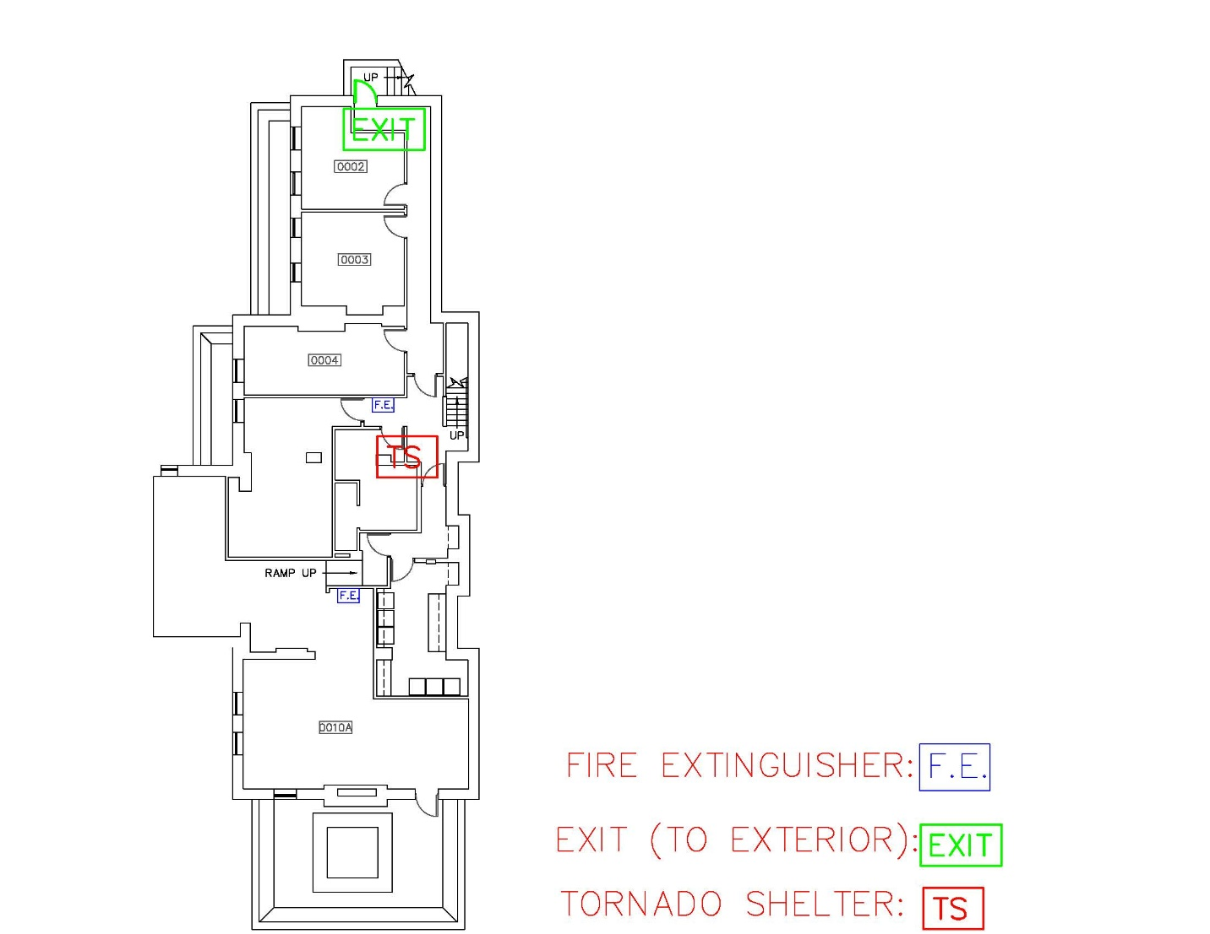
Wick House Basement

Wick House 1st Floor
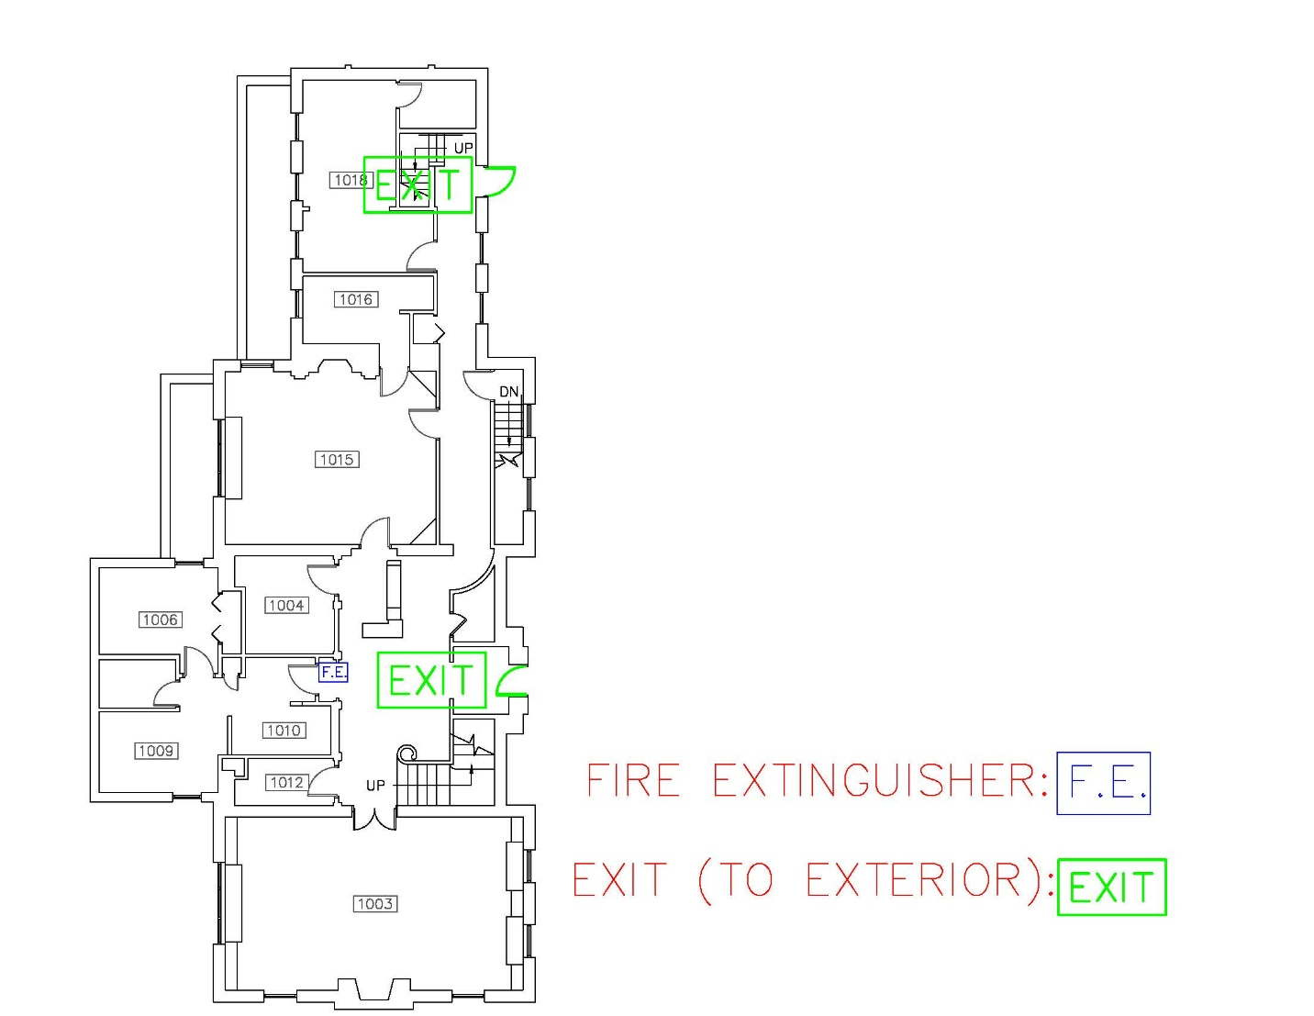

Wick House 2nd Floor
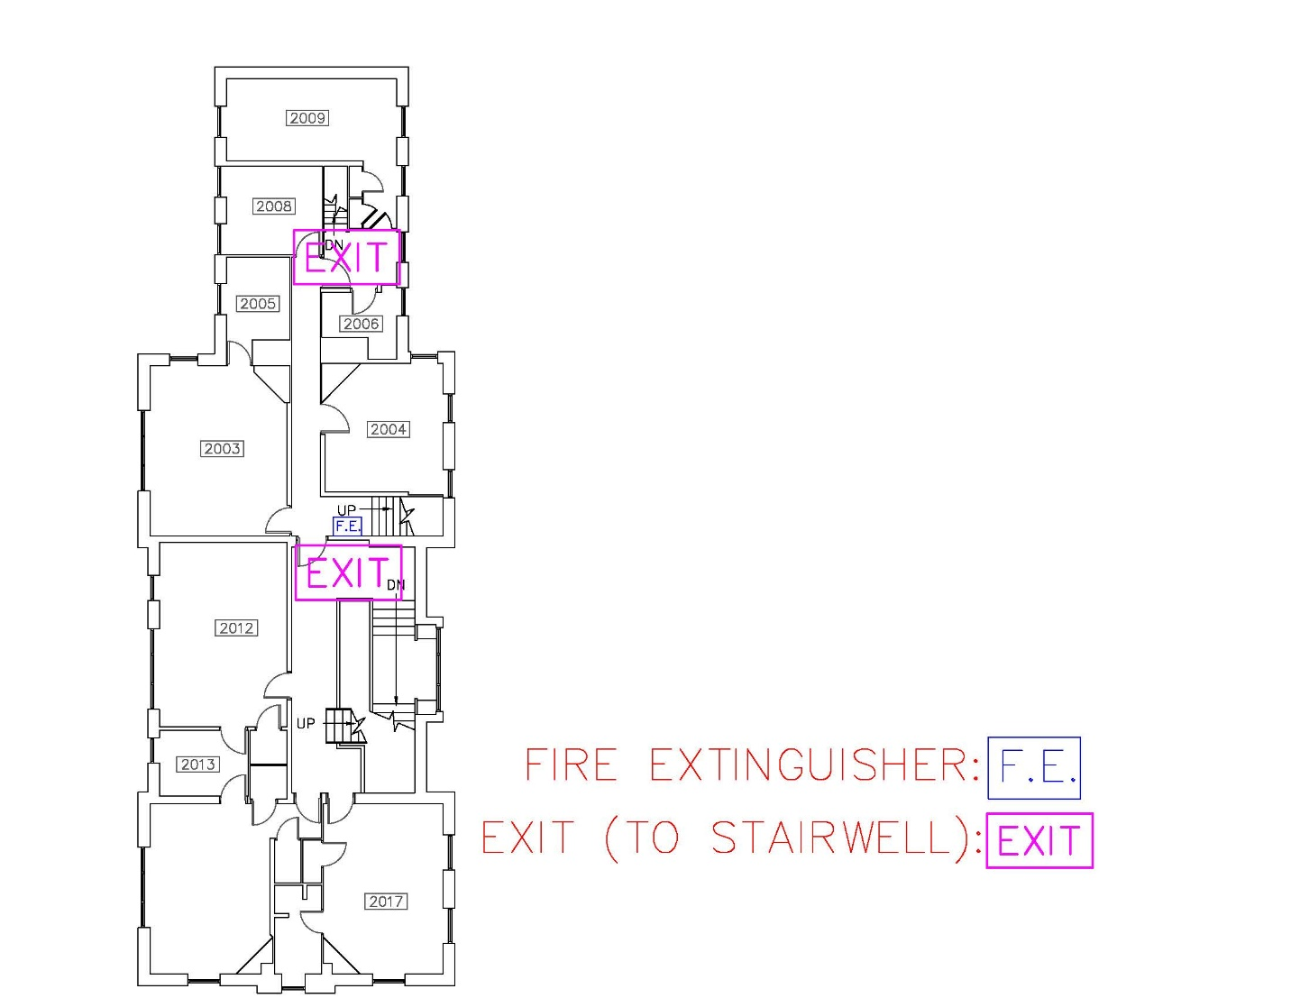

Wick House 3rd Floor
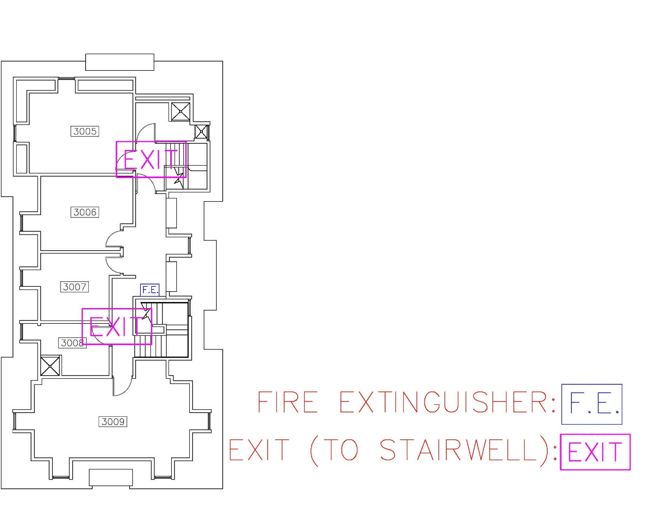

Campus Evacuation
An emergency of the magnitude and seriousness requiring the evacuation of the campus will likely and similarly affect surrounding communities. When the emergency is confined to the local community, evacuation to neighboring communities and routes leaving the immediate area are used. When an emergency is regional or larger scale, evacuation routes direct traffic to interstate highways for mass evacuation and relocation. A person evacuated from the campus may have few options regarding the direction of travel and should immediately follow the directions they are given.
Madison Avenue expressway located North of Stambaugh Stadium has been identified as the major traffic artery toward which evacuating traffic will be directed if possible. From there, evacuees can be integrated into the larger regional evacuation plan if necessary. However, the main surface roads around campus, Belmont Ave, Fifth Ave, Wick Ave, and Rayen Ave will also be used to allow for the maximum number of vehicles to evacuate campus in the shortest time possible. Listed below are the primary egress routes to be utilized:
Areas West of Fifth Avenue (M-70 Lot, Edge Apartments)
All parking lots and areas west of Fifth Avenue will evacuate west to Belmont Avenue.
North to Madison Avenue Expressway then west to I680, or;
South to Rayen Avenue then west towards US 422.
Areas East of Fifth and West of Elm Street (Lincoln Avenue Deck, M-53 Lot)
All Lots between Fifth Ave and Elm St. Proceed North on Fifth to West bound Service Road then Madison Ave Expressway to I680, or;
North on Fifth Avenue to Gypsy Lane, then west to 711, or;
Southbound on Fifth Avenue to Mahoning Avenue. Mahoning Avenue to I680.
Areas North of the Madison Avenue Expressway (Lyden and Cafaro House, Flats at Wick)
All parking lots north of the Madison Avenue Expressway should go North on Elm Street to Gypsy Lane. Then west to 711 or east to Logan Avenue and then North on Logan Avenue.
Areas East of Elm Street and West of Walnut Street (Wick Avenue Deck, Enclave)
All parking areas East of Elm Street and West of Walnut Street will proceed northbound on Wick Avenue to Madison Avenue Expressway to either I680 or Himrod Expressway, or;
Northbound on Wick Avenue to McGuffey Road, or;
Northbound on Wick to Logan Avenue, or
Southbound to Rayen Avenue (US 422) then east.
Areas East of Walnut Streets (Courtyard Apartments)
All parking East of Walnut will proceed East to Andrews Avenue then north on Andrews Avenue to Logan Avenue, then North on Logan.

Campus Evacuation Map
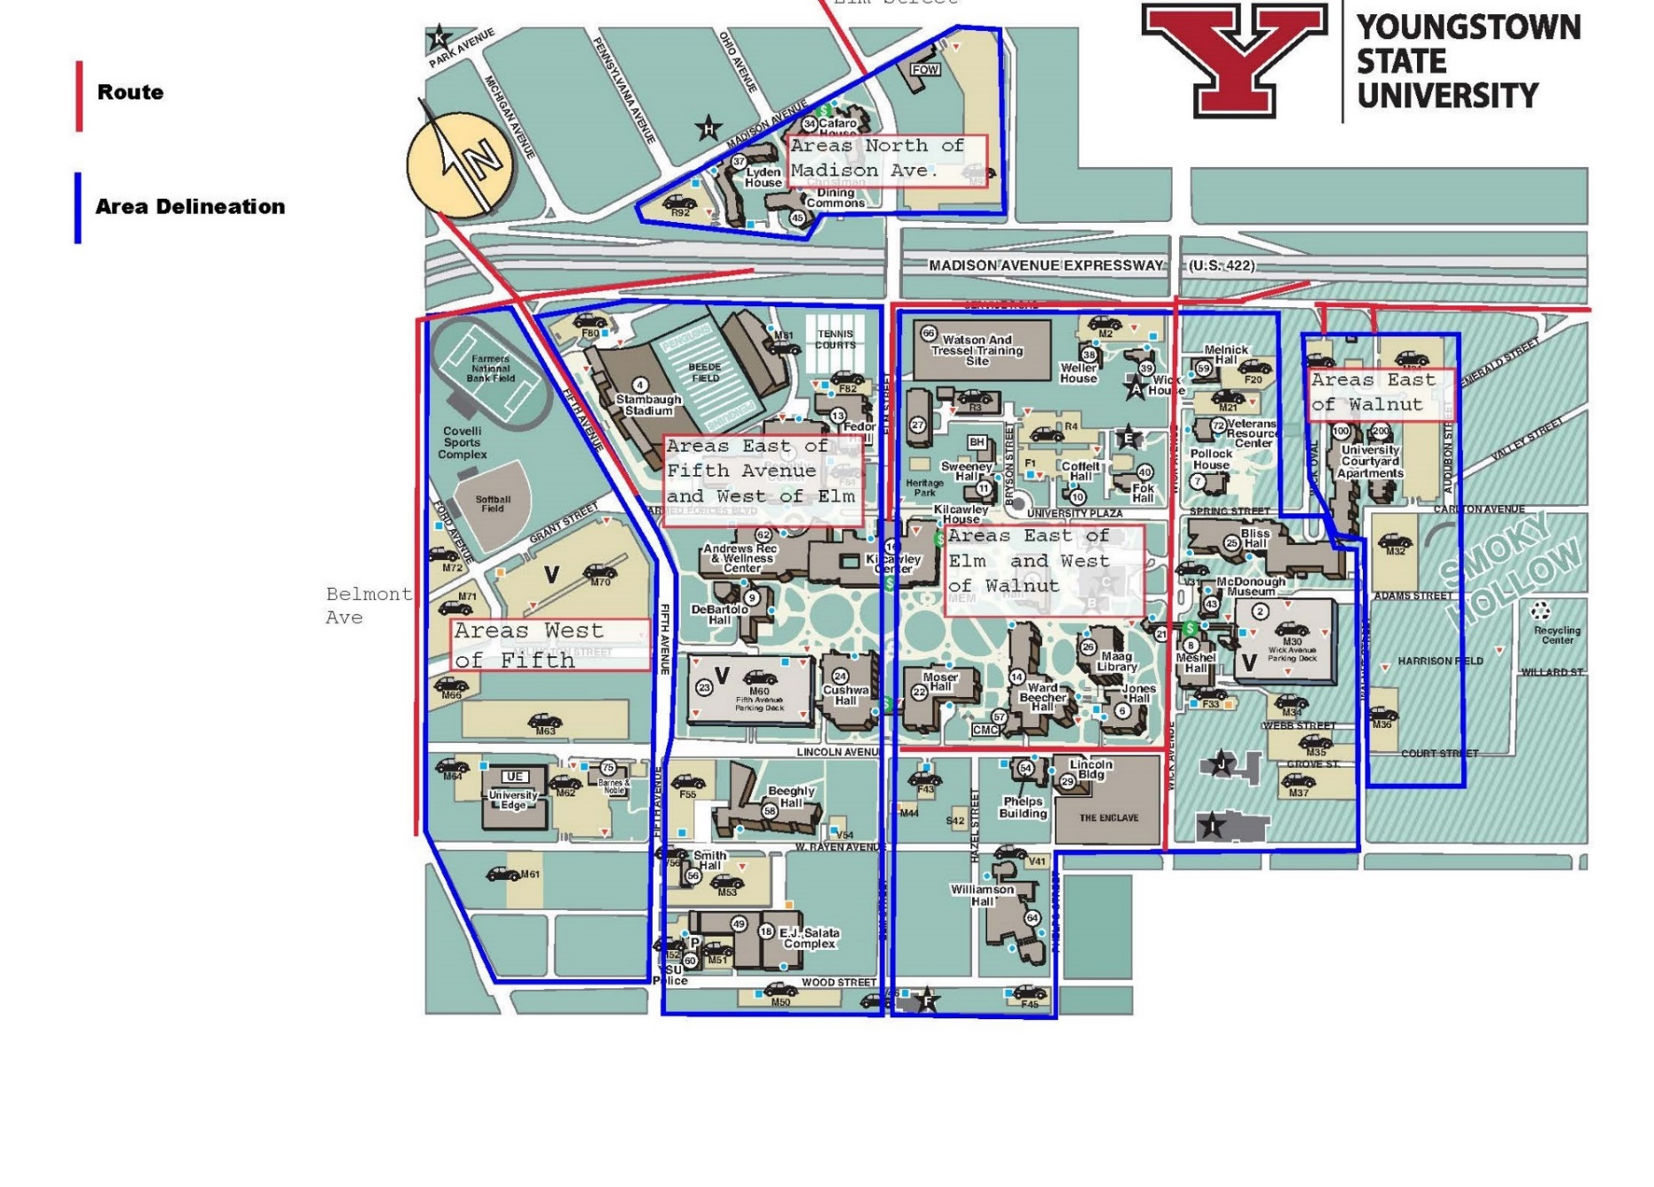

Active Shooter, Assault, and Human Trafficking

Active Shooter:

Contact the YSU Police at (330) 941-3527 or 911 from a campus phone.
An active shooter is an individual actively engaged in killing or attempting to kill people in a confined and populated area, typically through the use of firearms.

Action Steps:

If an active shooter is in the same building as you or outside your building:
- Proceed to a room that can be locked or lock/barricade the room you are in.
- Close and lock all windows and doors.
- Turn off the lights.
- If possible, get everyone down on the floor where no one is visible from outside the room.
- Have one person call 911. Advise the dispatcher of your location and what is taking place.
- Remain in place until the police or campus administrator known to you gives the “all clear”.
- Unfamiliar voices may be the shooter attempting to lure victims from their safe space. Do not respond to any voice commands until you can verify the source.

If an active shooter enters your office/area/classroom:
- Try to remain calm.
- Dial 911, if possible, and alert the police to the shooter’s location. If you can’t speak, leave the line open so the dispatcher can listen to what’s taking place.
- If there is absolutely no opportunity to escape attempting to overpower the shooter with force should be considered last resort, after all other options have been exhausted.
- If the shooter leaves the area, proceed immediately to a safer place and do not touch anything that was near the shooter.

If you decide to flee during an active shooter situation:
- Do not attempt to carry anything.
- Move quickly, keep your hands visible and follow the instructions of any police officers you may encounter.
- Do not attempt to remove injured people. Notify authorities of their location as soon as possible.

How to respond when law enforcement arrives:
- Remain calm and follow instructions.
- Put down any items in your hands (i.e., bags, jackets).
- Raise hands and spread fingers.
- Keep hands visible at all times.
- Avoid quick movements toward officers such as holding on to them for safety.
- Avoid pointing, screaming or yelling.
- Do not stop to ask officers for help or direction when evacuating.

Information you should provide to law enforcement or the 911 Operator:
- Location of the active shooter.
- Number of shooters.
- Physical description of shooters.
- Number and type of weapons held by shooters.
- Number of potential victims at the location.

The Fire alarm system should NOT be activated for an active shooter emergency; pulling the fire alarm facilitates evacuation but does not facilitate the proper tactics.

Report any unusual blocked, barricaded or chained doors to the YSU Police Department at once.

Workplace Violence & Unruly Individuals

If you witness or experience workplace violence:

- Avoid or discretely remove yourself from the area where the confrontation is occurring.
- Call YSU Police at (330) 941-3527 or 911 from a campus telephone.

Under no circumstances should staff engage persons in a shouting match or become involved in a physical altercation. Defuse or walk away from a potentially violent situation and call the police. Throughout the event, don't lose your cool; remain calm and keep your composure. Don’t argue, speak slowly and quietly no matter how loud or confrontational the patron becomes. Don't take anything an angry person says personally, it's never about you.

- If the situation becomes violent call the YSU Police at (330) 941-3527 or 911 from a campus phone.
- Remain Calm: Maintain control of yourself, even if the person’s tirade makes you feel like yelling yourself.
- Do not take it personally: Remember, the person is not angry with you; they are inconvenienced or displeased by the situation.
- Use your best listening skills: The first thing an angry person wants to do is vent; they want someone to listen; and, for better or worse, you are that person. Listening patiently can defuse a situation as long as the person feels acknowledged in his or her complaint; hear them out.
- When they are done talking, summarize what they told you, and ask questions to clarify their complaint.
- Body language is critical; keep eye contact, stand up straight and keep your arms uncrossed. Show how closely you are paying attention to their problem.
- Actively sympathize: After the person vents, they want to know you understand where they are coming from and how they feel. Express sympathy for their unpleasant experience.
- Find a solution: Once you understand the situation, offer a solution if possible. Seek out your supervisor for situations beyond your control.
- Take a few minutes on your own: After the situation has been resolved, it is helpful to take your own “time out”, by taking a short walk, having a snack, or taking a restroom break. Remember, the person’s actions were due to a situational frustration, and nothing you did.

Sexual Assault:

Youngstown State University prohibits all forms of discrimination based on sex including sexual harassment as well as sexual misconduct and sexual violence. The University has numerous resources and education initiatives regarding sexual assault. If a student, visitor, or fellow faculty/staff member reports they were a victim of a sexual assault; the following resources are here to help.

YSU Police: (330) 941-3527
Title IX Coordinator: (330) 941-4629
Compass Rape Crisis and Counseling Center: (330) 782-5664
RAINN: 1 (800) 656-HOPE

Human Trafficking:

Human trafficking is a form of modern slavery—a multi-billion-dollar criminal industry that denies freedom to 24.9 million people around the world. Moreover, no matter where you live, chances are it's happening nearby. From the girl forced into prostitution at a truck stop, to the man discovered in a restaurant kitchen, stripped of his passport and held against his will. All trafficking victims share one essential experience: the loss of freedom.

Victims of human trafficking are frequently lured by false promises of a lucrative job, stability, education, or a loving relationship. Victims can be men or women, adults or children, foreign nationals or U.S. citizens. While they share the trait of vulnerability, victims have diverse ethnic and socio-economic backgrounds, varied levels of education, and may be documented or undocumented.
As defined under U.S. law, victims of human trafficking can be divided into three populations:
- Children under age 18 induced into commercial sex.
- Adults aged 18 or over induced into commercial sex through force, fraud, or coercion.
- Children and adults induced to perform labor or services through force, fraud, or coercion.
Traffickers lure and ensnare people into forced labor and sex trafficking by manipulating and exploiting their vulnerabilities. Human traffickers recruit, transport, harbor, obtain, and exploit victims – often-using force, threats, lies, or other psychological coercion. Traffickers promise a high-paying job, a loving relationship, or new and exciting opportunities. In other cases, they may kidnap victims or use physical violence or substance abuse to control them.

Traffickers employ a variety of control tactics, including physical and emotional abuse, sexual assault, confiscation of identification and money, isolation from friends and family, and even renaming victims. Often, traffickers identify and leverage their victims’ vulnerabilities in order to create dependency. They make promises aimed at addressing the needs of their target in order to impose control. As a result, victims become trapped and fear leaving for myriad reasons, including psychological trauma, shame, emotional attachment, or physical threats to themselves or their children’s safety.

If you believe a student, visitor, or fellow faculty/staff member is a victim of human trafficking contact the YSU Police.

For assistance call:

YSU Police: (330) 941-3527
National Human Trafficking Hotline: 1 (888) 373-7888

Terroristic and Civil Related Incidents

Terrorism:

Terrorism is defined as “premeditated, politically motivated violence perpetrated against noncombatant targets by subnational groups or clandestine agents.” Examples include (but not limited to): chemical, biological, nuclear, radiological and conventional weapon (explosives, small arms, etc.) attacks, vehicle-borne and improvised explosive devices, hostage situations and suicide attacks. In the event of a terrorist threat, the YSU Police will coordinate with Ohio Homeland Security.

“If you see something, say something!”

To report acts of terrorism call:

YSU Police: (330) 941-3527 or 911 from a campus phone
OHS Terrorism Analysis Tip Line: 1 (877) 647-4683
Statewide Terrorism Analysis Center: 1 (844) 557-8222
NE Ohio Regional Fusion Center: 1 (216) 515-8477
Greater Cincinnati Fusion Center: 1 (513) 263-8000

Hostage Situations:

A hostage situation involves one or more persons being held against their will by one or more individuals. If weapons are present, this should be viewed as an active shooter situation. Hostage situations may develop out of active shooter incidents.

In the event of a hostage situation:
- Contact the YSU Police at (330) 941-3527 or 911 from a campus phone immediately.
- Cooperate with the hostage taker.
- De-escalate the situation, if possible.
- Stall for time, if possible.
- Provide the YSU Police with the last known location, description of clothing, physical features and if the individual is known.

Civil Disturbance:

Civil disturbance is a general term used to describe a variety of violent situations. It does not include nonviolent demonstrations protected by the first amendment. The Youngstown State University campus is a public venue, where nonviolent demonstrations are protected. If a situation arises where crowd control is necessary, the YSU Police will handle this task. If outside assistance is needed the YSU Police will request help from the Youngstown Police Department, Mahoning County Sheriff, or State Highway Patrol. Staff and students should not inject themselves in a protest that becomes violent. Instead, call the YSU Police at (330) 941-3527 or 911 from a campus phone.

Bomb Threats:

If you receive a bomb threat by telephone:
- Remain calm. Keep the caller on the line as long as possible so that the call may be traced.
- DO NOT transfer the call or interrupt the caller.
- If your phone has a display, copy the information in the display.
- Call or have someone nearby call YSU Police at (330) 941-3527 or 911 from a campus phone.

Ask the caller:
- Where is the bomb located?
- When will it go off?
- What does it look like?
- What kind of bomb is it?
- What will make it explode?
- Did you place the bomb?
- Why?
- What is your name?
Write down the exact wording of the bomb threat.

Note the callers voice, was it:
- Angry, calm, laughing, etc.

Was the caller:
- Coughing, crying, excited, etc.

Suspicious Package or Mail:

For suspicious packages and letters:
If you are unable to verify mail contents with the addressee or sender:
- Do not open it.
- Treat it as suspect.
- Isolate it; don’t handle it.
- Ensure that all persons who have touched it wash their hands with soap and water.
- Notify your supervisor immediately.
- Call YSU Police at (330) 941-3527 or 911 from campus phone.

What should you do if you receive a suspicious substance by mail?
- Isolate the damaged or suspicious mail piece or package. Restrict the immediate area.
- Ensure that all persons who have touched the mail piece wash their hands with soap and water.
- Call YSU Police at (330) 941-3527 or 911 from campus phone.

Mental Health Related Incidents

Suicidal Persons:

- In an emergency call the YSU Police at (330) 941-3527 or 911 from a campus phone.

- Contact Counseling Services at (330) 941-3737
- A Person of concern form is available at Student Outreach and Support. The form can also be found at the Student Outreach and Support website.

Any member of the University community, who learns that a student is exhibiting warning signs of suicide but has not engaged in suicidal behavior or communicated a suicide threat, should contact Student Counseling Services (330) 941-3737, for consultation and support, especially if the student is exhibiting suicidal ideation.

A Student of Concern Report should also be made through the Student Outreach and Support Office or online via their website: https://ysu.edu/student-experience/student-outreach-support.
For immediate assistance with a student if Student Counseling Services is closed, contact YSU Police at (330) 941-3527 or 911 from a campus telephone.

Any member of the college community who learns that a student has communicated a suicide threat/ideation/plan should make a Student of Concern Report through the Student Outreach and Support Office or online at Student Outreach and Support.

If at any point it seems reasonable to assume that suicidal behavior is imminent, especially if the student is uncooperative with attempts to help, call YSU Police at 330-941-3527 or 911 from a campus phone. Share the student’s name, description, details of the suicide threat, and location/destination (if known). Police officers can check on the student and transport them, as appropriate, to be evaluated for suicidal risk.

Any member of the university community who learns that a student has just engaged in, is in the processing of engaging in, or is about to engage in suicidal behavior (i.e. a suicide attempt), should immediately report this behavior to emergency personnel by calling YSU Police at (330) 941-3527 or 911 from a campus telephone.

If possible, provide responding emergency personnel with any pertinent information that is known about the student. A Student of Concern Report should also be made through the Student Outreach and Support Office or online at https://ysu.edu/student-experience/student-outreach-support.

Mental Health/Counseling Services:

Faculty, staff, and other concerned persons often call student Counseling Services when faced with students displaying a range of behaviors that may be a cause for concern, including:

- Worry, anxiety, expressions of sadness/hopelessness, or poor hygiene.
- A pattern of withdrawal from participation or excessive absences.
- Irritability and conflict with others.
- Confused patterns of thinking or communicating.
- Oral or written expressions of distress, self-harm and/or suicidal/homicidal ideation.

Our therapists are happy to speak with you on the phone about your concerns and how to make the most appropriate referral for the student. We work closely with many departments on campus including Student Outreach and Support, Center for Student Progress and the Student Health Clinic and may refer to these or others groups/organizations on and off campus to best help a student.

For counseling and outreach support call:

Counseling Services: (330) 941-3737
Student Outreach: (330) 941-4721

Student Outreach and Support:

The Director of Student Outreach and Support can assist students by offering advices on how to handle a particular situation, or by providing information on or arranging campus and community resources when necessary.

Medical Related Incidents

General Medical Emergencies:

If someone is ill or injured and requires assistance:
- Call YSU Police at (330) 941-3527 or by dialing 911 from a campus phone. If an ambulance is needed, tell the dispatcher at the beginning of your conversation.
- Give the dispatcher the following information:
  - The location of the person, include the building and the room number.
  - The illness or injury of the person.
  - Whether the person is conscious.
  - Any other information that is known, such as existing health conditions.

- Designate an individual to meet responders and show them where the victim is in the building.

Remember, it is important to stay on the line until the dispatcher gathers the pertinent information about the victim’s location, consciousness, breathing, etc. Those trained to perform CPR and first aid can act within their expertise while those who are not trained should remain calm and stay with the victim. Crowding is generally not helpful, and can hinder emergency services performing their duties.

Blood-Borne Pathogens:

Blood borne pathogens are present in human blood and can cause disease in humans. Some examples are, hepatitis B, and HIV. Always assume blood is infected with a dangerous disease and cleanse thoroughly if you are exposed to any bodily fluids.

If you encounter blood or bodily fluids, contact the Environmental and Occupational Health and Safety department at (330) 941-3700.

Unless you have the proper protection available (gloves, eye protection, mask, etc.) you should not attempt to clean up blood or bodily fluids. Instead, you can keep bystanders from entering the area.

Medical Pandemic:

A pandemic is an outbreak of disease that can spread from person to person. When people do not have natural immunity to a virus, serious illness or death is more likely to occur in any age group. This may be a local, regional, or global outbreak.

Reduce the spread of disease by:
- Maintaining personal hygiene and protection.
- Wash hands frequently.
- Limit international travel.
- Pharmaceutical intervention.

Any type of medical incident that would affect the campus community will be relayed using the Penguin Alert system.

Poison Control:

For help in a poison emergency call:
Poison Control: 1-800-222-1222
YSU Environmental and Occupational Health and Safety: (330) 941-3700
YSU Police: (330) 941-3527

Drug Overdose:

The symptoms of a drug overdose can vary dramatically. For example, people who overdose on stimulant drugs might experience symptoms quite similar to a heart attack. They may have a racing pulse, chest pain, and a feeling of impending death. People who overdose on sedating drugs might seem intensely sedated and sleepy. They might even turn blue, due to the lack of oxygen reaching their vital tissues. While symptoms can vary, there are signs commonly associated with a drug overdose. Anyone who experiences symptoms within this list need immediate medical attention:

- Convulsions.
- Agitation.
- Slow or difficult breathing.
- Vomiting.
- Pupils that don’t react in response to light.
- Sweating or dry skin.
- Unresponsiveness.
- Violent behavior.

If you suspect someone is suffering from a drug overdose, contact the YSU Police immediately at (330) 941-3527 or 911 from a campus phone.

Unidentified Drugs and Paraphernalia:

If you encounter an unknown powder or substance use caution when handling it. Be aware that certain commonly used drugs are “transdermal” which means the pharmaceutical can be absorbed through the skin. Fentanyl, in particular, can potentially be lethal; which is frequently used as a cutting agent for cocaine and heroin.

If you encounter unknown powder or substances, contact the YSU Police immediately at (330) 941-3527 or 911 from a campus phone.
- Do not touch, or handle the unknown substance.
- Narcan (Naloxone) is available, and YSU Police officers carry and are trained in its use.
- Secure the area where the substance is located until the YSU Police arrive.

Drug paraphernalia can also be dangerous due to sharp edges (crack pipes), biological (syringes), and any residual drug or substance transferred from handling. If you encounter any drug paraphernalia, do not handle it; secure the area and contact the YSU Police at (330) 941-3527.

Fire and Chemical Related Incidents

Fire:

In case of a fire or a fire alarm, the following procedure is to be followed. Generally, the RACE procedure is used in all university facilities with some variations. Always consult and follow your building-specific Building Emergency Action Plan or posted evacuation procedures.
If you discover a fire or smoke condition: RACE
- Rescue any person in immediate danger.
- Alarm, pull the fire alarm to alert everyone.
- Confine the fire by closing all doors, where possible. Turn off electric and gas equipment in your area as you evacuate, if possible.
- Evacuate using the nearest stair exit. Follow the exit signs.
- Extinguish a small fire using a fire extinguisher, if trained.
- Report the incident by calling 9-1-1 from a safe location.
- Report any discharged fire extinguishers and any first-hand information that you might have.
If you hear or see a fire alarm signal or announcement:
- Follow the emergency procedure for your building and area.
- Follow the announcements on the public address system or instructions of your area floor captains.
- Evacuate or stand by and stay alert as instructed on the public address system.
- Follow the EXIT signs. Use stairs. Do not use elevators. Walk at a normal pace.
- Wait outside in the designated assembly areas at least 50 feet or more away from the building as instructed.
- Re-enter the building only after the “all clear” is announced by YSU Police or the responding fire department.
Procedure for Individuals with Disabilities:
- All occupants: report the presence of any person with a disability in the building to the fire department.
- Four Types of Evacuation: Horizontal, stairway evacuation, shelter in place, or seek an area of refuge.
- Evacuation Assistants: Assist individuals with evacuation. Report to first responders.
- Floor Evacuation Coordinators: Assist individuals with evacuation. Report to first responders.
- Do not evacuate vertically unless the person is able to ambulate.
- Do not use the elevators unless assisted by first responders.
In addition to the fire evacuation procedure, the following responses may be necessary:
Clothing Fire and Burn Injury Response:
What you do for a burn in the first few minutes can make a difference in the severity of the injury.
- Stop the burning process. Remove the source of heat. If clothing catches fire, STOP, DROP, AND ROLL to smother the flames.
- Remove all burned clothes. Clothing may retain heat and cause a deeper injury. If clothing adheres to the skin, cut or tear around adherent area to preserve good skin tissue.
- Pour cool water over areas burned. Keep pouring the cool water for at least 3-5 minutes (30-40 minutes for chemical injury). DO NOT PACK THE BURNED AREAS IN ICE! This may increase the extent of injury and cause hypothermia.
- Remove all jewelry, belts, tight clothing, etc., from the burned areas and from around the victim’s neck. Swelling of burned areas occurs immediately.
- Do not apply ointments or butter to wounds. These may cause infection because of their oil base and convert wounds to deeper injury.
- Cover burns with a clean dry dressing, bandage or sheet.
- Seek medical attention as soon as possible!

Fire Alarm Pull Stations:
As you walk toward an exit in the corridor or near the stairwell door, you should find at least one wall-mounted red box marked “Fire Alarm”. In case of fire or smoke, just pull it down as indicated. An alarm should sound and an announcement might follow, where equipped. The alarm system also can be activated automatically when a heat or smoke detector senses a fire or smoke condition.
Once the alarm is activated, notification goes to YSU Police Department, which then dispatches appropriate responders. Use the fire alarm promptly to minimize the loss of life and property because of fire.
Some pull stations may have Plexiglas covers that, when lifted, produce a local warning sound. Note that this is not a fire alarm sound. To activate the fire alarm throughout the building, you must pull the inner pull handle.
To ensure that the system will protect you, you should know at least two pull station locations in your area. Maintain pull stations free of obstructions and clearly visible at all times.
Report any fire alarm concerns to the YSU Police at (330) 941-3527.

Fire Extinguishers:
Portable fire extinguishers of appropriate type and size are provided as required in all areas. Extinguishers are inspected, tested, maintained and documented as required by the Ohio Fire Code. Facilities Operations, Environmental Health & Safety (EOHS), must ensure compliance with this requirement as applicable. Fire extinguishers are provided throughout all university buildings for use by trained students, faculty, and staff. Portable fire extinguishers effectively extinguish 90% of all fires before the fire department responds. Research shows that fires get out of control in 3-5 minutes. A fire extinguisher is your first aid to fire fighting. Because an average extinguisher discharges completely in less than 1 minute, it is important that you know at least two locations for extinguishers nearest to your work area and know how to use them effectively.
Safety Precautions:
Before using a fire extinguisher, always pull the building fire alarm.
- Do not attempt to use a fire extinguisher if the fire is large and spreading. Use it only for small-firedefense (e.g., a wastepaper basket).
- Do not use the fire extinguisher if the lock pin is tampered, the cylinder is damaged, or if the pressure gauge pointer is in the “recharge” zone.
- Do not use the fire extinguisher if you are not trained and confident about using it.
- Read the extinguisher label to ensure it is the right type for the kind of fire at hand. The label indicates one or more of the fire classes and symbols (below), and specific applications for which it can be used.
Protect yourself at all times:
- Never block your escape route.
- Stay low. Avoid breathing the heated smoke and fumes.
- If the fire cannot be controlled, get out immediately to safety.

Types of Fire Extinguishers:
A | Letter “A” in triangle | Ordinary combustibles.  (e.g., wood, paper, cloth) | Stainless steel cylinder body with pressure gauge. Cools fire with pressurized water. Do not use for flammable liquids (B) or electrical (C) fire.
B | Letter “B” in square | Flammable liquids/gases.  (e.g., gasoline, oil, paint) | Red cylinder body and horn, no gauge. Deprives the fire reaction of oxygen with carbon dioxide. Home kitchen fire use.
C | Letter “C” in circle | Energized electrical equipment.  (e.g., powered appliances) | Interrupts chemical chain reaction. Both carbon dioxide and ABC type extinguishers can be used.
ABC | A, B, and C | All of the above applications.  Multipurpose ABC, home use | Red cylinder body. Interrupts chemical chain reaction of fire with dry chemical powder. Most commonly used.
K | Letter “K” | Commercial cooking, deep-frying with oils and fats.  Minimum rating: 2A: 1B: C: K | Stainless steel cylinder body with long safety wand. Cool and interrupts chemical reaction. Uses wet chemical with fine mist application. Relatively new.
AC | Water Mist  Letter “A”  Letter “C” | Trash, wood, paper, and electrical equipment.  For clean rooms; minimum rating 2A: C | White paint finish cylinder with long safety wand. Preferred for clean  rooms, telecom, electronics equipment areas. Relatively new.

How to Use a Fire Extinguisher:
- Position yourself at a safe distance from the fire (e.g., 8-10 feet when using an ABC-type unit, 5-7 feet when using a CO2 unit, or 20-25 feet with Pressurized Water extinguisher).
  - Remember the “P-A-S-S” procedure:
  - Pull the pin: This unlocks the operating lever and allows you to discharge the extinguisher.
  - Aim low: Point the extinguisher nozzle, horn, hose at the base of the fire.
  - Squeeze and hold the handle to discharge the extinguishing agent without any interruption.
  - Sweep slowly from side to side as you hold the handle squeezed.
  - Move closer carefully as the fire gets smaller and as you continue spraying.
  - Watch the fire area until it has completely cooled down.
  - Repeat the “P-A-S-S” procedure if the fire re-ignites.
  - Report the discharged extinguisher to the YSU Police at (330) 941-3527. Once used, the extinguisher must be recharged.
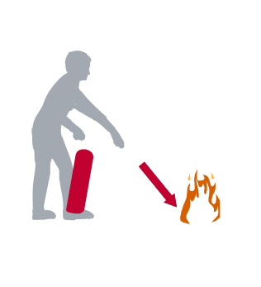
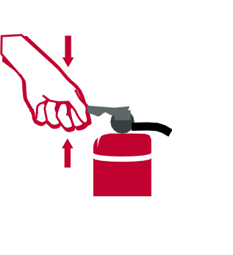
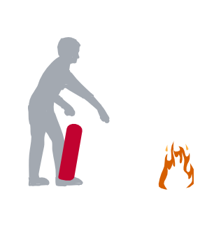
P
A
S
S
PULL THE PIN
AIM AT BASE OF FIRE
SQUEEZE THE HANDLE
SWEEP SLOWLY FROM SIDE TO SIDE

Explosion:

Explosions can occur from natural gas leaks, chemicals, boilers or other items that are under pressure. If an explosion occurs and you are in the immediate area, take cover under a sturdy object such as a desk. Be prepared for further explosions.

- Try to remain calm.
- Stay away from windows, objects that may fall on you, and electrical equipment.
- Evacuate the building carefully, watch for falling objects while you are exiting the building.
- If you should become trapped, yell or bang on any metal in the vicinity.
- Do not use the elevators.
- Do not move seriously injured victims unless they are in immediate danger such as fire or the building collapsing.
- Contact YSU Police at (330) 941-3527 or 911 from a campus phone.
- Give YSU Police all pertinent information regarding the explosion.
  - Location.
  - If anyone is injured and the extent of the injuries.
  - Your contact and information.

Chemical Release:

For a Major Hazardous Spill or Leak:
- Sound the fire alarm to evacuate the building if fumes or smoke are present.
- Contact YSU Police at (330) 941-3527 or 911 from a campus phone.
- Give YSU Police a complete description of the incident. Describe the type of accident;(fire, explosion, chemical spill, leaking drum). If the incident is a chemical spill, and you know the name of the chemical, inform the dispatcher.
- Identify the building where the incident occurred and the room number or location of the incident.
- If the incident involves a chemical spill, give the approximate amount of the spill.
- Give your name and the telephone number from which you are calling.
- Note any injuries.

For a Major Hazardous Spill or Leak that Occurs Around the University:
- You will be alerted by either the Mass Communications System (PA System), or the PenguinAlert.
- Avoid the contaminated area.
- Follow the directions of emergency personnel.
- If told to evacuate, follow the prescribed route in the campus evacuation section or the route instructed by emergency personnel.
- For questions regarding chemical data sheet information, cleanup or other inquires, contact Environmental and Occupational Health and Safety at (330) 941-3700.

Nuclear Incident:

An accident at a nuclear power plant could result in dangerous levels of radiation that could affect the health and safety of those on the campus.

There are four levels of an emergency at a nuclear power plant:
- Notification of an Unusual Event: Actual or potential degradation of the level of safety of the plant or indication of a security threat to the facility.
- Alert: Actual or potential substantial degradation of the level of safety of the plant or a security event that involves probable life threatening risks to site personnel or damage to site equipment because of intentional malicious dedicated efforts of a hostile attack.
- Site Area Emergency: Actual or likely major failures of plant systems needed for protection of the public.
- General Emergency: Actual or imminent substantial core degradation or melting with potential for loss of containment integrity or security events that result in an actual loss of physical control of the facility.

Two nuclear power plants could affect the campus:
- Beaver Valley Power Station; Hookstown PA 50 Miles from campus.
- Perry Nuclear Power Plant; Perry Ohio. 72 miles from campus.

In the event of a nuclear incident, the Penguin Alert or the Simplex campus paging system will alert the campus community.

Weather Related Incidents

Tornado:

A tornado shelter is the lowest level of the building away from windows.

- Stay indoors, be alert to falling objects.
- Immediately walk to a tornado shelter area.

If you are in a building:
- Go to the lowest level of the building, find an interior area (e.g., interior hall, closet, or bathroom). Seek refuge under a table or desk kneeling face down with your hands covering your head to reduce injury. If available, cover yourself with a coat or other such material.
- Avoid areas that have a large roof span that may collapse: auditoriums, gymnasiums, etc.
- Stay away from windows and glass, and unsecured objects such as filing cabinets or bookcases.
- Do not use the elevators.

If you are outside:
- Lie flat on the ground in a depression and cover the back of your head and neck with your hands.
- Do not seek cover in an automobile or under a tree.

If driving a vehicle:
- Get out and seek shelter in a building or low area; never try to outrun a tornado.
- Never try to “out run” a tornado.

Remain in the safe area until an “all clear” message is received via the PA system or PenguinAlert.

Note that all buildings may not have a basement, in this case you should find an area of the building that is away from windows/glass and objects that could fall.

The best area for a tornado shelter in this building is located in the basement.

Earthquake:

Keep in mind that most earthquakes are of a short duration and that injury usually occurs from falling objects. With that in mind, the following procedures can assist you in the case of an earthquake.

If in a building:
- Remain calm.
- Stay inside the building.
- Find cover under a sturdy object such as a desk or in a door frame.
- Watch for falling objects.
- Stay away from windows and any other objects, which may fall on you.

If you are outside:
- Go to an open, area free of trees, power lines and away from buildings.
- Cover your head and watch for falling objects.

After the earthquake is over:
- Expect aftershocks so remain protected.
- Remain calm.
- Follow the instruction of YSU Police and evacuate the building if told to do so.
- When evacuating, watch for falling objects and walk carefully as the floor or steps may be damaged.
- Do not use the elevators.
- Do not move seriously injured persons unless there is danger from fire or building collapse.
- Do not re-enter the building.
- Do not light cigarettes, matches, lighters or use cellular phones as this may cause an explosion if natural gas is present in the immediate area.

Flood:

Floods can occur anytime of the year. Flood waters can appear suddenly (flash flood), or can rise slowly. If buildings are flooded, care should be exercised when electrical appliances are submerged. Report flooding bathrooms, or classrooms to facilities. Contact facilities at (330) 941-3239.

Disruption of Public Services

Power Outages:

The inherent danger during a major power outage is panic. All University personnel should stay calm. In the event of a major campus-wide outage, the University has emergency generators that will provide limited temporary power to some areas of the campus. To report a minor localized power outage, call University Facilities at (330) 941-3239.

Major Campus-Wide Power Outages:
- Remain calm, the power will be restored.
- Per University Policy, do not use candles or any other type of flame for light.

If People are trapped in an Elevator:
- Contact the YSU Police at (330) 941-3527.
- Should you ever become stuck in an elevator, don’t panic. Use the in-car emergency phone to call for help.
- Under no circumstances should you try to pry the doors, or occupy the hoist way. Exposure to the moving equipment in the shaft is dangerous and could potentially be lethal.

Water Outage/Restriction:

A water outage can occur at any time, for a variety of reasons, and usually without warning. There is a difference between a water outage (no running water) and a drinking water restriction (water is not suitable for consumption or cooking, but is available).

The water for the University is provided by the City of Youngstown. If there is a restriction on consumption, that information will be relayed to the campus community. To report a localized outage or problem in your building, contact facilities at (330) 941-3239.

Gas Leak:

If you smell gas inside or outside the building, contact the YSU Police immediately at (330) 941-3527 or 911 from a campus phone. Do not create sparks by turning on or off lights, or ignite any flames.

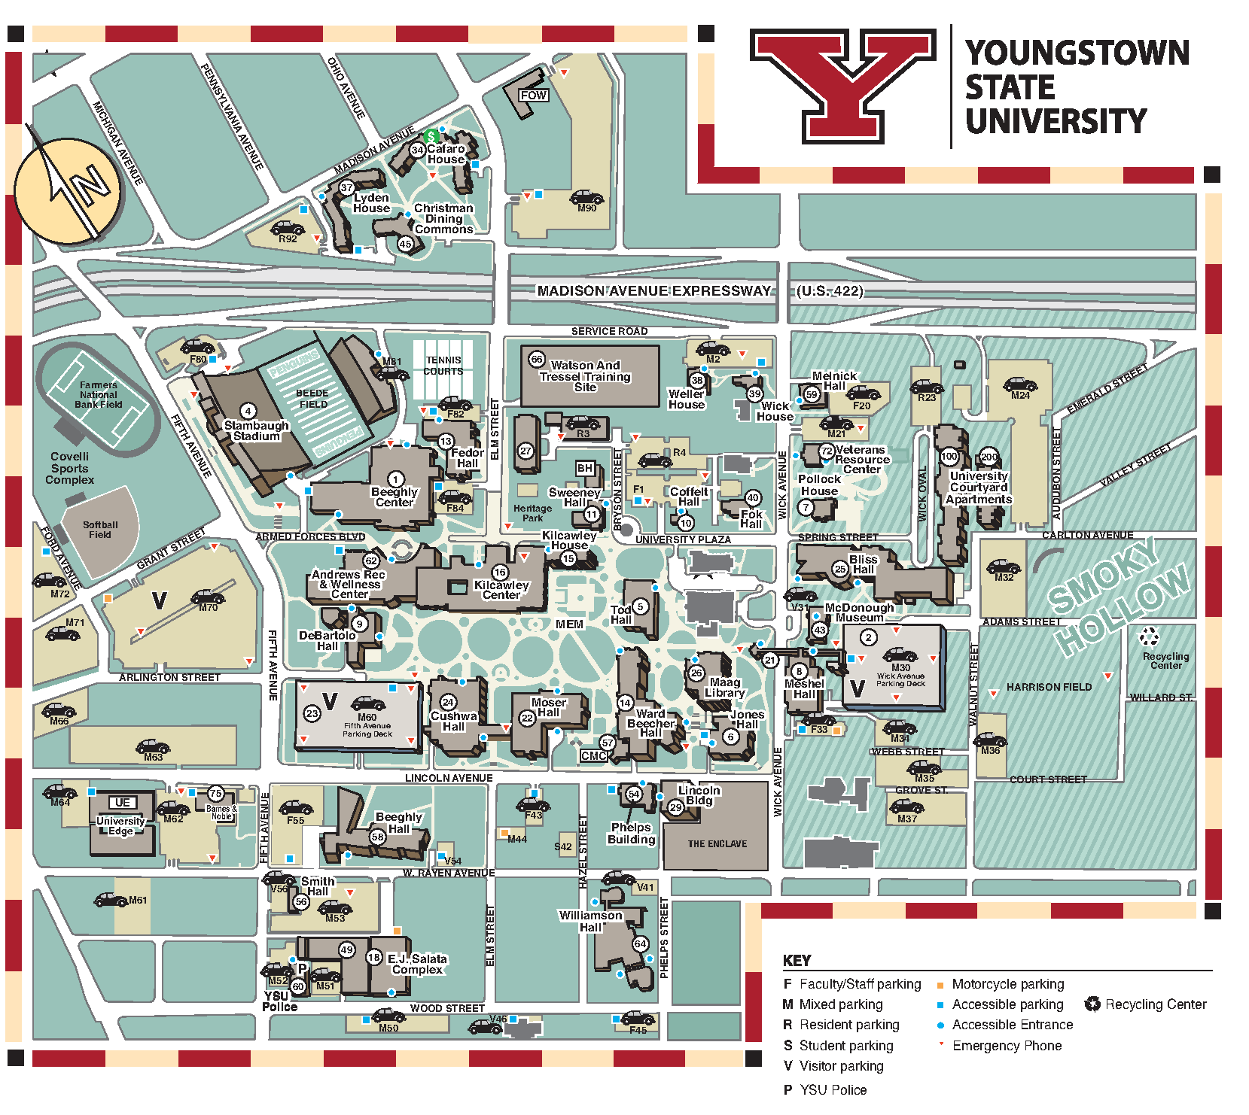
Campus Map

