Emergency
Operation Plan

Outdoor Athletic
Fields/Complexes

Table of Contents
Emergency Defined 3
Reporting Emergencies 4
Field Identification Maps 5
Stambaugh Stadium 1st Floor Tornado Shelter 6
Bliss Hall Basement Tornado Shelter 7
Campus Evacuation 8
Campus Evacuation Map 9
Weather Related Incidents 10
Tornado: 10
Earthquake: 10
Flood: 10
Disruption of Public Services 11
Power Outages: 11
Water Outage/Restriction: 11
Gas Leak: 11

Emergency Defined

An Emergency is any event or condition that presents an imminent risk of death, serious injury or illness to the University Community, suspension or significant disruption of university operations, significant physical or environmental damage, or significant threat to the University’s financial wellbeing.
Rather than establishing rigid parameters for qualifying an event as an emergency, this definition is intended to emphasize the actual and potential catastrophic effect, the imminent threat, and seriousness inherent to emergencies. Other events may produce crises or harmful effects but an emergency is distinguished by the severity of the threat and its effects as well as the ongoing threat posed to the University Community.

Revision History:

4/18/2019 Emergency Plan Updated

To update or correct this emergency operation plan contact:

William Rogner (330) 941-7496 whrogner@ysu.edu

Reporting Emergencies

Anyone witnessing a safety, security or medical related incident in or near the University should secure their immediate safety, and the safety of those involved and around the incident. Call the YSU Police Department and provide the dispatcher with the following information:
- Incident Location.
- Incident Description.
- Injuries.
- Your Name and Contact Information.
Follow the dispatcher’s instructions and do not hang up until directed to do so.

If you are on campus, call extension 3527 or 911 from a campus phone. You can also use the emergency tower phones.

If you are off campus, or calling from a cell phone, dial (330) 941-3527.

Remember: If you see something, say something! The YSU Police are available 24 hours a day, 7 days a week.

Important: You can reach the YSU Police on campus phones (the phones in your office and in campus buildings) by either dialing 911 or extension 3527. If you are using a cellphone you must dial (330) 941-3527 to contact the YSU Police. If you dial 911 from your cellphone, you will be connected with the Youngstown City Police dispatcher.

Field Identification Maps

- If you are located on Farmers National Field, Softball Complex, or Beede Field: Proceed to the west doors of Stambaugh Stadium. The first floor of the stadium is a suitable tornado shelter.
  - ALTERNATE SHELTER: Any substantial shelter made of brick or block near the Farmers or softball field stands.
- If you are located on Harrison Field or shotput field: Proceed to the west door of Bliss Hall (near kiln). The basement is a suitable tornado shelter.
  - ALTERNATE SHELTER: Go to the lowest level of the parking deck.
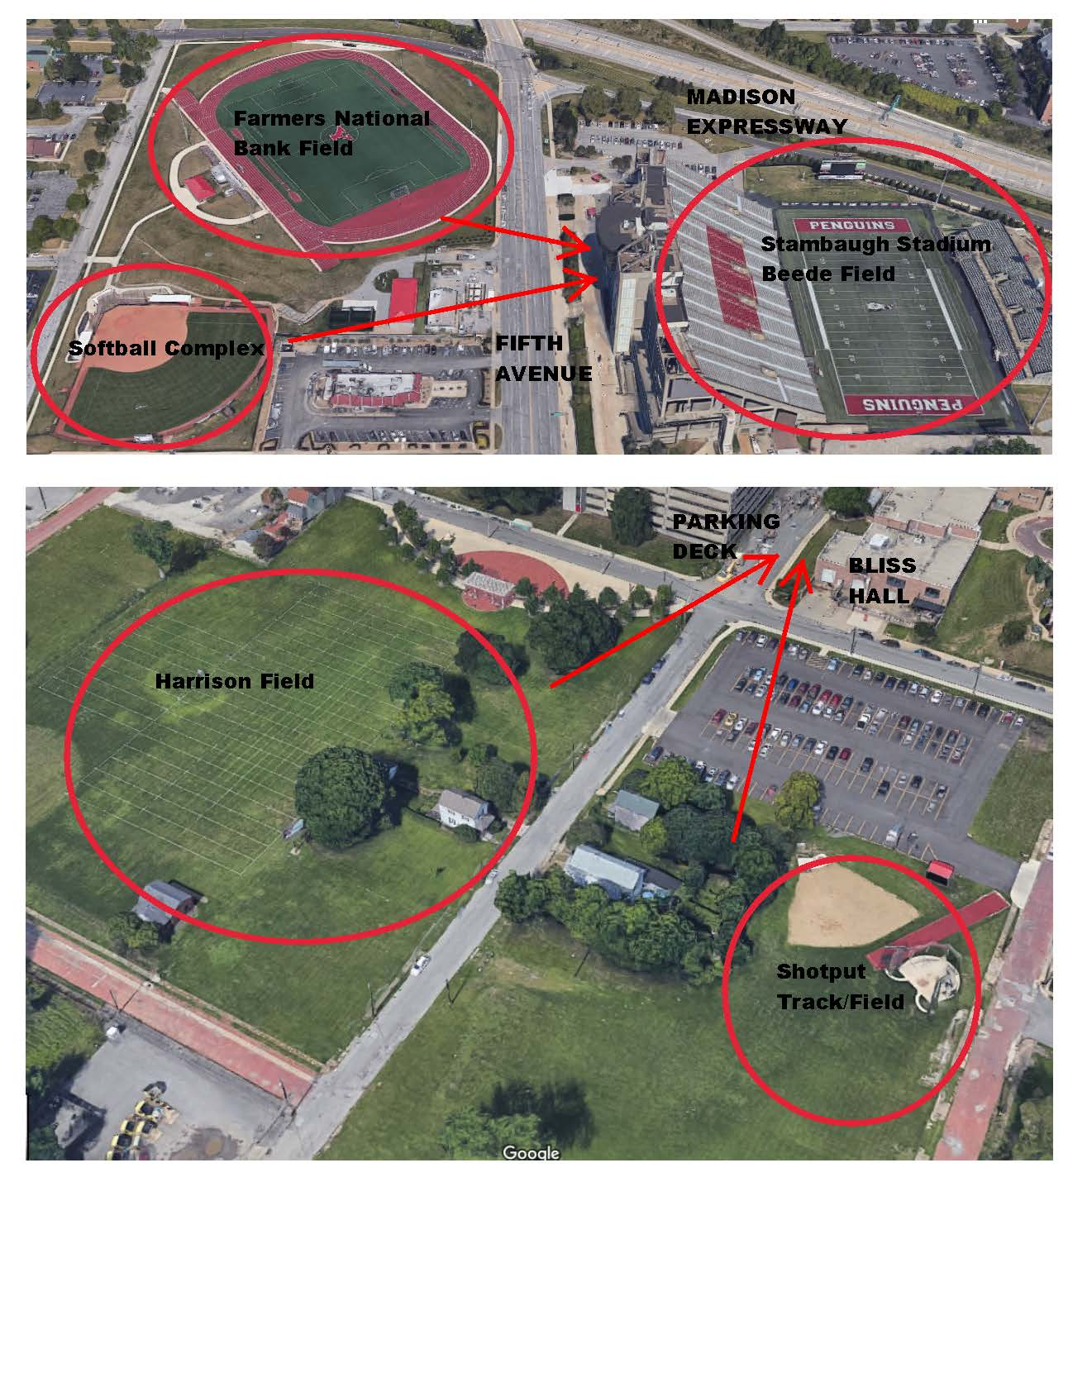

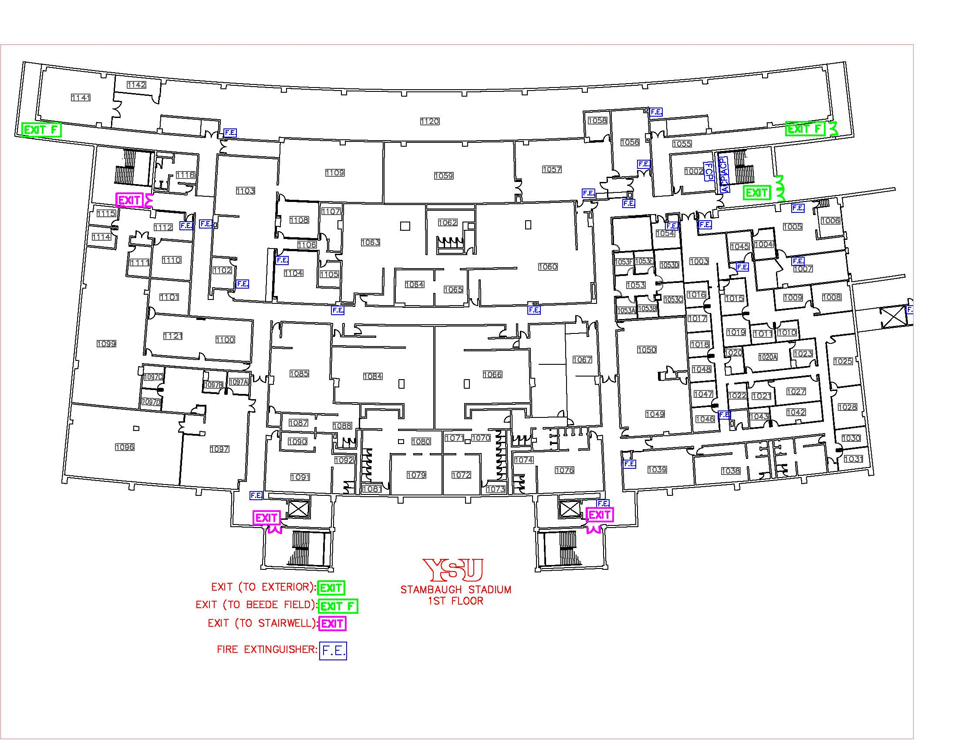
Stambaugh Stadium 1st Floor Tornado Shelter

Bliss Hall Basement Tornado Shelter
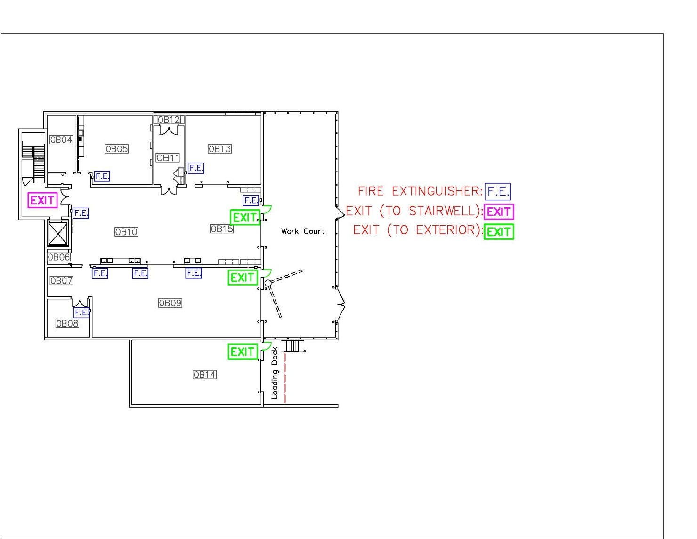

Campus Evacuation
An emergency of the magnitude and seriousness requiring the evacuation of the campus will likely and similarly affect surrounding communities. When the emergency is confined to the local community, evacuation to neighboring communities and routes leaving the immediate area are used. When an emergency is regional or larger scale, evacuation routes direct traffic to interstate highways for mass evacuation and relocation. A person evacuated from the campus may have few options regarding the direction of travel and should immediately follow the directions they are given.
Madison Avenue expressway located North of Stambaugh Stadium has been identified as the major traffic artery toward which evacuating traffic will be directed if possible. From there, evacuees can be integrated into the larger regional evacuation plan if necessary. However, the main surface roads around campus, Belmont Ave, Fifth Ave, Wick Ave, and Rayen Ave will also be used to allow for the maximum number of vehicles to evacuate campus in the shortest time possible. Listed below are the primary egress routes to be utilized:
Areas West of Fifth Avenue (M-70 Lot, Edge Apartments)
All parking lots and areas west of Fifth Avenue will evacuate west to Belmont Avenue.
North to Madison Avenue Expressway then west to I680, or;
South to Rayen Avenue then west towards US 422.
Areas East of Fifth and West of Elm Street (Lincoln Avenue Deck, M-53 Lot)
All Lots between Fifth Ave and Elm St. Proceed North on Fifth to West bound Service Road then Madison Ave Expressway to I680, or;
North on Fifth Avenue to Gypsy Lane, then west to 711, or;
Southbound on Fifth Avenue to Mahoning Avenue. Mahoning Avenue to I680.
Areas North of the Madison Avenue Expressway (Lyden and Cafaro House, Flats at Wick)
All parking lots north of the Madison Avenue Expressway should go North on Elm Street to Gypsy Lane. Then west to 711 or east to Logan Avenue and then North on Logan Avenue.
Areas East of Elm Street and West of Walnut Street (Wick Avenue Deck, Enclave)
All parking areas East of Elm Street and West of Walnut Street will proceed northbound on Wick Avenue to Madison Avenue Expressway to either I680 or Himrod Expressway, or;
Northbound on Wick Avenue to McGuffey Road, or;
Northbound on Wick to Logan Avenue, or
Southbound to Rayen Avenue (US 422) then east.
Areas East of Walnut Streets (Courtyard Apartments)
All parking East of Walnut will proceed East to Andrews Avenue then north on Andrews Avenue to Logan Avenue, then North on Logan.

Campus Evacuation Map
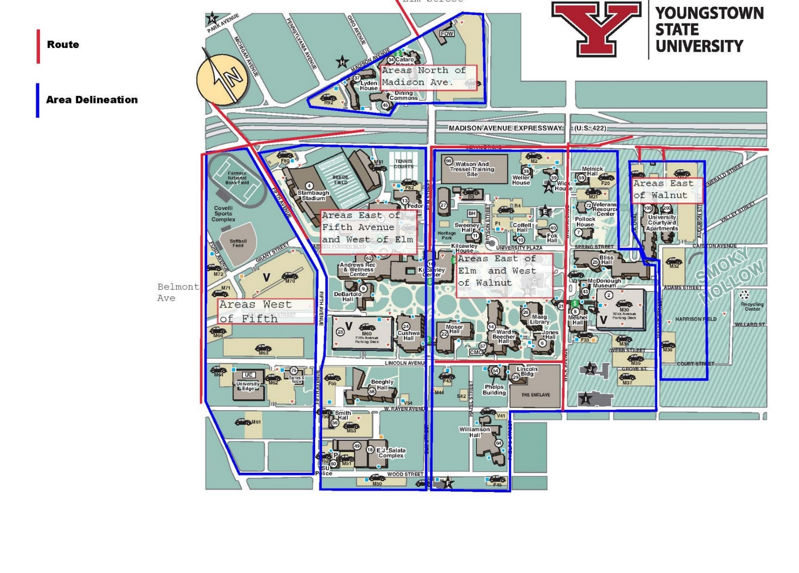

Weather Related Incidents

Tornado:

If you are outside:
- Go to the nearest building/structure, and proceed to the lowest level/basement level.
- If you cannot get to a building safely, lie flat on the ground in a depression and cover the back of your head and neck with your hands.
- Do not seek cover in an automobile or under a tree.

If driving a vehicle:
- Get out and seek shelter in a building or low area; never try to outrun a tornado.

Earthquake:

Keep in mind that most earthquakes are of a short duration and that injury usually occurs from falling objects. With that in mind, the following procedures can assist you in the case of an earthquake.

If you are outside:
- Go to an open, area free of trees, power lines and away from buildings.
- Cover your head and watch for falling objects.

After the earthquake is over:
- Expect aftershocks so remain protected.
- Remain calm.
- Follow the instruction of YSU Police and evacuate the building if told to do so.
- When evacuating, watch for falling objects and walk carefully as the floor or steps may be damaged.
- Do not use the elevators.
- Do not move seriously injured persons unless there is danger from fire or building collapse.
- Do not re-enter the building.
- Do not light cigarettes, matches, lighters or use cellular phones as this may cause an explosion if natural gas is present in the immediate area.

Flood:

Floods can occur anytime of the year. Flood waters can appear suddenly (flash flood), or can rise slowly. If buildings are flooded, care should be exercised when electrical appliances are submerged. Report flooding bathrooms, or classrooms to facilities. Contact facilities at (330) 941-3239.

Disruption of Public Services

Power Outages:

The inherent danger during a major power outage is panic. All University personnel should stay calm. In the event of a major campus-wide outage, the University has emergency generators that will provide limited temporary power to some areas of the campus. To report a minor localized power outage, call University Facilities at (330) 941-3239.

Major Campus-Wide Power Outages:
- Remain calm, the power will be restored.
- Per University Policy, do not use candles or any other type of flame for light.

If People are trapped in an Elevator:
- Contact the YSU Police at (330) 941-3527.
- Should you ever become stuck in an elevator, don’t panic. Use the in-car emergency phone to call for help.
- Under no circumstances should you try to pry the doors, or occupy the hoist way. Exposure to the moving equipment in the shaft is dangerous and could potentially be lethal.

Water Outage/Restriction:

A water outage can occur at any time, for a variety of reasons, and usually without warning. There is a difference between a water outage (no running water) and a drinking water restriction (water is not suitable for consumption or cooking, but is available).

The water for the University is provided by the City of Youngstown. If there is a restriction on consumption, that information will be relayed to the campus community. To report a localized outage or problem in your building, contact facilities at (330) 941-3239.

Gas Leak:

If you smell gas inside or outside the building, contact the YSU Police immediately at (330) 941-3527 or 911 from a campus phone. Do not create sparks by turning on or off lights, or ignite any flames.

