Create & Route a Posting for Approval – Hiring Manager
*Do not update or enter any information into the Posting that is not explicitly mentioned in this instruction sheet. This includes the section pertaining to the Search Committee; no entry is to be made in those fields.
- Log into PeopleAdmin with your YSU credentials.

- In the upper left hand corner, click on the 3 blue dots to reveal the drop down menu
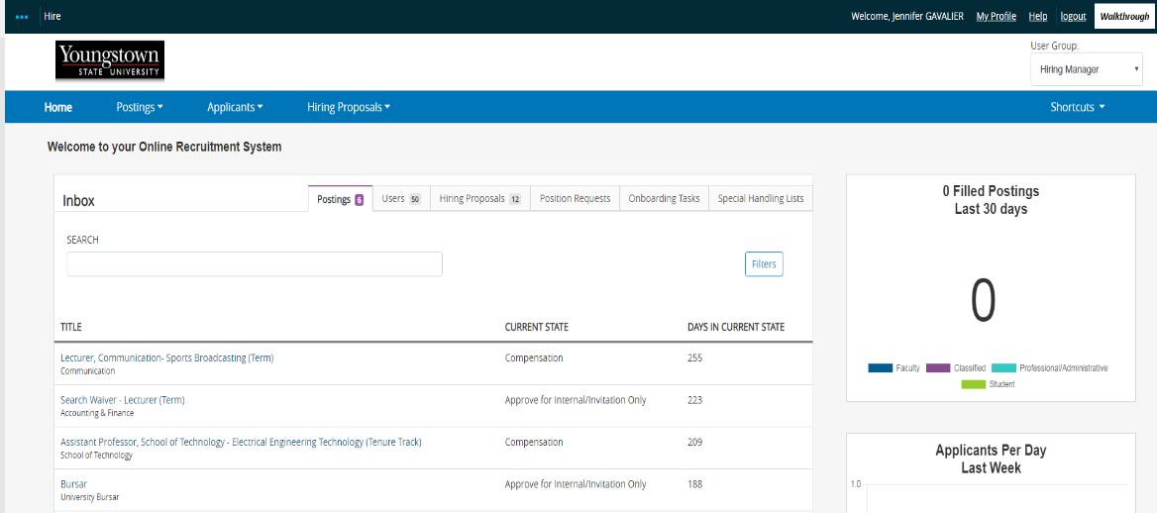

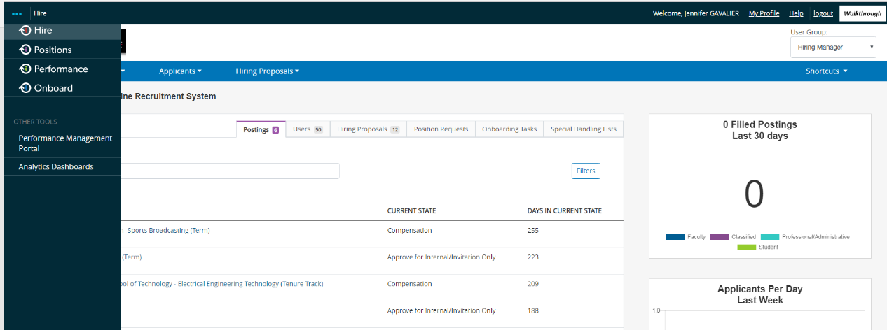
- From the drop down menu, select Hire (the heading color will be Blue)

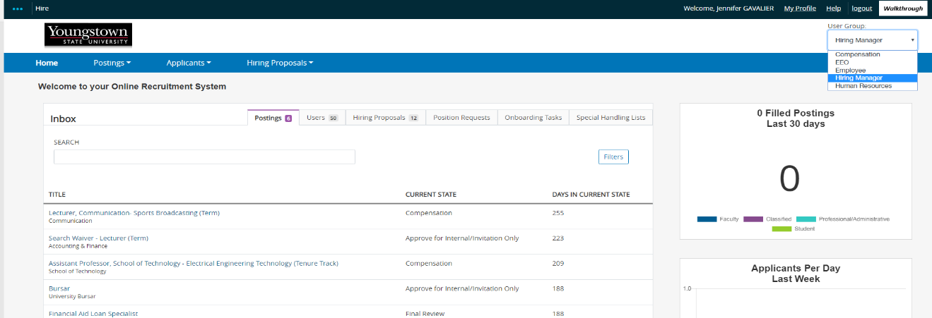
- Change your Current Group to Hiring Manager.

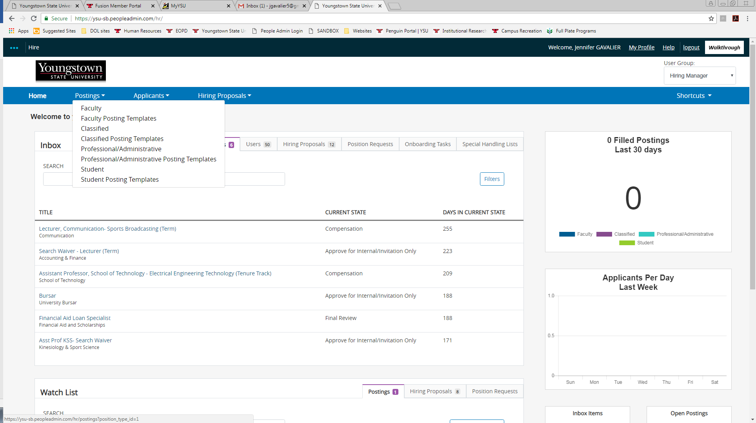
- Click on Postings and select the appropriate position type.

- On the right hand side click on the orange box that says Create New Posting.

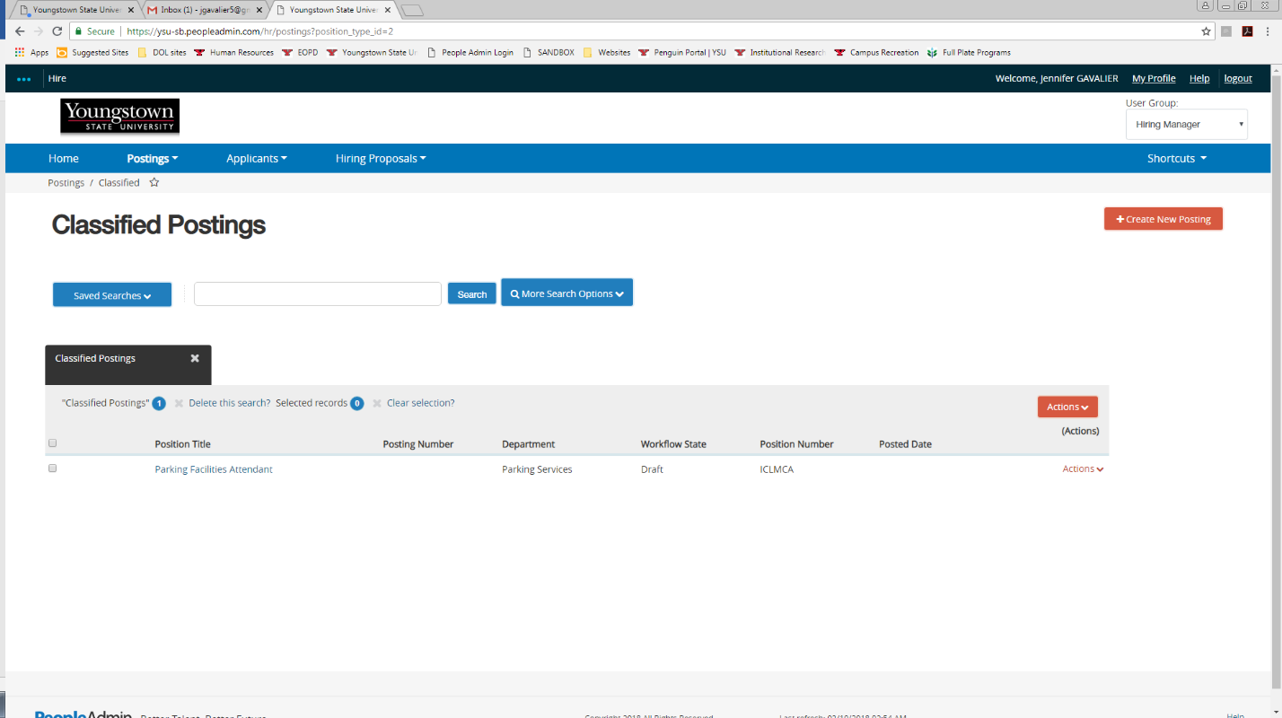

- Select Create from Position Description.

- Hover over the orange ACTIONS dropdown to the far right of the position description you will be posting. Select Create From.
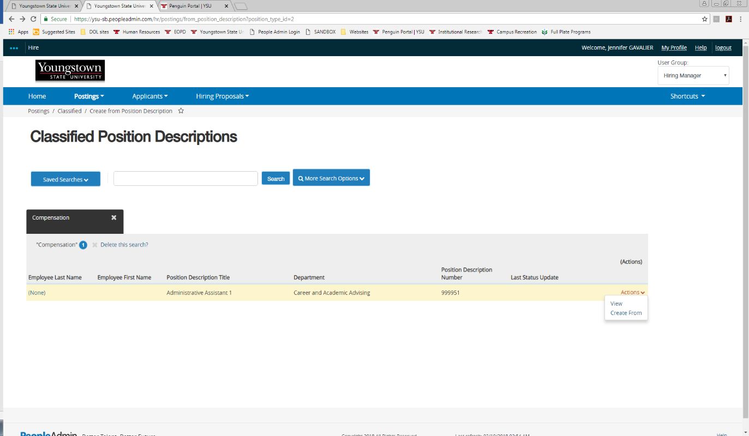

- Review the settings displayed and click Create New Posting either at the top or the bottom of the screen.
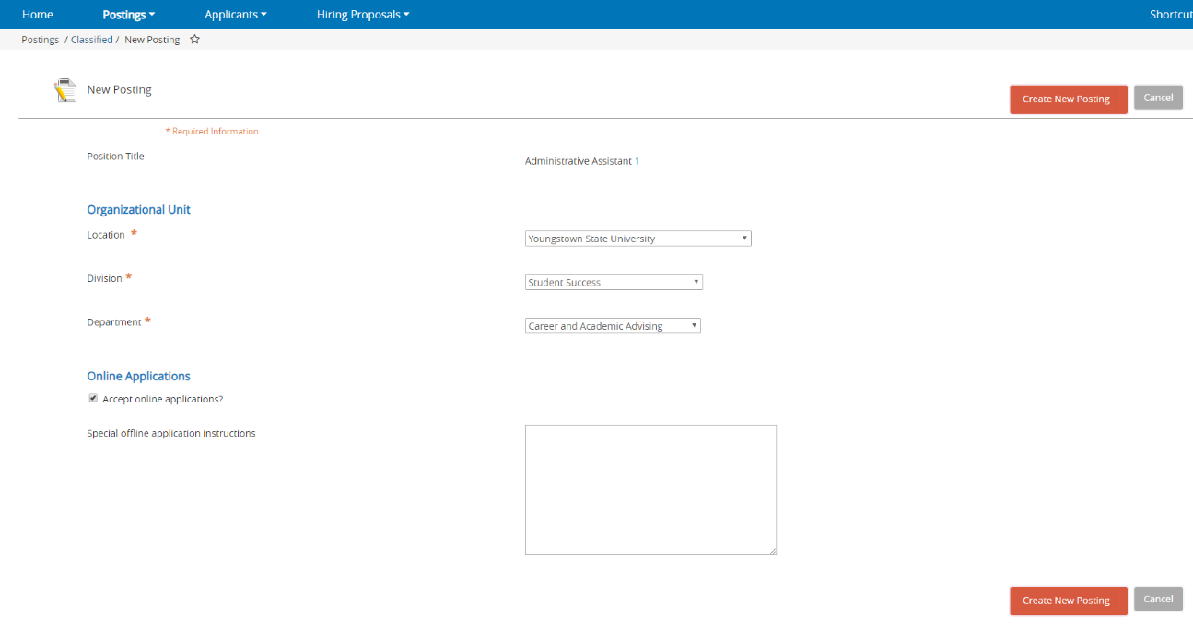

- Move through each section of the posting by clicking the NEXT button in the top right corner. Review the information displayed, which is pulled directly from the position description. Click NEXT until you’ve reached the summary page. If you would like to change any of the information displayed, please contact Human Resources before you proceed.
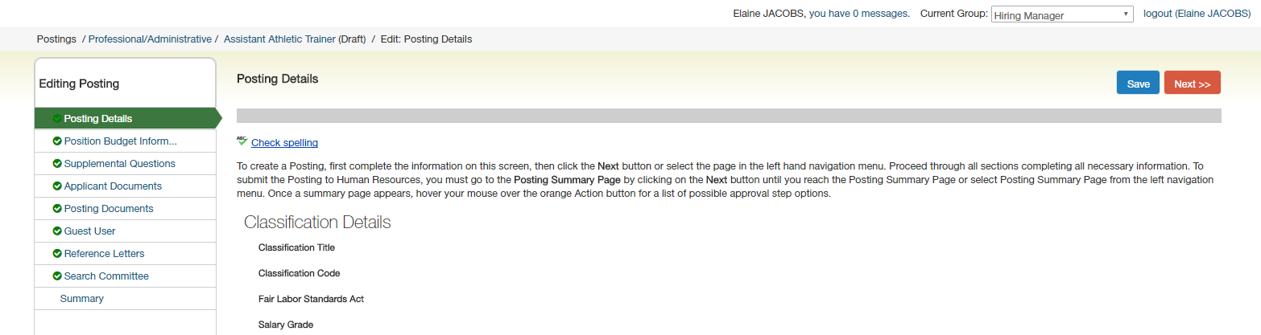
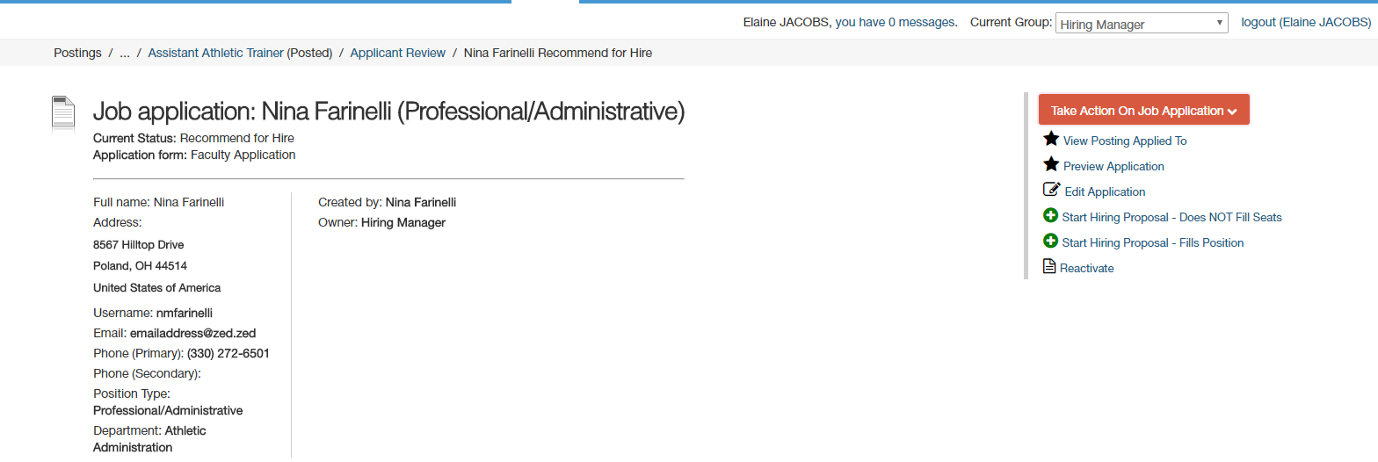

- Hover over the Take Action on Posting drop down menu on the right side of the screen. Make the appropriate selection based on your position in the University’s organizational structure. If you are unsure of which to select, please refer to the email that was originally sent with these instructions and it will indicate the appropriate selection.
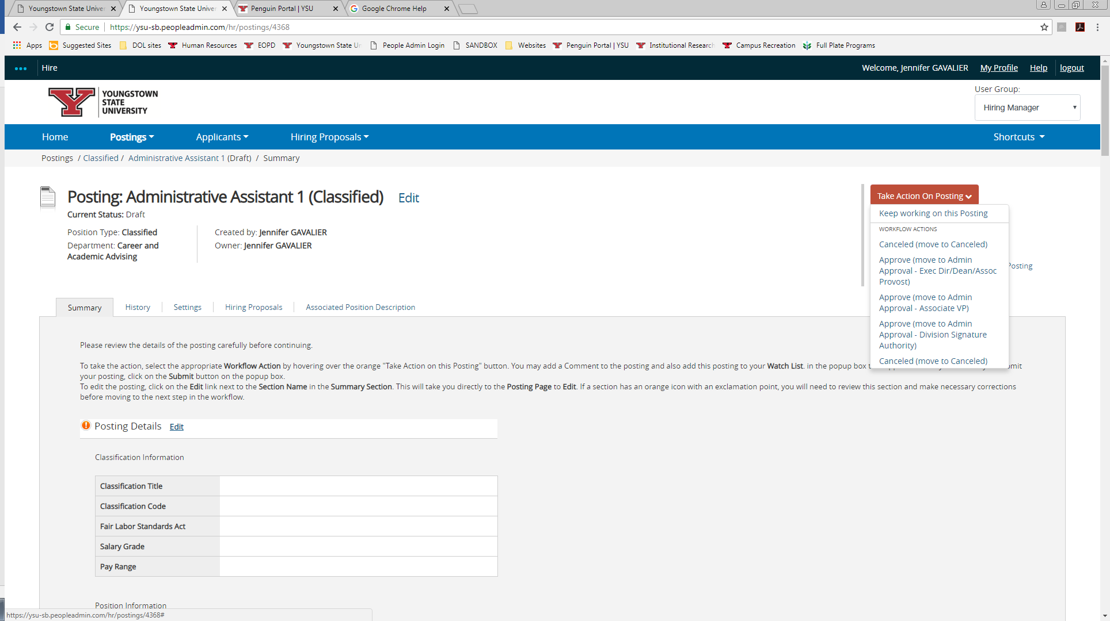

- Add a comment explaining whether the position is new or a replacement. If the position is a replacement, include the name of the employee being replaced. Click SUBMIT.

Approval Workflow

