- Sign into Office 365.
- In the upper right corner of the page, click the down arrow found to the right of your name.
- Click change shown below the avatar (silhouette to the left of your name).
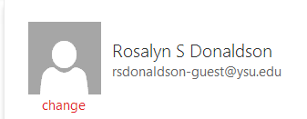
- Click the folder icon to browse your files to find an image.

- When an image is found, double click it to return to Office 365. OR
Single click the photo then click the OPEN button to return to Office 365.

- Click SAVE to keep the image, DELETE to remove it or CANCEL to ignore your choice.

NOTE: There is no photo size limit. Your image will be sized to the correct proportions for the avatar square.

