Setting a Self-Service Banner PIN and Security Question

Onetime setup unless you forget your PIN.
You must set a PIN (Personal Identification Number) when you first use Web Time Entry or Leave Reporting. The PIN is a unique six-digit number for certifying your identity when submitting time sheets and leave reports, not the registration PIN.
On the Main Menu in Self-Service Banner click Personal Information.
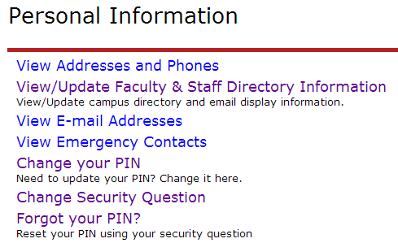

Change Your PIN
- Click Change your PIN to select a new PIN on the Change PIN page.
- Enter your Old PIN. The Old PIN for first time users is yynnnn (where yy is your birth year and nnnn is the last 4 digits of your SSN). If you have ever changed this PIN but cannot remember it, you must have it reset.*
- Enter a New PIN. Choose a six digit number. Be selective in your choice here as your identity is verified by the use of your PIN when submitting your time sheets and approvals.
- Re-enter new PIN.
- Click Change PIN after completing your entries. The Reset button clears all entry fields.
*If your old PIN is incorrect you will see: “Old PIN number verification error!” Please contact the Tech Desk at x1595 for a PIN reset. After you are reset, Self-Service returns you to the option to Change PIN.

Change Your Security Question
To reset your own PIN at a future time, please establish a security questions. (One time set-up)
- Click Change Security Questions on the Personal Information page.
- Enter your current PIN to Confirm your PIN
- Enter a Question and Answer in the designated boxes.
- Click Submit when you are finished. Reset clears the Question and Answer boxes if you are making corrections.

Forgotten PIN
When you do not remember the PIN and you have a security question established,
- Click Forgot your PIN?
- Respond to the security question
- Click Submit Answer, Reset your PIN to a new six digit number.
*Contact the Tech Desk at X1595 to reset your PIN if you do not have a security question.
For more details on completing your time sheet or leave report, please see the Web Time Entry & Web Leave Reporting page.

