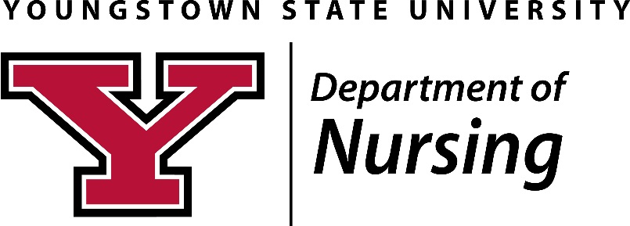
PROGRAM OUTCOME DATA
Graduates’ success on the licensure and/or certification examination
NCLEX-RN for entry-level BSN students (January 1 – December 31)
YSU data Ohio data National data (95% of national average)
2014 81.91% 77/94 77.18% 81.79% 77.75%
2015 87.64% 78/89 81.21% 84.51% 80.28%
2016 88.54% 85/96 81.12% 84.56% 80.33%
2017 90.59% 77/85 84.96% 87.12% 82.76%

Certification: Family Nurse Practitioner; Nurse Anesthesia
2015 FNP: 15/17 (AANP =9; ANCC = 6; 2 NC)
2016 FNP: 15/16 (AANP =8; ANCC = 7; 1 NC) NA: 73% 1st time; 91% 2nd time
2017 FNP: 16/16 (AANP =6; ANCC = 10) NA: 15 certified

Students’ completion of the nursing program
Program Completion Entry-level BSN: Expected level of achievement > 80%
2016 Fall, 2013 86.2 % August, 2013 – May, 2016
2017 Fall, 2014 83.0% August, 2014 – May, 2017
2018 Fall, 2015 87.0% August, 2015 – May, 2018

RN-BSN Completion Program: Expected level of achievement > 80%
2015 Fall, 2014 100% August, 2014 – December, 2015
2016 Fall, 2015 100% August, 2015 – December, 2016
2017 Fall, 2016 100% August, 2015 – December, 2017

MSN Completion Rates: Expected level of achievement > 80%
2015 78% 32/36 (3 Withdrawals: 1 NA; 2 FNP)
2016 93.75% 30/32 (2 Withdrawals: 1 NA; 1 FNP)
2017 100% 13/13 (full-time FNP)
2018 100%

Post Master’s Certificate FNP Completion Rates: Expected level of achievement > 80%
2015 100% 3/3
2016 100% 3/3
2017 N/A

Graduates obtaining a job (BSN, MSN and PMC) one year after graduation
2014 100%
2015 100%
2016 100%

